1. 

**GAMES SHOP**

**Software Requirement Specification**

Table of Contents

I. Overview 2

1. Introduction 3

2. System Functions 4

2.1. Screen Flow 4

2.2. Screen Details 5

2.3. User Authorization 13

2.4. Non-Screen Functions 14

II. Functional Requirements 15

1. Login 15

2. Signup 15

3. Forget password 17

4. Reset password 18

5. Homepage 18

6. Product 21

7. Product detail 23

8. User Profile 24

9. Change password 25

10. Post 26

11. Post Details 27

12. FAQs 30

13. Notification 31

14. Cart 32

15. Checkout 36

16. Payment 36

17. Order History 38

18. Order History Detail 38

19. Dashboard 39

20. Account Management 42

21. Product Management 44

22. Categories Management 46

23. Order Management 48

24. Posts Management 49

25. FAQs Management 51

26. Notifications Management 53

27. Product Review 54

28. Promotion Management 56

29. Send Email Management 57

30. About Us 59

III. Use-case Requirements 61

1. Use-case diagram 61

2. Use-case list 67

3. Use-case description 71

3.1. Login 71

3.2. Logout 71

3.3. Register 72

3.4. Forgot password 73

3.5. Reset password 74

3.6. Search product 75

3.7. Filter products 76

3.8. View List product 77

3.9. View product detail 77

3.10. View product review 78

3.11. Add new review 79

3.12. View review‘s reply 80

3.13. Add new review‘s reply 81

3.14. View List post 82

3.15. View post detail 83

3.16. View suggest relate posts 83

3.17. Add product to Cart 84

3.18. View cart 85

3.19. Update cart 86

3.20. Delete cart 87

3.21. Checkout 88

3.22. Use promotion code 88

3.23. Payment 89

3.24. View order history 90

3.25. View order detail 91

3.26. Update order status (cancel) 92

3.27. View user profile 93

3.28. Edit user profile 93

3.29. Change user password 94

3.30. View List FAQ 95

3.31. View FAQ detail 96

3.32. View About us 97

3.33. View unread notification 98

3.34. View notifications 99

3.35. View detail notification 99

3.36. View Dashboard 100

3.37. View accounts list management 101

3.38. Update accounts management 102

3.39. Delete accounts management 103

3.40. Search accounts 104

3.41. View products list management 105

3.42. Update products management 106

3.43. Delete products management 106

3.44. Search products management 107

3.45. View posts list management 108

3.46. Update posts management 109

3.47. Delete posts management 110

3.48. Search posts management 111

3.49. View FAQ list management 112

3.50. Create new FAQ management 113

3.51. Update FAQ management 114

3.52. Search FAQ management 115

3.53. View orders list management 116

3.54. View orders detail management 117

3.55. Update order management 118

3.56. Search order management 118

3.57. View notifications management 119

3.58. Update notifications management 120

3.59. Delete notifications management 121

3.60. Search notifications management 122

3.61. View email list management 123

3.62. View email detail management 124

3.63. Update email management 125

3.64. Delete email management 126

3.65. Search email management 127

3.66. View promotions list management 128

3.67. Update promotions management 128

3.68. Delete promotions management 129

3.69. Search promotions management 130

3.70. View categories list management 131

3.71. Update category management 132

3.72. Delete category management 133

3.73. Search category management 134

3.74. User subscribe 135

–Hanoi, April 2022 –

* **Record of changeS**

|  |  |  |  |
| --- | --- | --- | --- |
| **Date** | **A*, M, D** | **In charge** | **Change Description** |
| 14/4/2022 | A | SonTN | Add context diagram and screen flow |
| 18/4/2022 | M | SonTN | Fix screenflow and context diagram |
| 28/4/2022 | M | HungDQ | Modify Use-case description |
| 28/4/2022 | M | HungTH | Modify Use-case description |
| 28/4/2022 | M | SangNQ | Modify Use-case description |
| 28/4/2022 | M | DinhNL | Modify Use-case description |
| 28/4/2022 | M | LongTN | Modify Use-case description |
| 28/4/2022 | M | SonTN | Modify Use-case description |
|  |  |  |  |
|  |  |  |  |
|  |  |  |  |
|  |  |  |  |
|  |  |  |  |

*A - Added M - Modified D - Deleted

|  |  |
| --- | --- |
| Actor | Description |
| Users | Everyone view and use website |
| Staff | Staff is summary of all user who can control website system |
| Admin | Highest roll can control account, product and blog |
| Marketing | This roll can write, edit blog and answer FQAs question |
| Seller | This roll can control product like add product change/edit product and accept or reject order of customers |
| Customers | This user can buy and give feedback on product |

1. Overview

Games Shop was built to help Organizations and many Professionals create and sell their online entertainment genres, and customers can play games with accounts with discounted prices and bundled promotions. The document that accompanies them when they purchase a game account distributed by the manufacturer.

The main advantage of this system is that customers can buy anytime, anywhere using a variety of devices such as smartphones, tablets and computers. This can be an alternative form for customers (Especially students) to be able to play hot games in foreign countries that require a separate account and pay fees.

Devine Shop gives you quick and safe access to local and international video games.

* 1. Introduction

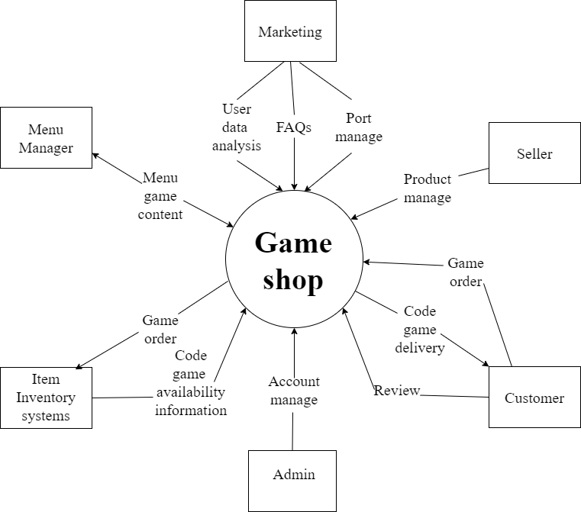

**Figure 1.1**: Context diagram

* This website is about game online selling codes, credits.
  1. System Functions
     1. Screen Flow

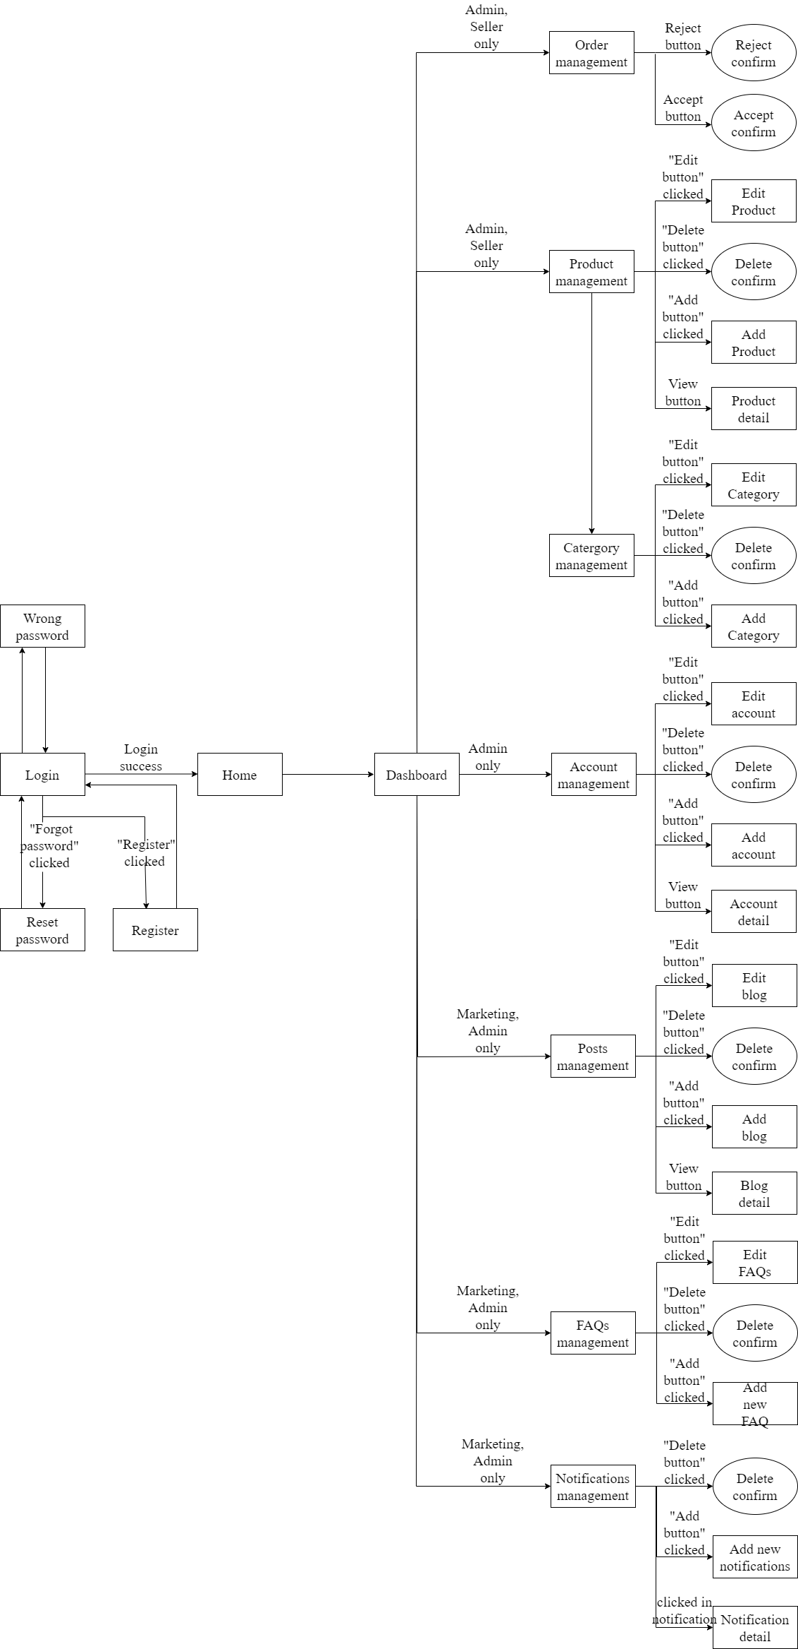

**Figure 1.2.1**. Staff screen flow

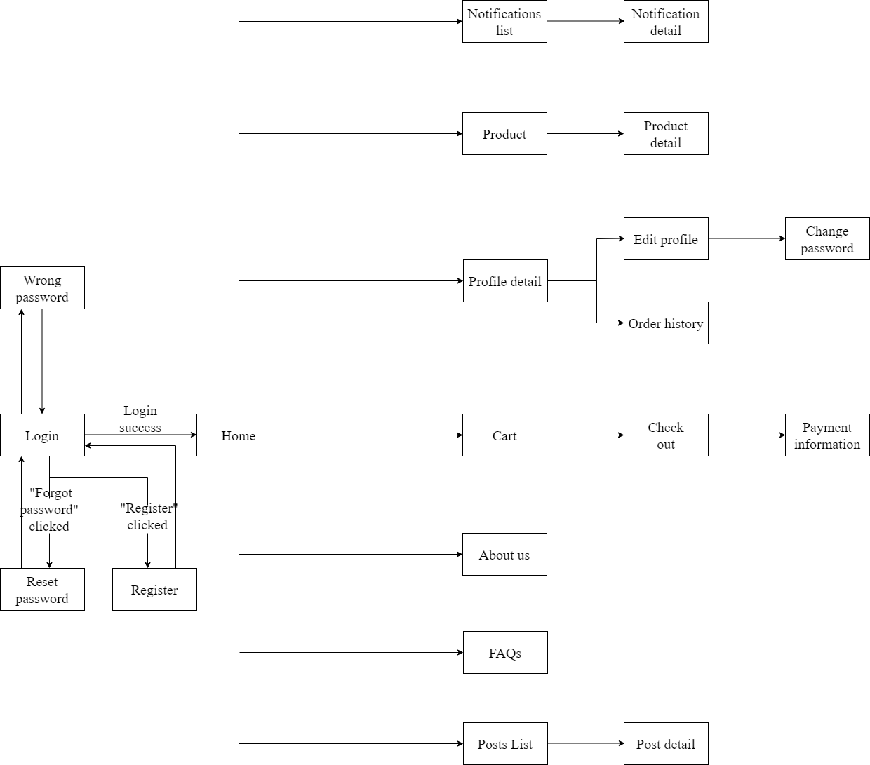

**Figure 1.2.2.** Customers screen flow

* + 1. Screen Details

|  |  |  |  |
| --- | --- | --- | --- |
| **No** | **Function/Screen** | **Feature** | **Function/Screen Details** |
| 1. 1 | User Register | Common | This is a screen which allows user register new account by input following information: full name, gender, email, mobile; User need to verify by clicking the link sent via email before login into system |
| 1. 2 | Reset Password | Common | This is a screen which allows user find account they forgot thought email register. User input email and click in reset password they will receive a mail contain reset password link.  This link will redirect user to password reset form allow user can change password of these own account without old password. |
| 1. 3 | Wrong password | Common | This is a screen will show message when user input wrong information of login account (password or email)  This screen will auto redirect back in login page |
| 1. 4 | Login | Common | This is a screen show login form for user want to login in to website |
| 1. 5 | Profile detail | Common | This is a screen which allows user to view their own profile information, including all personal information & avatar image.  User can change profile detail by click in edit button to redirect in edit profile screen.  User can view order history by click in order history button |
| 1. 6 | Order history | Common | This screen show information of all game their buy in history(OrderID , Productname, price, date,status) |
| 1. 7 | Edit profile | Common | This is a screen which allows user to edit their own profile information, including all personal information & avatar image.  Note user not allowed to change email |
| 1. 8 | Change Password | Common | This is a screen allows the user to change their password by input current password to verifies |
| 1. 9 | Home | Common | Show sliders, hot posts, featured subjects + the sider with the latest posts, static contacts/links  Shown slider information includes its image and title; the user is redirected to the slider's backlink on their clicking  Show post information includes its thumbnail, title, post date; the user is redirected to the post's details on his/her clicking  Show subject information includes its thumbnail, title, tag line; the user is redirected to the subject's details on their clicking |
| 1. 10 | Notification list | common | Customers can see all title notification of their account, list by pagination with information (id, title, status, time).  The customers can filter the notifications by status  Allow the customers to search notifications by name |
| 1. 11 | Notification detail | common | Show detail notification information(id, Content, status, time) |
| 1. 12 | Product | Common | Show list product the right side with the post search box, product categories, eight featured products (thumbnail, title, price); Product information includes its thumbnail, title, category, brief-info; the user is redirected to the Product Details page on his/her clicking on a product, redirected to this Product List page if the user clicks on a product category |
| 1. 13 | Product Detail | Common | Show details (including name, thumbnail, brief info, lowest price plan option (original price, discount price), product description and Buy button) of product user choose in product list  User can increase or decrease the number of products added to the cart  After choose right amount of product user can click in add to cart button to put product in cart to buy it later |
| 1. 14 | Cart | Common | All product user put to cart prepare to payment  Customer can change detail cart (product) beford checkout  After check all information correct user can checkout |
| 1. 15 | Checkout | Common | This screen will show all information of your order (OrderID , ProductName, User information, price, date)  After check all information is correct click in payment button to view payment screen |
| 1. 16 | Payment information | Common | This screen will guide users how to payment their order will full information of bank account , content transfer, price user need to pay |
| 1. 17 | About Us | Common | This is a screen allow user contact to admin by input following information: full name, user title (Mr, Mrs, Ms,..), email, mobile, address; |
| 1. 18 | Posts List | Common | Show blog list with the post search box, posts categories, latest posts, static contacts/links; Show post information includes its thumbnail, title, category, brief-info; the user is redirected to the post's details on their clicking |
| 1. 19 | Port Details | Common | Show details (including title, author, updated date, category, and post details) of blog user choose in blogs list |
| 1. 20 | Dashboard | Admin, seller, marketing | This screen for staff only  It give all staff member abilities to change information in system depend on their roll |
| 1. 21 | Order Management | Admin | Admin can see all order list by pagination with information (id, Total Price, date, note).  admin can filter the orders by status  Allow admin to search orders by name  From each order, admin can choose to view detail  Show detail order with information(id, Total Price ,date , note) can view, edit/update the information of the order |
| 1. 22 | Product Management | Admin | Admin can see all product list with information(id, name, thumbnail, original price, sale price, category, status, description).  Admin can filter the products by status  Allow the admin to search products by name  Admin can choose view product their choose  Admin can add new product in to product list  Show detail product information (id, name, thumbnail, original price, sale price, category, status, description)  The admin can edit/update the information of the product |
| 1. 23 | Category Management | Admin | Admin can see all category list with information(id, category name).  Allow the admin to search category by name  Admin can choose view category their want  Admin can add new category in to category list  The admin can edit/update the information of the product |
| 1. 24 | Account Management | Admin | Show the paginated list of accounts (include user id, full name, gender, email, mobile, role, status):  The admin can filter the account by role, status  Allow the admin to search accounts by full name, email…  From each account, admin can choose to view or edit it  The page also have the button/link that allows the admin to add new account |
| 1. 25 | Posts Management | Marketing, Admin | Admin and marketing roll can see all blog list by pagination with information(id, author, title, content, image).  Admin and marketing can filter the blogs by date and name  Admin and marketing can search blogs by name  Admin and marketing can choose blog to view detail and edit  Admin and marketing can write new blog  Show detailed blog information (id, author, title, content, image)  Admin and marketing can edit/update the information of the blog |
| 1. 26 | Notification Management | Admin | Admin can see all notification list by pagination with information(id, UserID, OrderID, Content, status, time).  The admin can filter the notifications by status  Allow the admin to search notifications by name  Show detailed notification information(id, UserID, OrderID, Content, status, time), allow the admin to add new or view notification information |
| 1. 27 | FAQs management | Admin, marketing | Admin and marketing roll can see all FAQs list by pagination with information(id, author, title, content, date).  Admin and marketing can filter the FAQs by date and name  Admin and marketing can search FAQs by name  Admin and marketing can choose FAQs to view detail and edit  Admin and marketing can write new FAQs  Show detailed FAQs information (id, author, title, content, date)  Admin and marketing can edit/update the information of the FAQs |
| 28.28 | Promotion management | Admin,  Seller | Admin, and marketing roll can see all Promotion lists by pagination with information(id, promotion code, sale percent, amount).  Admin and marketing can filter the promotion by date and name  Admin and marketing can search promotions by name  Admin and marketing can choose a promotion to edit  Admin and marketing can write a new promotion  Admin and marketing can edit/update the information of the promotion |
| 29.29 | Product Review | Customer,  Seller,  Marketer | At the product detail page, users can comment to review about the product. Seller or Marketing can reply to the user's review. |
| 30. | Email Management | Admin,  Marketing | Admin/Marketing can see all send-mail list with information(id, title, content, date, status).  Admin/Marketing can filter the email by status,date  Allow the admin/marketing to search email by name  Admin/Marketing can choose edit email  Admin/Marketing can add new email in to email list  Show detail product information (id, name, thumbnail, original price, sale price, category, status, description)  The admin can edit/update the information of the product |

* + 1. User Authorization

|  |  |  |  |  |
| --- | --- | --- | --- | --- |
| **Screen** | **Admin** | **Marketing** | **Seller** | **Customer** |
| Login | X | X | X | X |
| Home Page | X | X | X | X |
| Change Password | X | X | X | X |
| About Us | X | X | X | X |
| Check Out |  |  |  | X |
| Dashboard | X | X | X |  |
| Review | X | X | X | X |
| View Customer | X | X | X | X |
| Invalid Role | X | X | X | X |
| User Profile | X | X | X | X |
| Account Management | X |  |  |  |
| Reset Password | X | X | X | X |
| Cart |  |  |  | X |
| Error | X | X | X | X |
| Check out |  |  |  | X |
| Post management | X | X |  |  |
| List Post | X | X | X | X |
| Detail Post | X | X | X | X |
| Product list | X | X | X | X |
| Product Management | X |  | X |  |
| Order management | X | X | X |  |
| View Order Detail | X | X | X | X |
| View Order History | X | X | X | X |
| FQAs management |  | X |  |  |
| FQAs list | X | X | X | X |
| Category management | X |  |  |  |
| Notification management | X |  |  |  |
| Email Management | X | X |  |  |

* + 1. Non-Screen Functions

|  |  |  |  |
| --- | --- | --- | --- |
| **#** | **Feature** | **System Function** | **Description** |
| 1 | Database access | Read and write to database | Read and write to database |
| 2 | User authorise | Check account roll in database | Implementation of authorization mechanism in the system, including the specify the role of logged-in user, his/her authorized page links (building the displayed menu items (in the front end) and preventing unauthorized access via enter the links directly) |

1. Functional Requirements
   1. Login

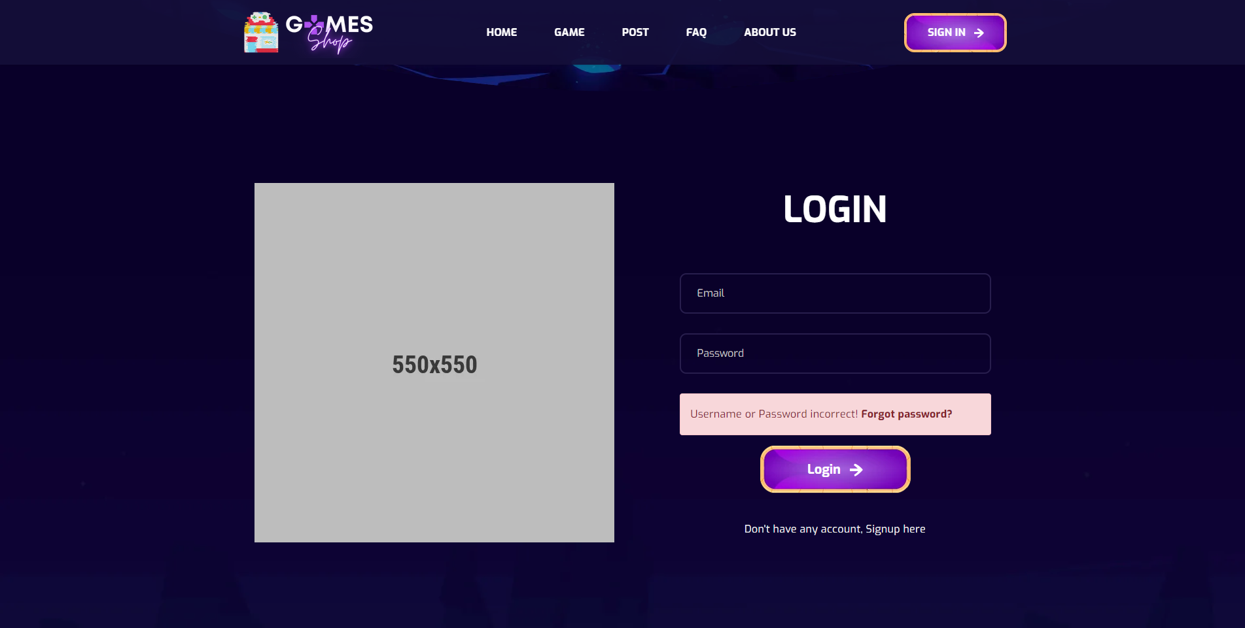

**Figure 2.1.1**: Login

|  |  |  |
| --- | --- | --- |
| **UI Element: Login page** | | |
| **UI Element Description** | | |
| ID | 1 | |
| Description | Login screen to user log in to system | |
| **UI Element Displays** | | |
| Precondition | Connect internet | |
| User not logged in | Screen show Login page | |
| User input wrong email or password | Screen show danger alert and Forgot password link | |
| **UI Element Behaviors** | | |
| **Precondition** | **Action** | **Respond** |
| User is not logged in | Click on Signin button at navbar | System will redirect to Login page |
| User is logged in | Input Login url page in browser | System will redirect to Homepage |

* 1. Signup

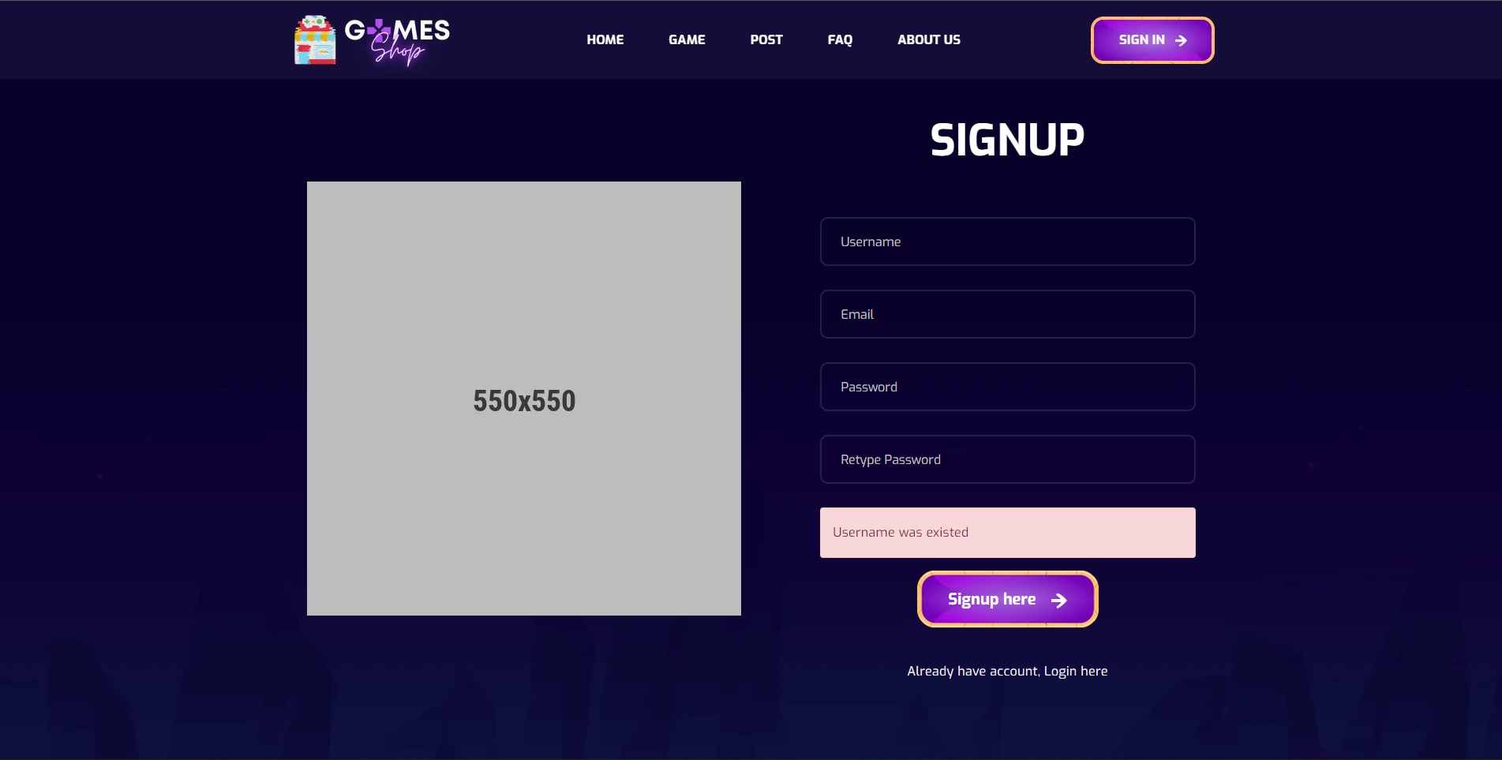

**Figure 2.2.2**. Signup

|  |  |  |
| --- | --- | --- |
| **UI Element: Signup page** | | |
| **UI Element Description** | | |
| ID | 2 | |
| Description | Signup screen to user register new account | |
| **UI Element Displays** | | |
| Precondition | Connect internet | |
| User not logged in | Screen show Signup page | |
| User input existed email or username | Screen show danger alert “Username / Email was existed” | |
| User input password and re-password not match | Screen show danger alert “Re-password not match” | |
| User registered new account success | Screen show success alert “Registered successfully” | |
| **UI Element Behaviors** | | |
| **Precondition** | **Action** | **Respond** |
| User is not logged in | Click on Signup link at Login page | System will redirect to Signup page |
| User is logged in | Input Signup url page in browser | System will redirect to Homepage |

* 1. Forget password

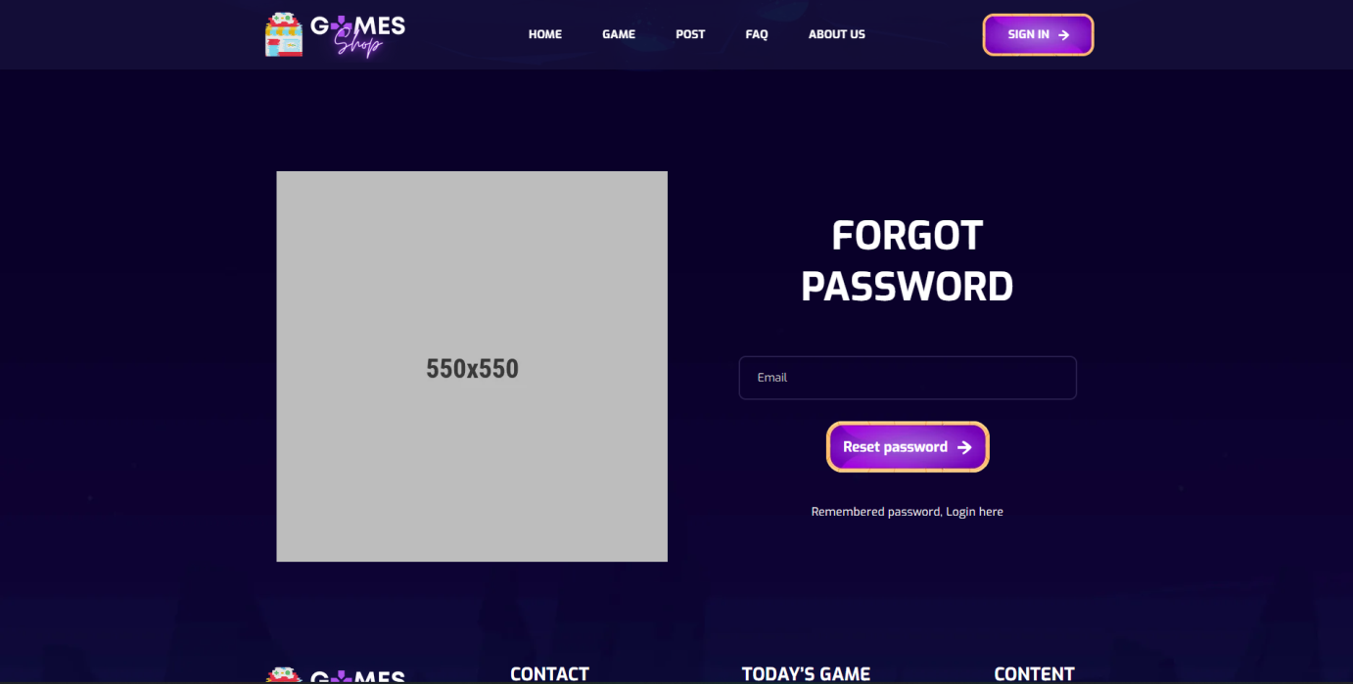

**Figure 2.3.1**: Forget password

|  |  |  |
| --- | --- | --- |
| **UI Element: Forgot password** | | |
| **UI Element Description** | | |
| ID | 3 | |
| Description | Forgot password page to user can input their account email to receive reset password link | |
| **UI Element Displays** | | |
| Precondition | Connect internet | |
| User not logged in | Screen show Forgot password page | |
| User input not exist email | Screen show danger alert “Email is not exist” | |
| User input exist email | Screen show success alert “Reset password link was sent to your email” | |
| **UI Element Behaviors** | | |
| **Precondition** | **Action** | **Respond** |
| User is not logged in | Click on Forgot password link at Login page | System will redirect to Signup page |
| User is logged in | Input Forgot password url page in browser | System will redirect to Homepage |

* 1. Reset password

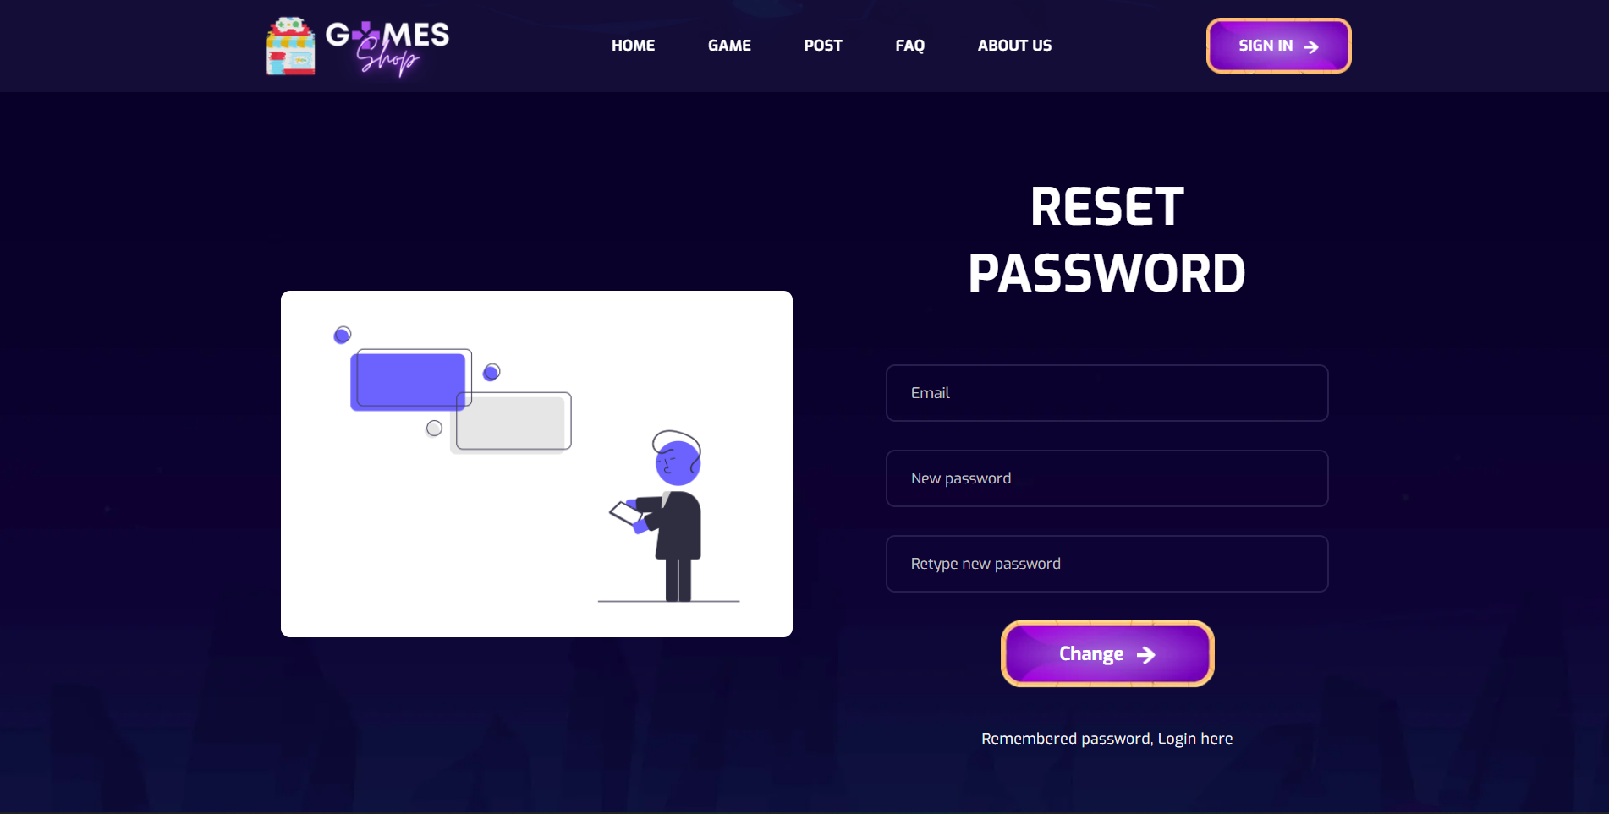

**Figure 2.4.1:** Reset password

|  |  |  |
| --- | --- | --- |
| **UI Element: Reset password** | | |
| **UI Element Description** | | |
| ID | 4 | |
| Description | Reset password page be access from link to user change their account password | |
| **UI Element Displays** | | |
| Precondition | Access from link | |
| User input password and re-password not match | Screen show danger alert “Re-password not match” | |
| **UI Element Behaviors** | | |
| **Precondition** | **Action** | **Respond** |
| User is not access with link | Input Reset password url page in browse | System will redirect to Reset Password page |
| User is access with link | Input Reset password url page in browse | System will redirect to Reset password |

* 1. Homepage

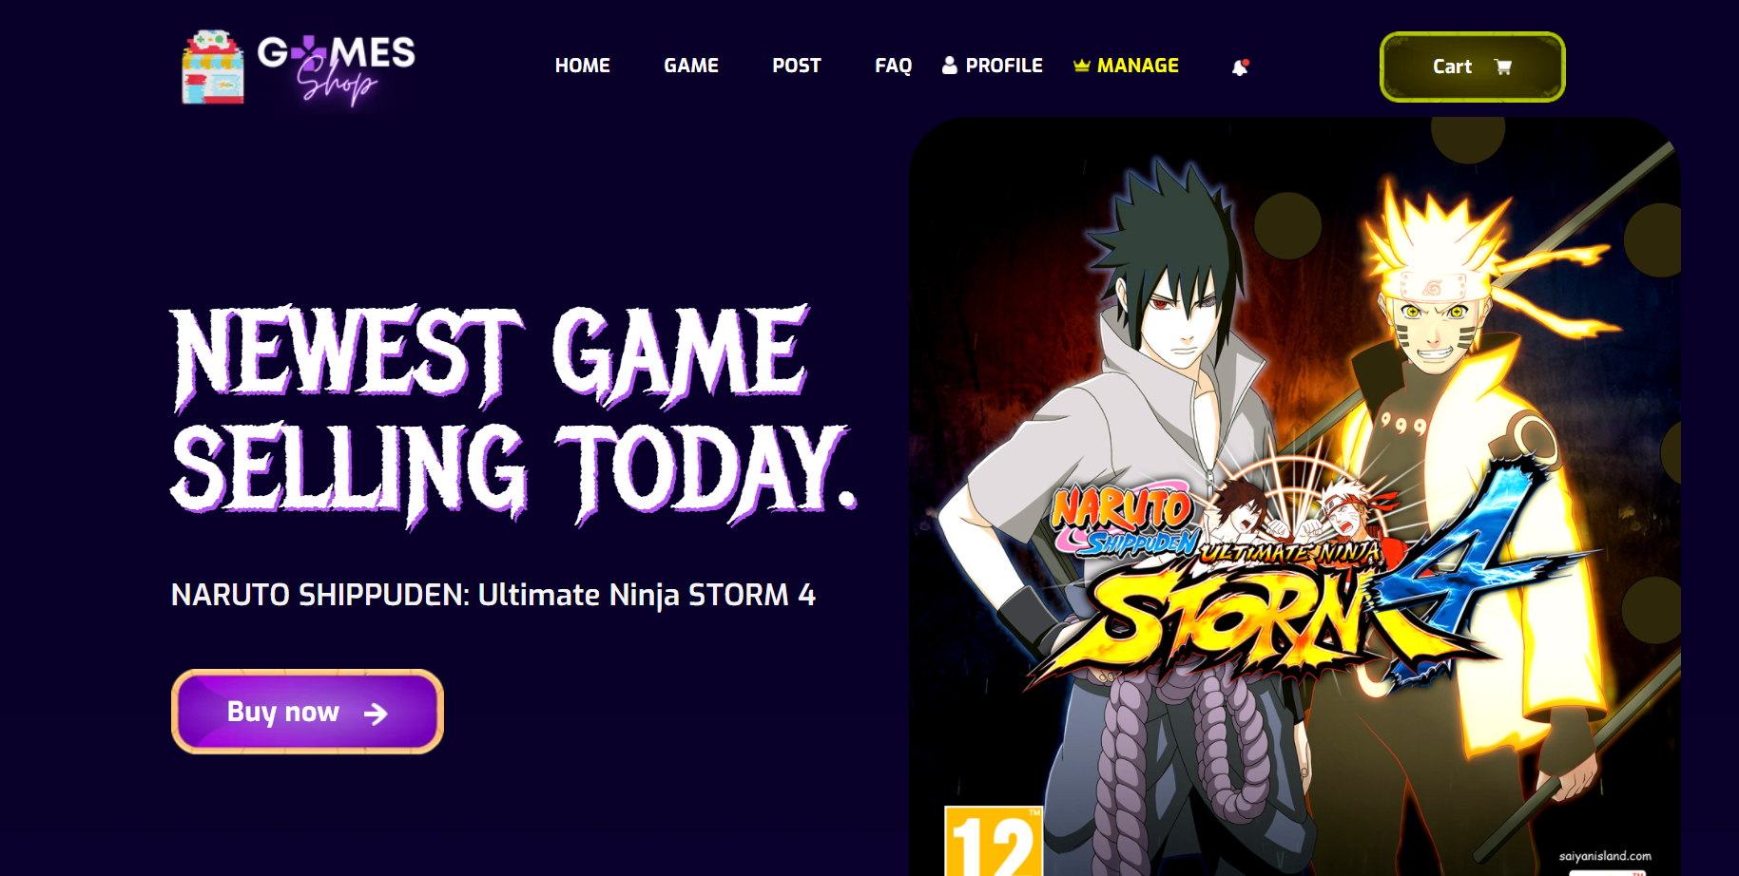

**Figure 2.5.1**: The home page shows the Latest game

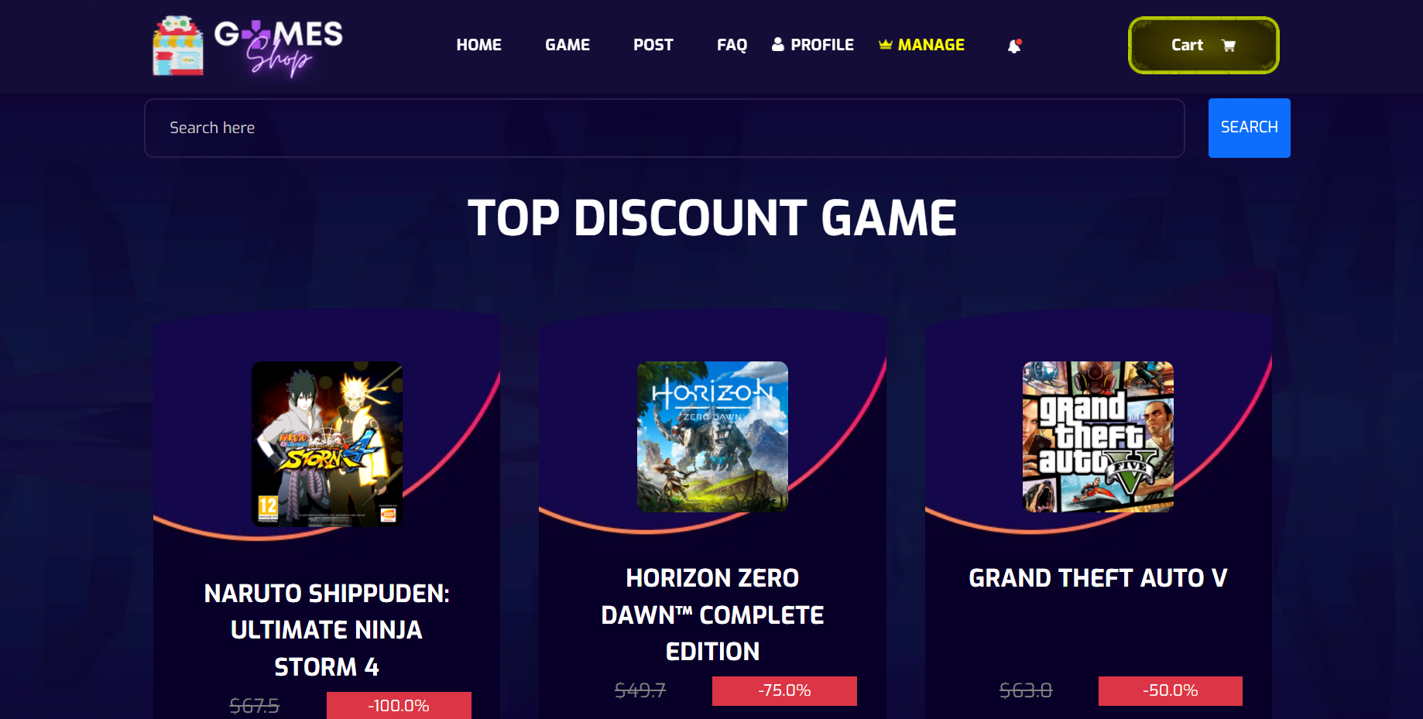

**Figure 2.5.2**: The home page shows the top discount game

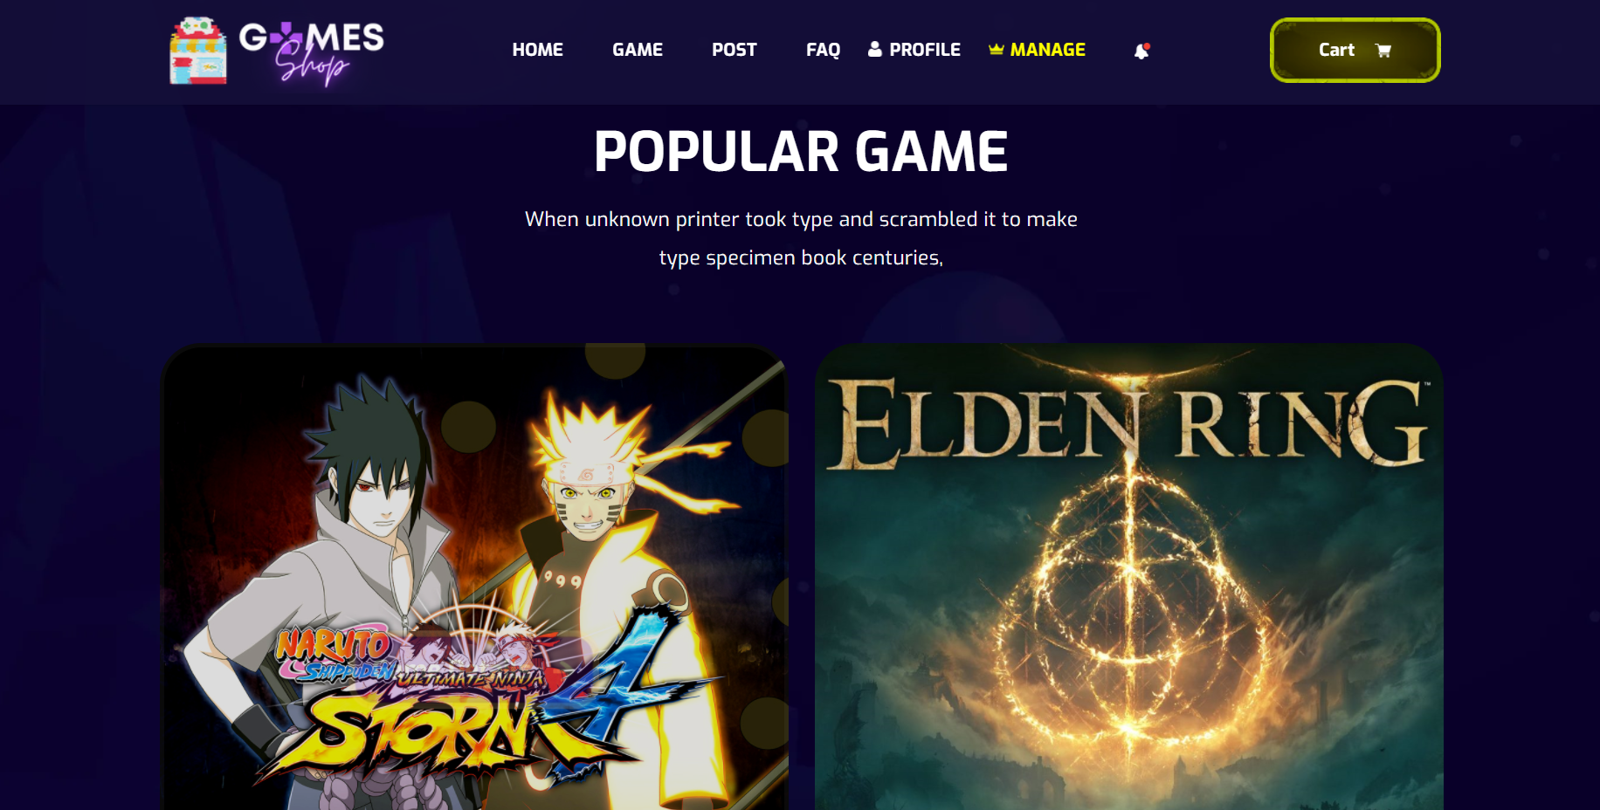

**Figure 2.5.3**: The home page shows the popular game

|  |  |  |
| --- | --- | --- |
| **UI Element: View Customer Information** | | |
| **UI Element Description** | | |
| ID | 5 | |
| Description | Screen show Homepage | |
| **UI Element Displays** | | |
| Precondition | Display | |
| Staff is not logged in | Screen show all product but doesn’t show Manager tabs in navigator bar | |
| Staff is logged in | Screen show all and Manager tabs in navigator bar | |
| **UI Element Behaviours** | | |
| **Precondition** | **Action** | **Respond** |
| Staff is not logged in | Input manage URL in browser | System will send back an error page and redirect back to home page |
| Staff is logged in | Click on manage in navigator bar or input manage URL in browser | System show screen of dashboard and navigator with full function for staff Includes: Product management, post management, category management, account management |
| Staff is not logged in | Input the product name in the search bar | Take the user to the page displaying the product they are looking for on the game page |
| Staff is not logged in | Click the button buy now, Product's name, detail | Take the user to the product detail display page |

* 1. Product
* 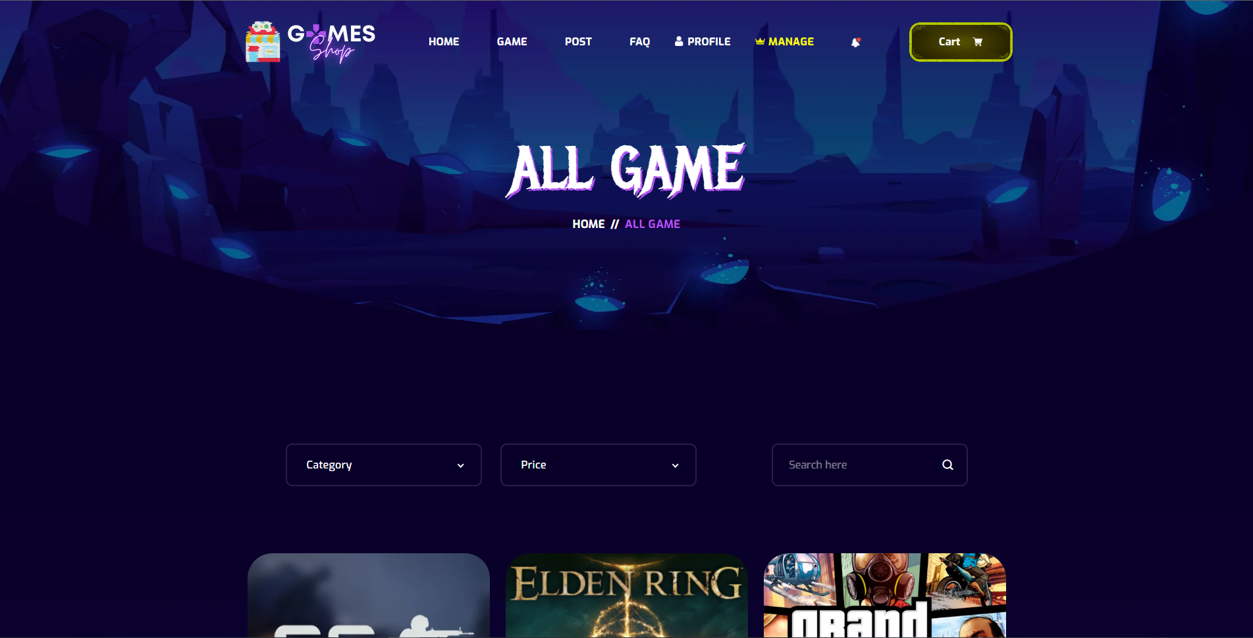

**Figure 2.6.1**: Show all the product

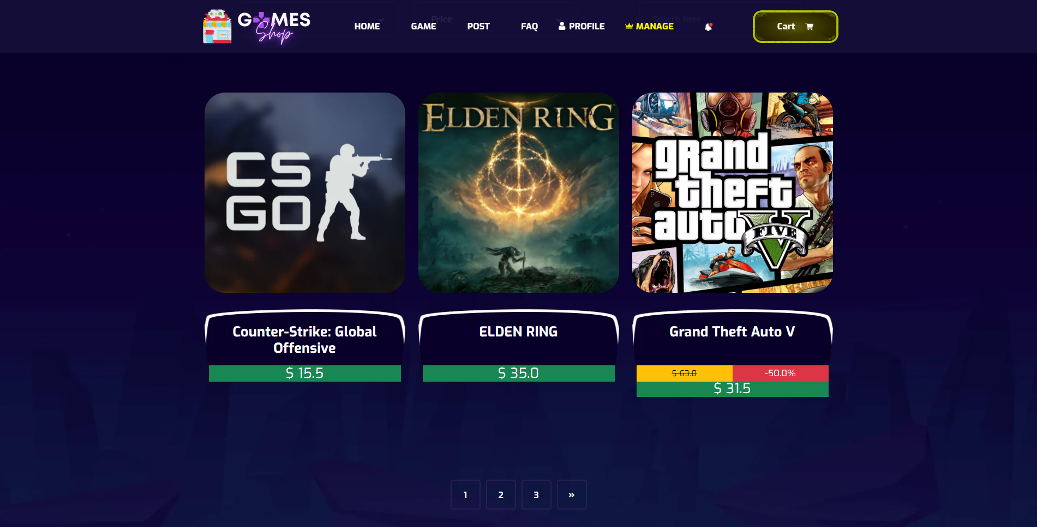

**Figure 2.6.2**: Show all the product

|  |  |  |
| --- | --- | --- |
| **UI Element: View Game Page** | | |
| **UI Element Description** | | |
| ID | 6 | |
| Description | Screen show Product | |
| **UI Element Displays** | | |
| Precondition | Display | |
| User is logged in | Screen show all product with percent discount and sell price but doesn’t show Manager tabs in navigation bar | |
| Staff is logged in | Screen show all and Manager tabs in navigator bar | |
| **UI Element Behaviours** | | |
| **Precondition** | **Action** | **Respond** |
| Staff is not logged in | Input manage url in browser | System will send back an error page and redirect back to home page |
| Staff is logged in | Click on manage in navigation bar or input manage url in browser | System show screen of dashboard and navigator with full function for staff Includes : Product management , post management, category management, account management |
| User | Click on the second page or another page | System shows other games on the second page or another page. |
| User | Click filter by category | System show games with category as selected |
| User | Click filter by price | System show games with price as selected |
| User | Click filter by text | System show games with text like they search |

* 1. Product detail
* 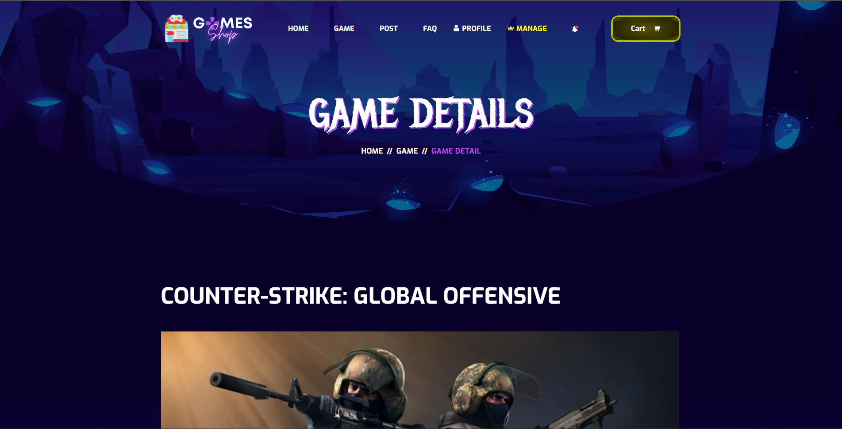

**Figure 2.7.1**: Product detail - title

* 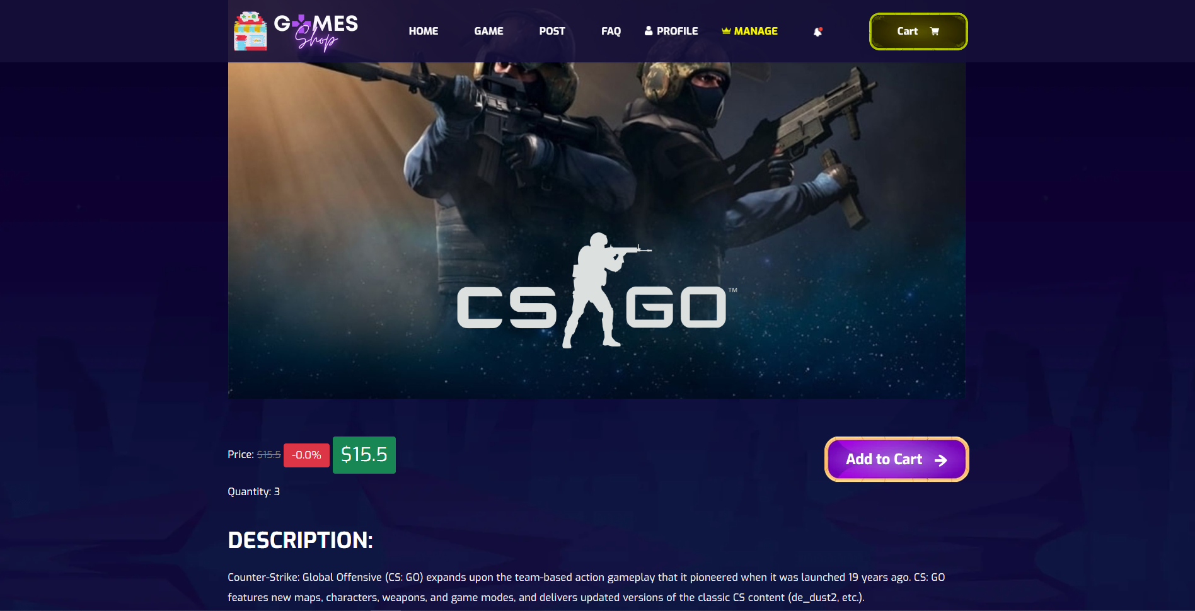

**Figure 2.7.2**: Product detail - content

|  |  |  |
| --- | --- | --- |
| **UI Element: View Game Page** | | |
| **UI Element Description** | | |
| ID | 7 | |
| Description | Screen show Product Detail | |
| **UI Element Displays** | | |
| Precondition | Display | |
| User is logged in | Screen show product detail with percent discount, description and sell price but doesn’t show Manager tabs in navigation bar | |
| Staff is logged in | Screen show all and Manager tabs in navigation bar | |
| **UI Element Behaviours** | | |
| **Precondition** | **Action** | **Respond** |
| Staff is not logged in | Input manage url in browser | System will send back an error page and redirect back to home page |
| Staff is logged in | Click on manage in navigation bar or input manage url in browser | System show screen of dashboard and navigator with full function for staff Includes : Product management , post management, category management, account management |
| User | Click on name of product | System will get requestDispatcher to product detail In product detail will show product detail with percent discount, description and sell price. |

* 1. User Profile

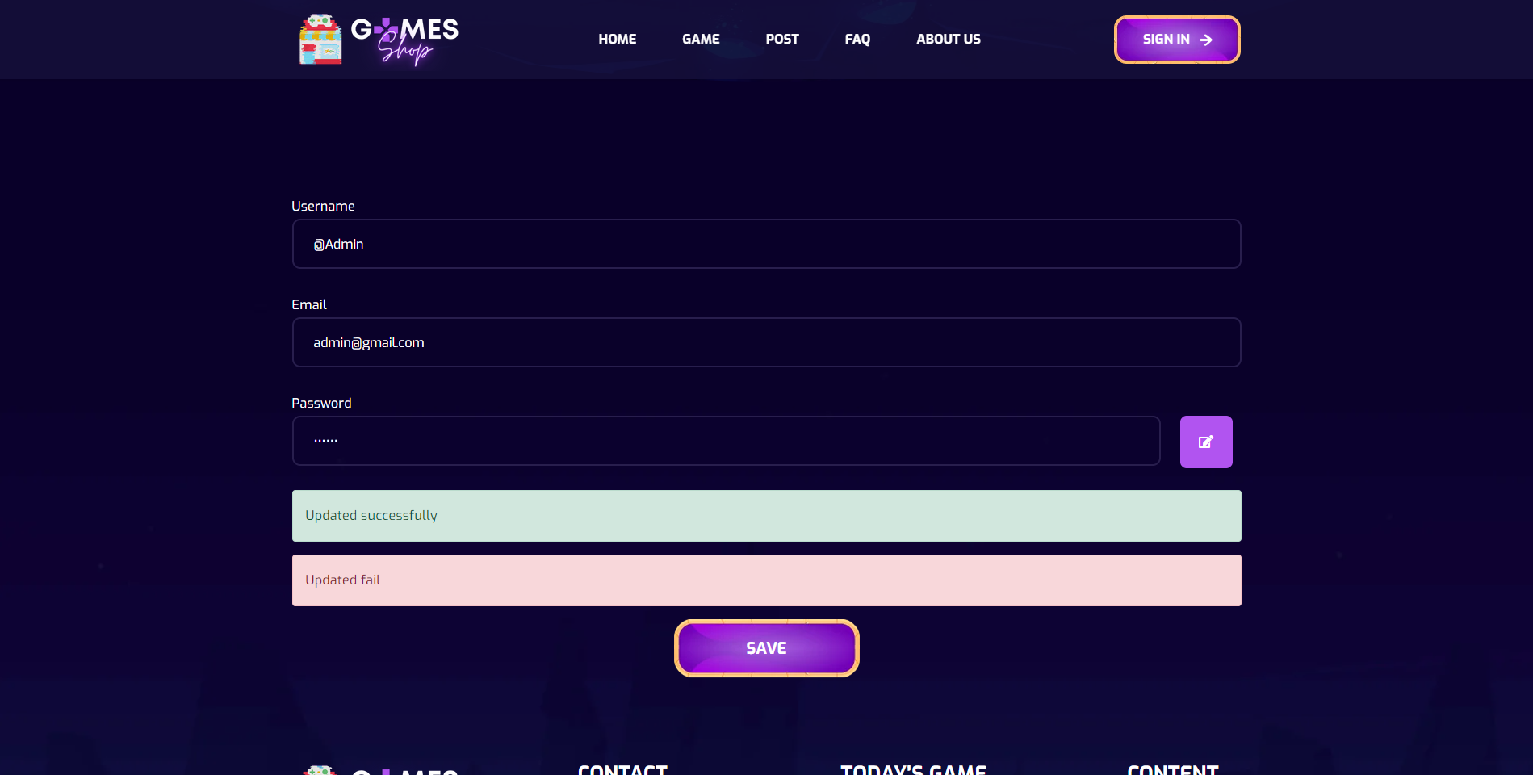

**Figure 2.8.1**: User profile

|  |  |  |
| --- | --- | --- |
| **UI Element: View User Profile** | | |
| **UI Element Description** | | |
| ID | 8 | |
| Description | Profile screen for user to change their profile | |
| **UI Element Displays** | | |
| Precondition | Connect internet | |
| User not logged in | Screen show Login page | |
| User do not input username | Screen show ERROR alert and require they input username | |
| User input satisfy username, Click Save button | Screen show alert SUCCESS | |
| **UI Element Behaviours** | | |
| **Precondition** | **Action** | **Respond** |
| Staff is not logged in | Click on Profile button at navbar | System will redirect to Login page |
| Staff is logged in | Click on Profile button at navbar | System will redirect to Profile page |

* 1. Change password

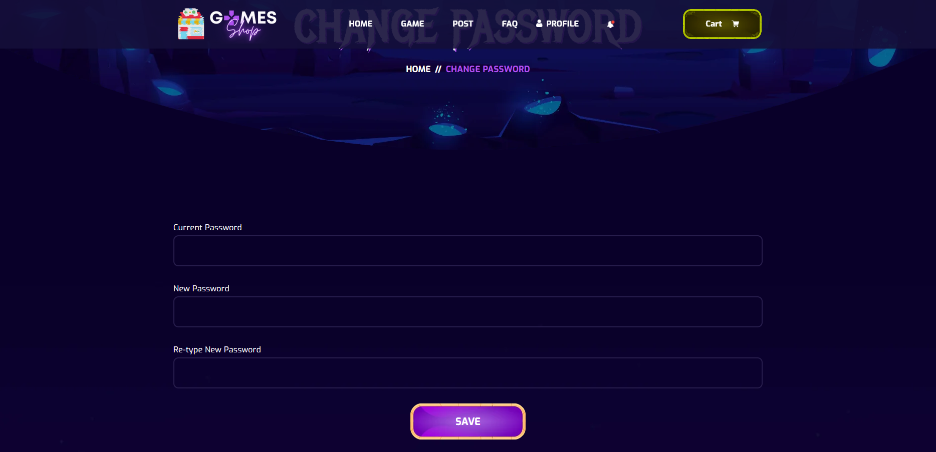

**Figure 2.9.1**: Change password

|  |  |  |
| --- | --- | --- |
| **UI Element: Change Password** | | |
| **UI Element Description** | | |
| ID | 9 | |
| Description | User input all fields and click save to change password | |
| **UI Element Displays** | | |
| Precondition | Connect internet | |
| User not logged in | Screen show Login page | |
| User do not input | Screen show ERROR alert and require they input all field | |
| User input satisfy all fields, Click Save button | Screen show alert SUCCESS | |
| **UI Element Behaviours** | | |
| **Precondition** | **Action** | **Respond** |
| User is not logged in | User input url /changepassword | System will redirect to Login page |
| User is logged in | Click on Change Password button in Profile at navbar | System will redirect to Change Password page |

* 1. Post

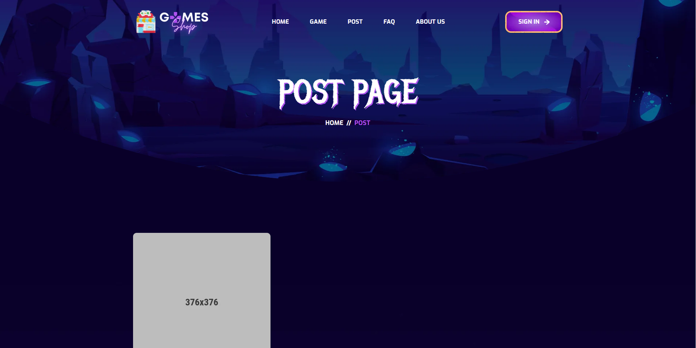

**Figure 2.10.1**: Post page

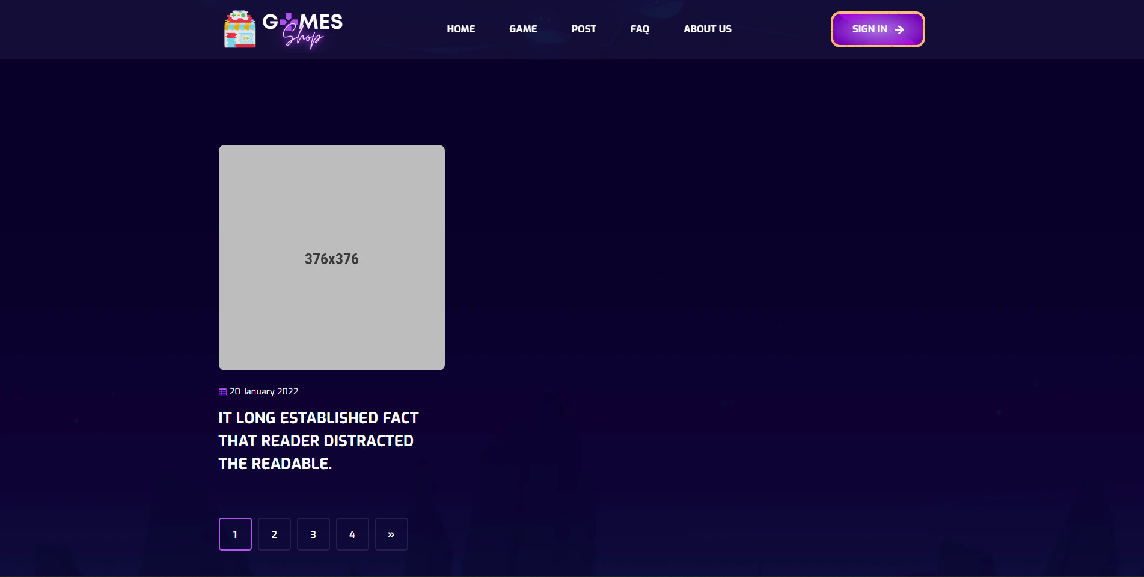

**Figure 2.10.2**: Post page

|  |  |  |
| --- | --- | --- |
| **UI Element: View Post** | | |
| **UI Element Description** | | |
| ID | 10 | |
| Description | Screen show list all Post | |
| **UI Element Displays** | | |
| Precondition | Connect internet | |
| User is not logged in | Screen show all Post | |
| User is logged in | Screen show all Post | |
| **UI Element Behaviours** | | |
| **Precondition** | **Action** | **Respond** |
| User | Click on Post in navbar | System will redirect to Post page |

* 1. Post Details

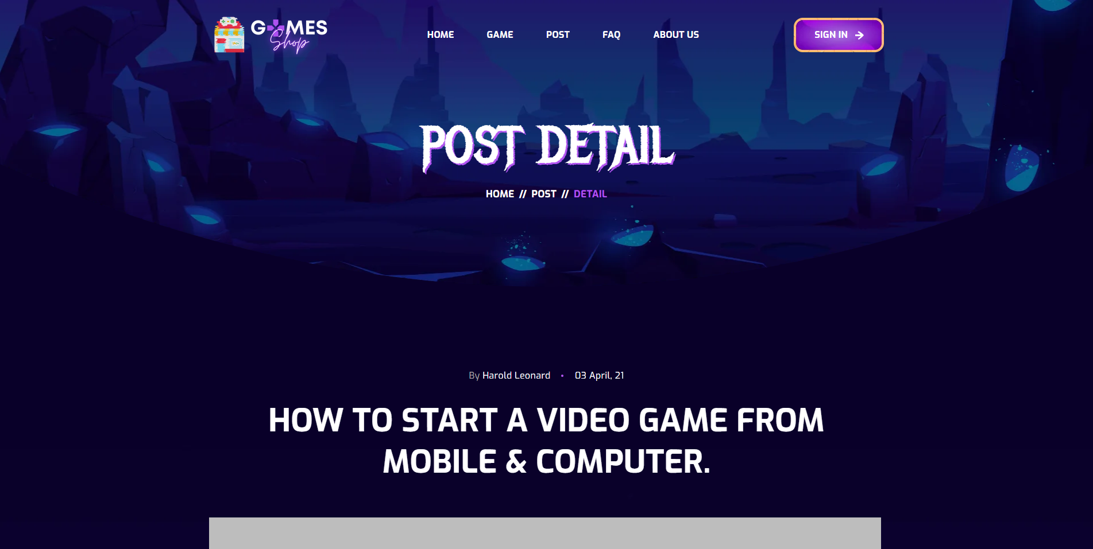

**Figure 2.11.1**: Post title detail

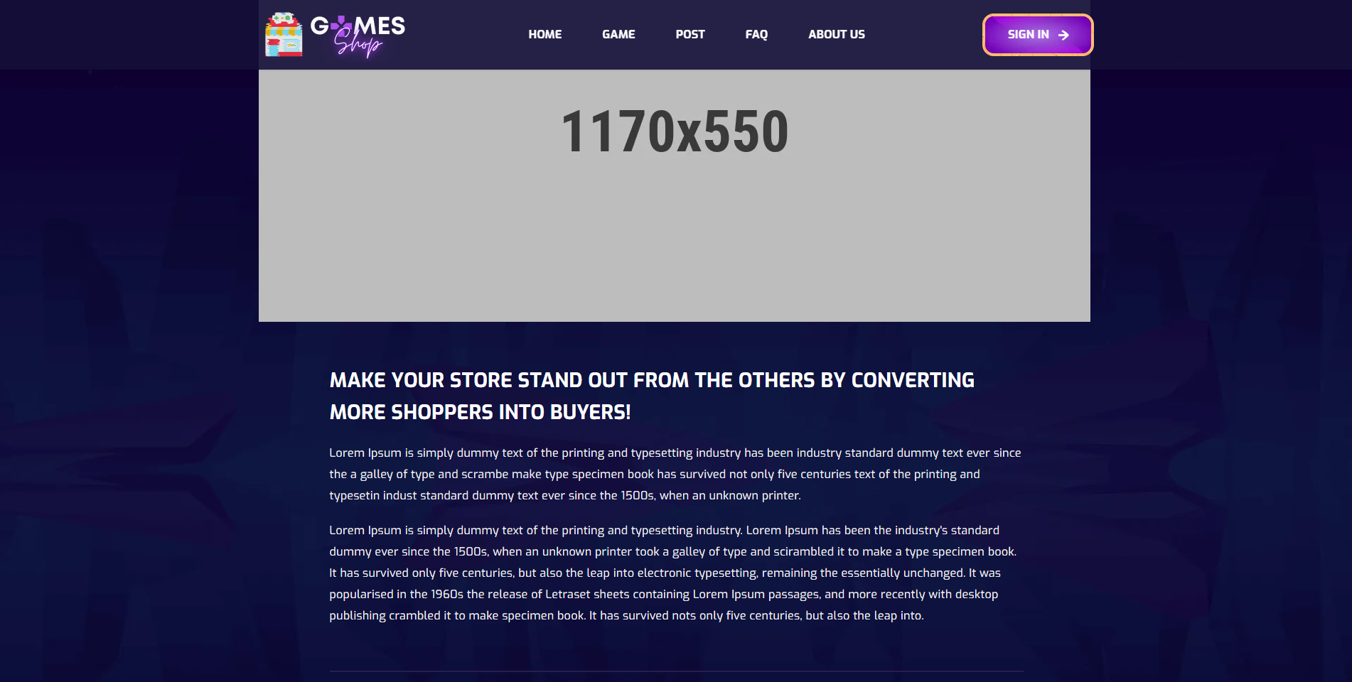

**Figure 2.11.2**: Post conent detail

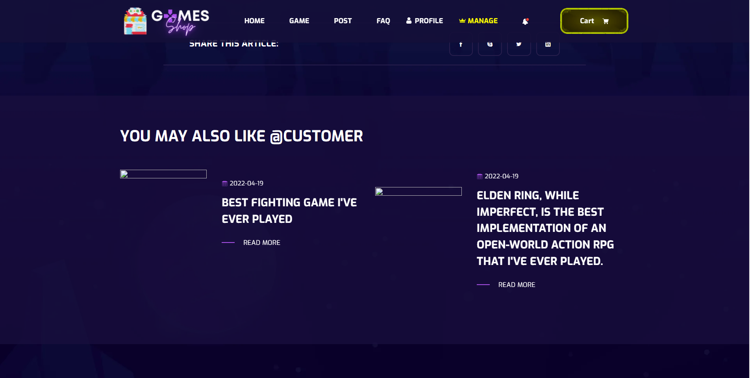

**Figure 2.11.3**: List post of author

|  |  |  |
| --- | --- | --- |
| **UI Element: Post detail** | | |
| **UI Element Description** | | |
| ID | 11 | |
| Description | Screen show Post detail and list posts of that author | |
| **UI Element Displays** | | |
| Precondition | Connect internet | |
| User is not logged in | Screen show Post detail | |
| User is logged in | Screen show Post detail | |
| **UI Element Behaviours** | | |
| **Precondition** | **Action** | **Respond** |
| User | Click on Post title in Post page | System will redirect to that Post detail |

* 1. FAQs
* 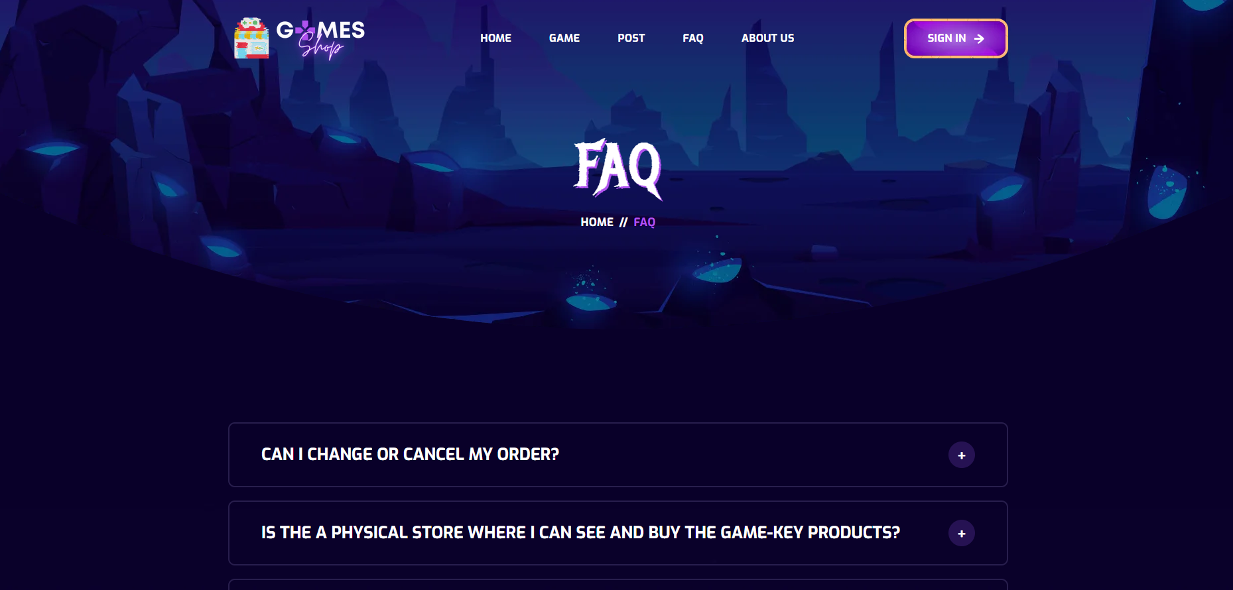

**Figure 2.12.1**: FAQ List

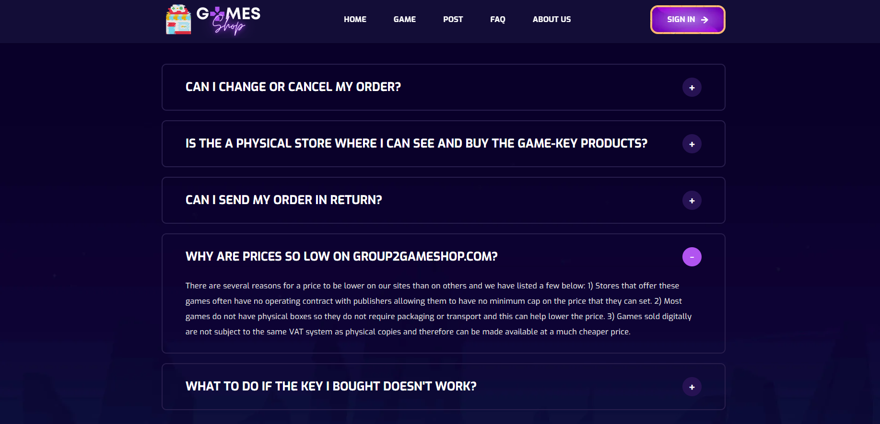

**Figure 2.12.2**: Click to show collapsed detail of each FAQ

|  |  |  |
| --- | --- | --- |
| **UI Element: View FAQs** | | |
| **UI Element Description** | | |
| ID |  | |
| Description | Screen show FAQs | |
| **UI Element Displays** | | |
| Precondition | Display | |
| Staff is not logged in | Screen show all FAQs | |
| Staff is logged in | Screen show all FAQs | |
| **UI Element Behaviours** | | |
| **Precondition** | **Action** | **Respond** |
| User | Click on FAQ in navbar | System will redirect to FAQ page |

* 1. Notification

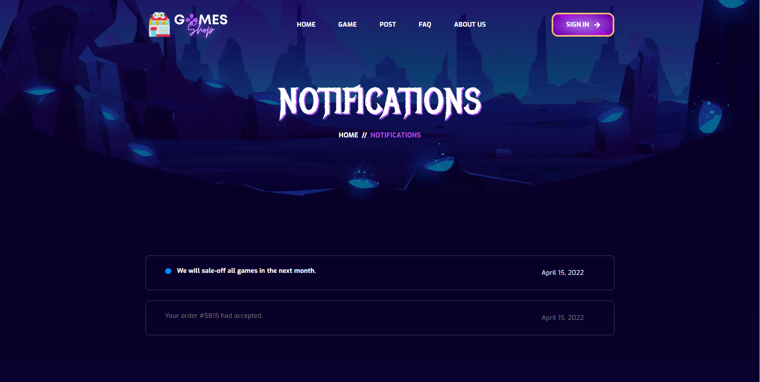

**Figure 2.13.1**: Notification list

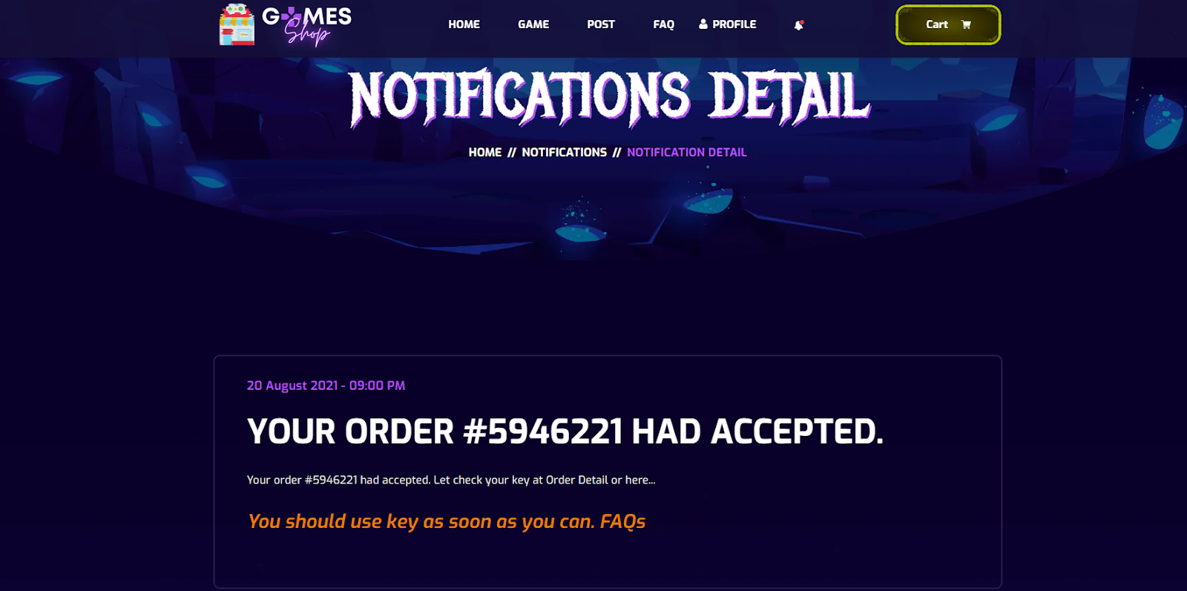

**Figure 2.13.2**: Notification detail

|  |  |  |
| --- | --- | --- |
| **UI Element: Notification** | | |
| **UI Element Description** | | |
| ID | 13 | |
| Description | Screen show list notification | |
| **UI Element Displays** | | |
| Precondition | Connect internet | |
| User is not logged in | Screen show error page | |
| User is logged in | Screen show Notification page | |
| **UI Element Behaviours** | | |
| **Precondition** | **Action** | **Respond** |
| User is not logged in | Input notification url page in browser | Display error page |
| User is logged | Click on “See all Notification” button at nav-bar | Display notification page |
| User is logged | Click on Notification title | Display notification detail |

* 1. Cart

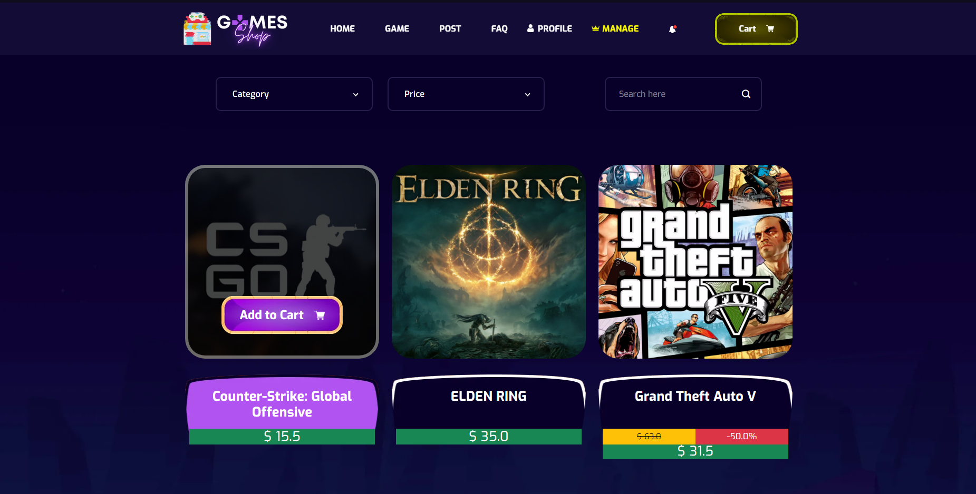

**Figure 2.14.1**: Button Add to cart in Game Page

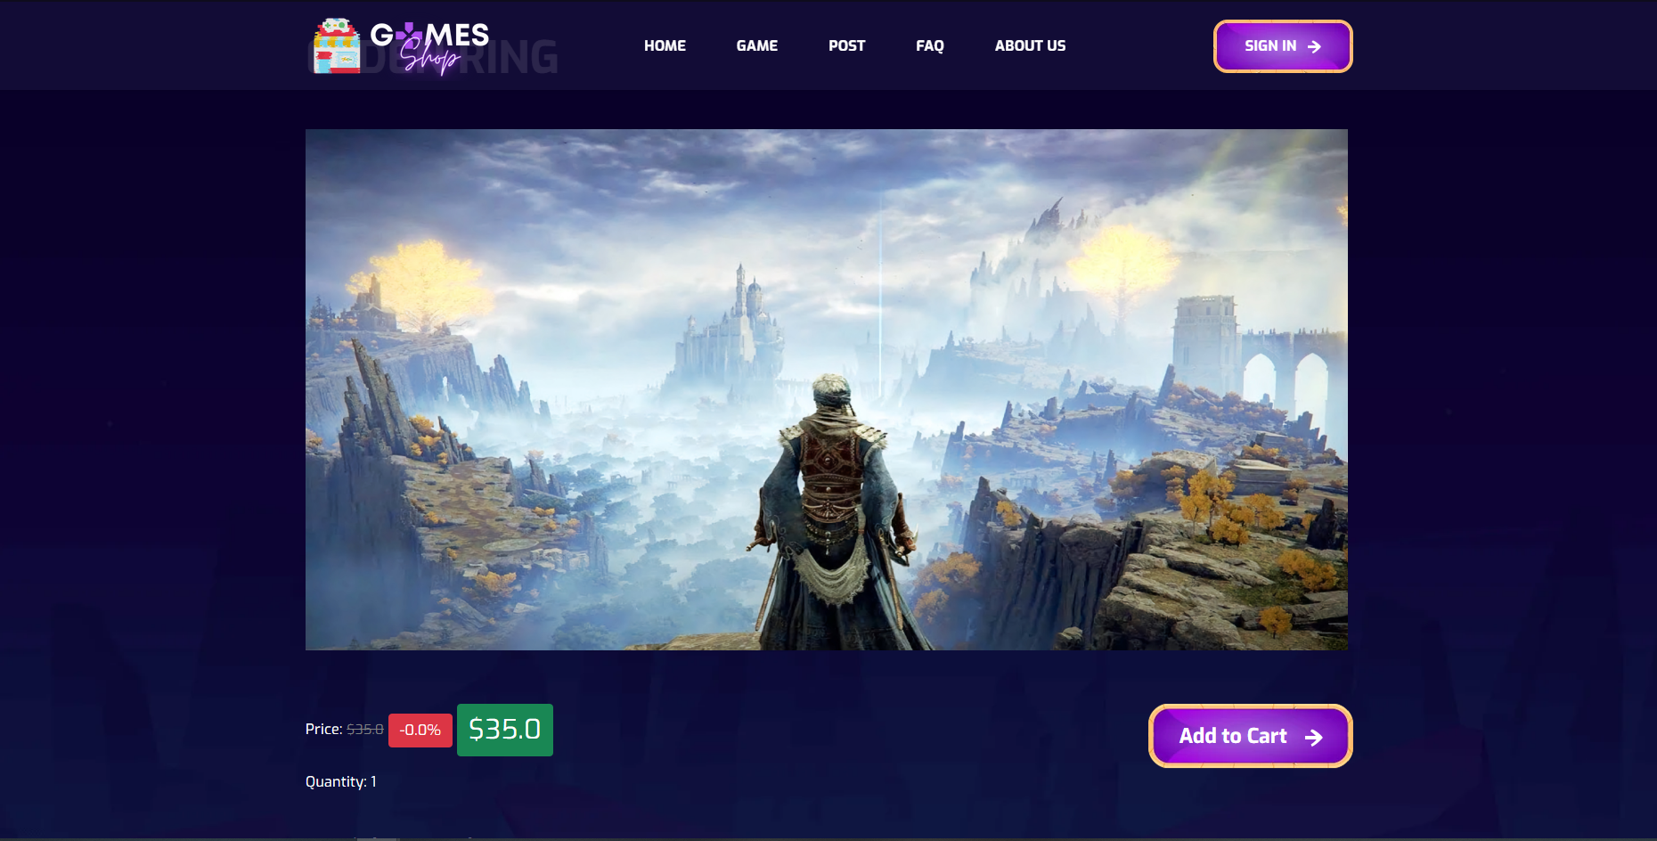

**Figure 2.14.2**: Button Add to cart in Game Detail

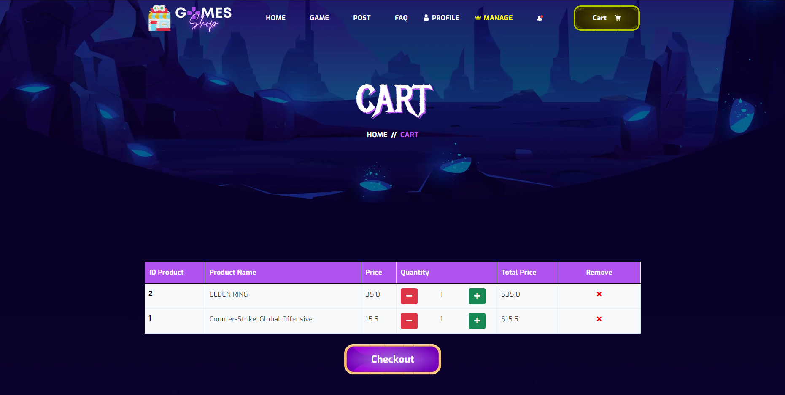

**Figure 2.14.3**: Cart Page

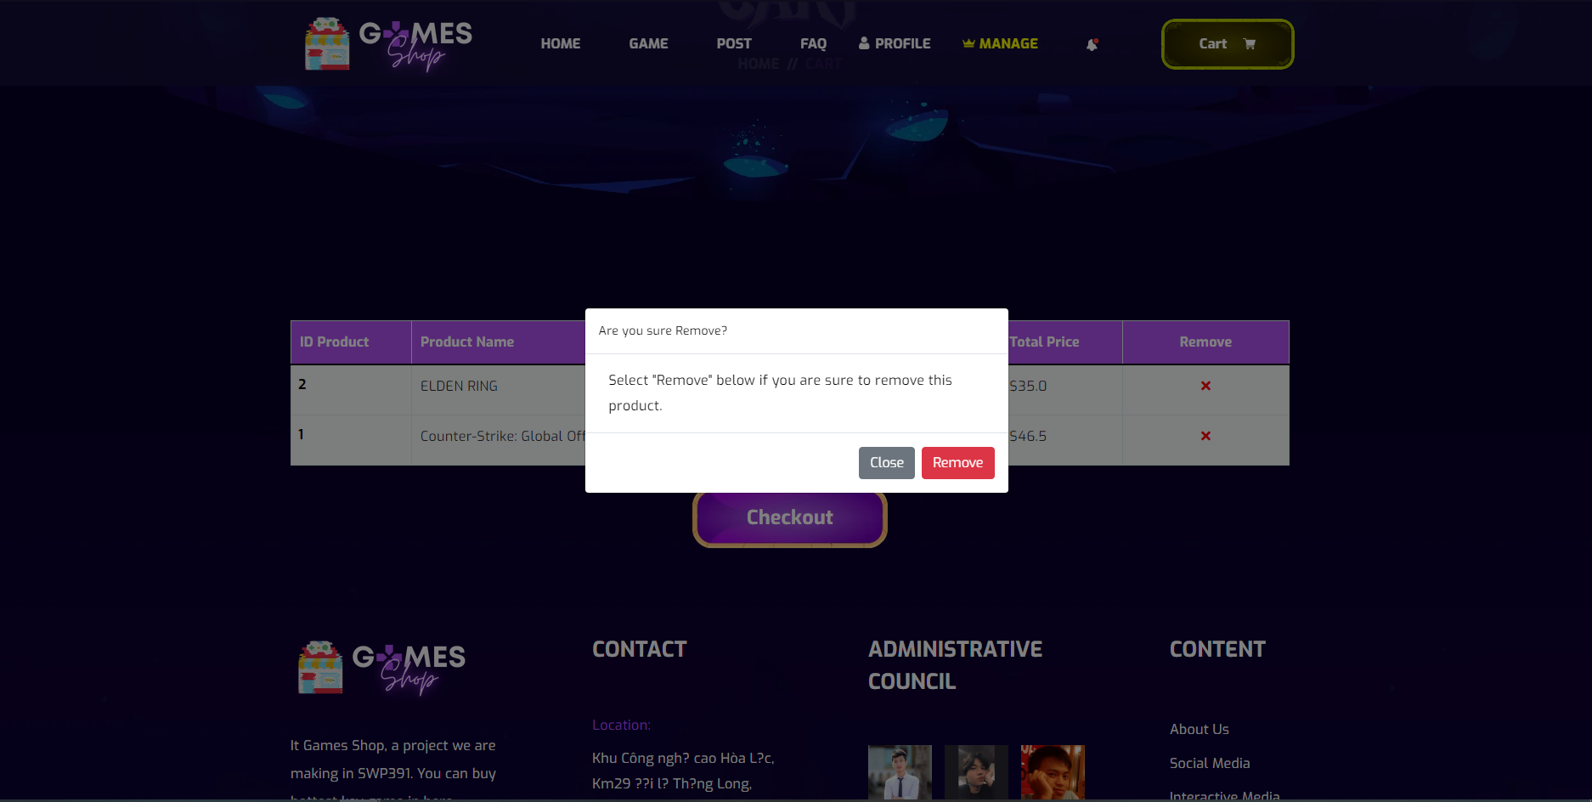

**Figure 2.14.4**: Modal remove

|  |  |  |
| --- | --- | --- |
| **UI Element: Cart** | | |
| **UI Element Description** | | |
| ID | 14 | |
| Description | Screen show Cart | |
| **UI Element Displays** | | |
| Precondition | Display | |
| Staff is not logged in | Screen show all product but doesn’t show Manager tabs in navigation bar | |
| Staff is logged in | Screen show all and Manager tabs in navigation bar | |
| **UI Element Behaviours** | | |
| **Precondition** | **Action** | **Respond** |
| Staff is not logged in | Input manage URL in browser | System will send back an error page and redirect back to home page |
| Staff is logged in | Click on manage in navigation bar or input manage URL in browser | System show screen of dashboard and navigator with full function for staff Includes: Product management, post management, category management, account management |
| User | Click on the cart button | System will send to Cart Page |
| User | Click the button Add to cart | System will send notifications that add to cart successfully. |
| User | On cart page, user click on plus button | Quantity of product you click will + 1 |
| User | On cart page, user click on minus button | Quantity of product you click will - 1 |
| User | On cart page, user click on remove button | System will show modal that confirm to remove the product from the cart. |

* 1. Checkout

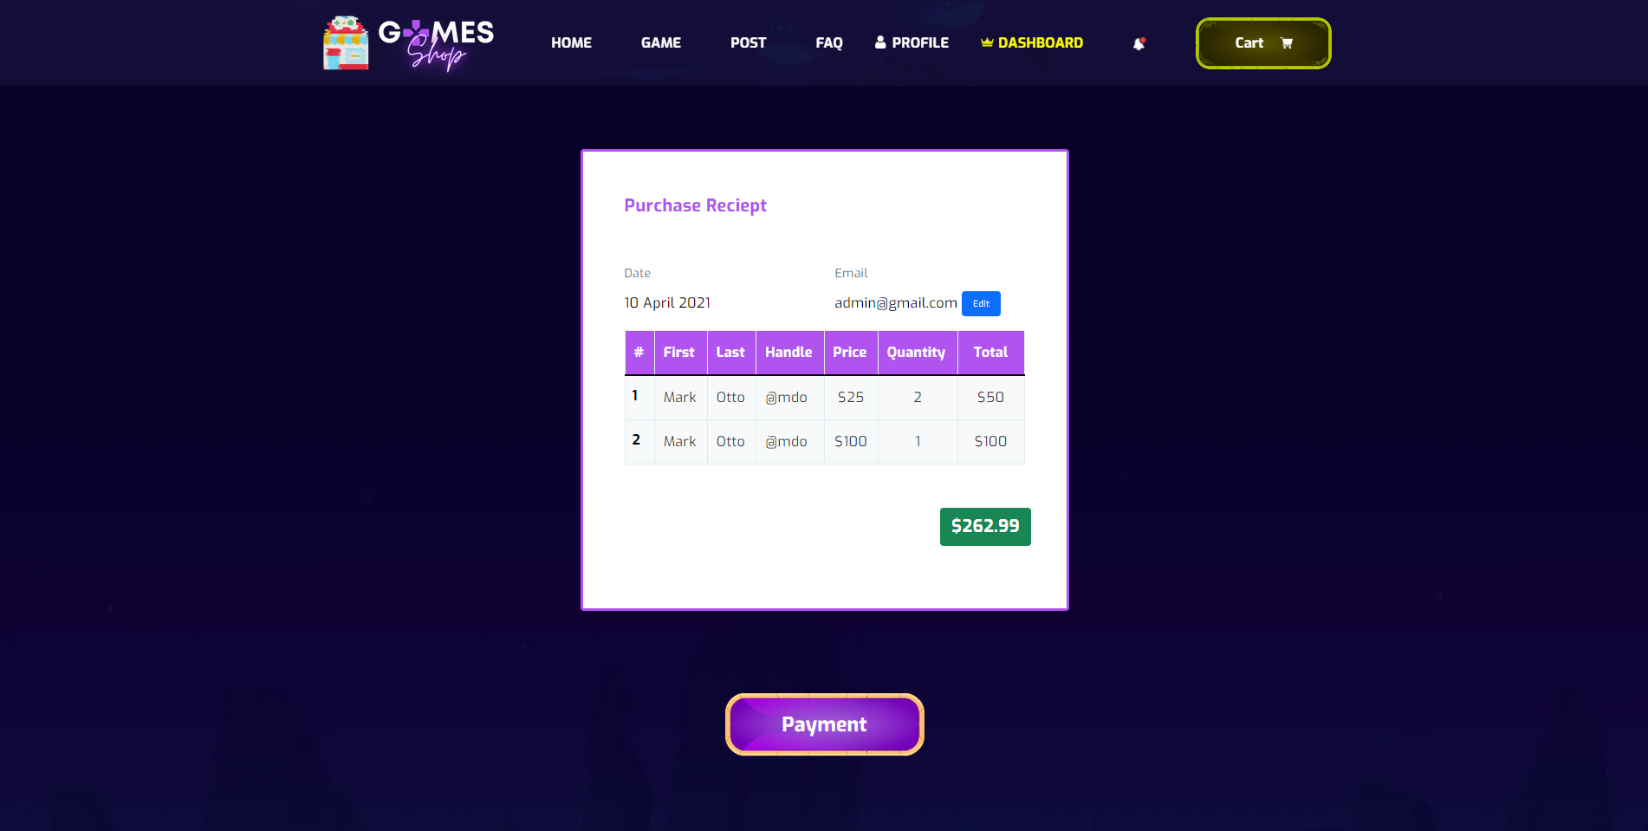

**Figure 2.15.1**: Check Out Screen

|  |  |  |
| --- | --- | --- |
| **UI Element: Check Out** | | |
| **UI Element Description** | | |
| ID | 15 | |
| Description | Screen show Check Out screen of that author | |
| **UI Element Displays** | | |
| Precondition | Access in to the website and Cart has items | |
| User is logged in | Screen show Check out | |
| **UI Element Behaviours** | | |
| **Precondition** | **Action** | **Respond** |
| User | Click on check out button | System will redirect to check out |
| User | Click on check out button | System will redirect to payment |

* 1. Payment

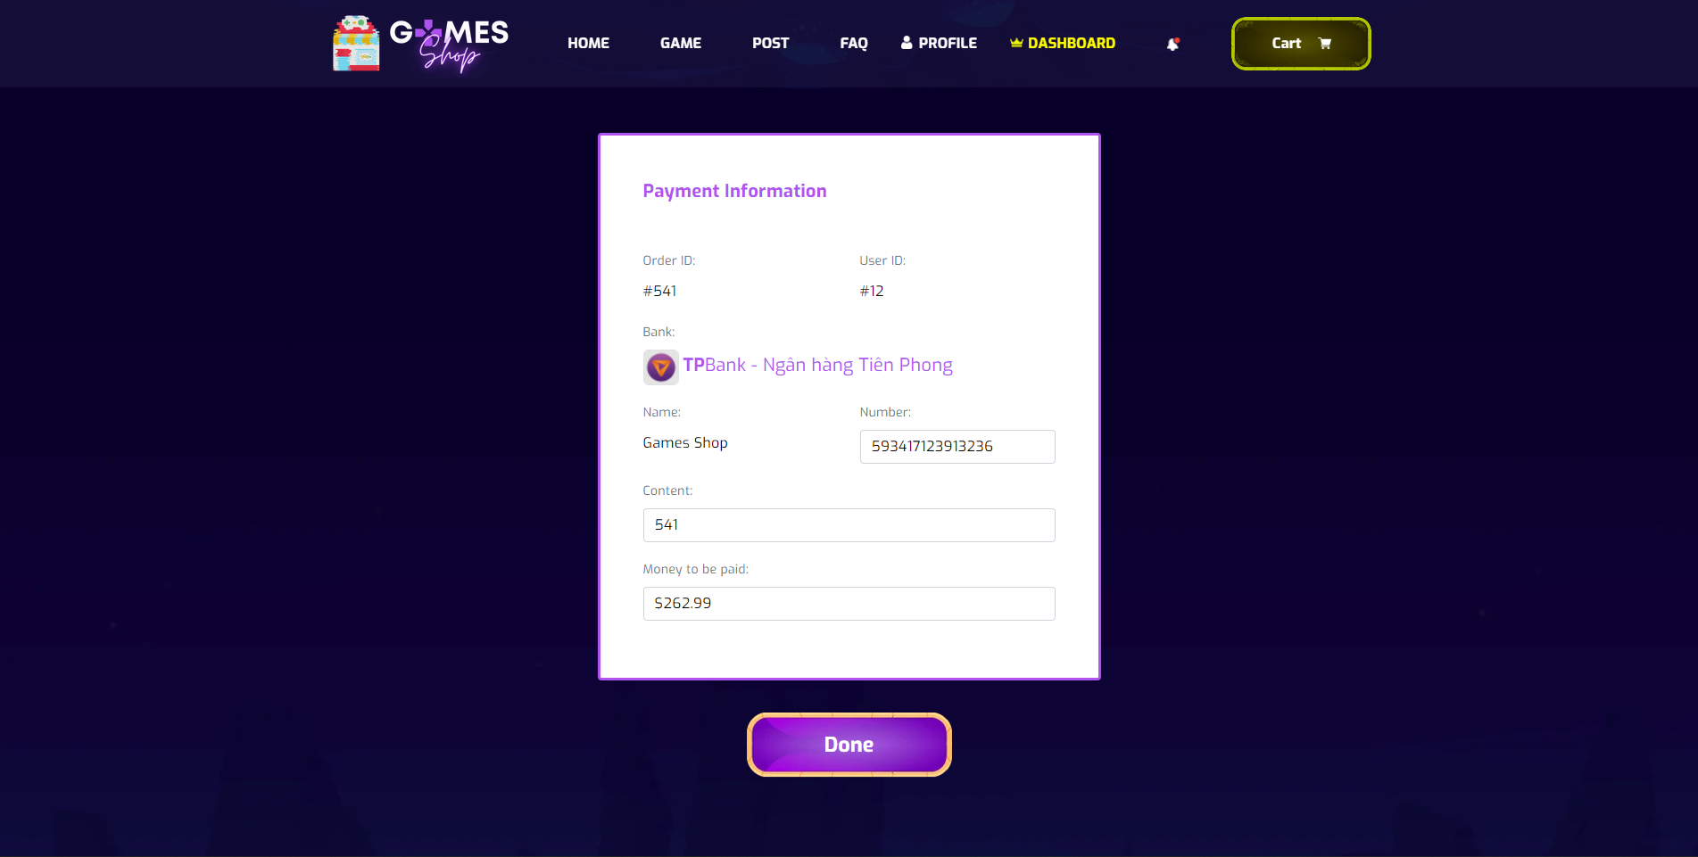

**Figure 2.16.1**: Payment Screen

|  |  |  |
| --- | --- | --- |
| **UI Element: Payment** | | |
| **UI Element Description** | | |
| ID | 16 | |
| Description | Screen show Payment of that author | |
| **UI Element Displays** | | |
| Precondition | Access in to the website, Cart has items , checkout successfully | |
| User is logged in | Screen show Payment | |
| **UI Element Behaviours** | | |
| **Precondition** | **Action** | **Respond** |
| User | Click on payment button | System will redirect to Payment screen |
| User | Click on Done button | System will redirect to Homepage |

* 1. Order History

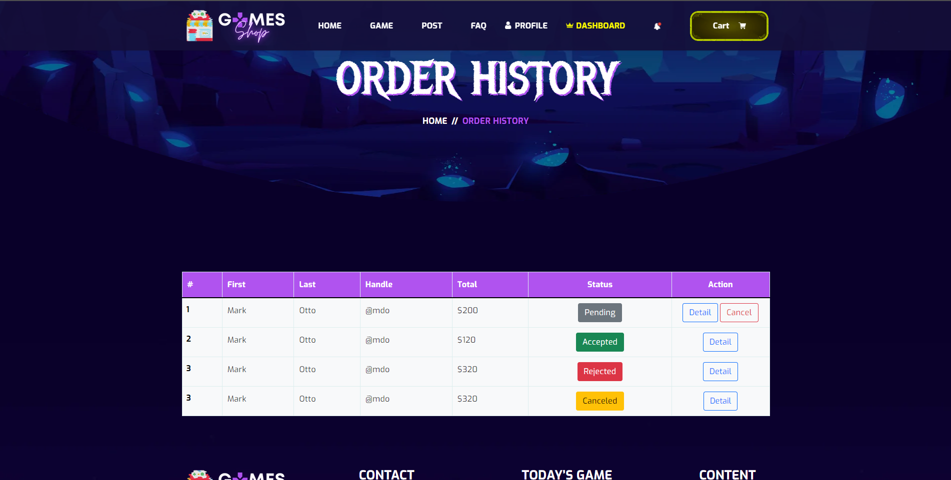

**Figure 2.17.1**: Order History Screen

|  |  |  |
| --- | --- | --- |
| **UI Element: Order history** | | |
| **UI Element Description** | | |
| ID | 17 | |
| Description | Screen show order history and them status | |
| **UI Element Displays** | | |
| Precondition | Connect internet | |
| User is not logged in | Screen show error page | |
| User is logged in | Screen show Order history page | |
| **UI Element Behaviours** | | |
| **Precondition** | **Action** | **Respond** |
| User is not logged in | Input order history url page in browser | Display error page |
| User is logged | Click on Order history at nav-bar | Display order history page |
| User is logged | Click on “Cancel” button at order detail | Display cancel status alert |

* 1. Order History Detail

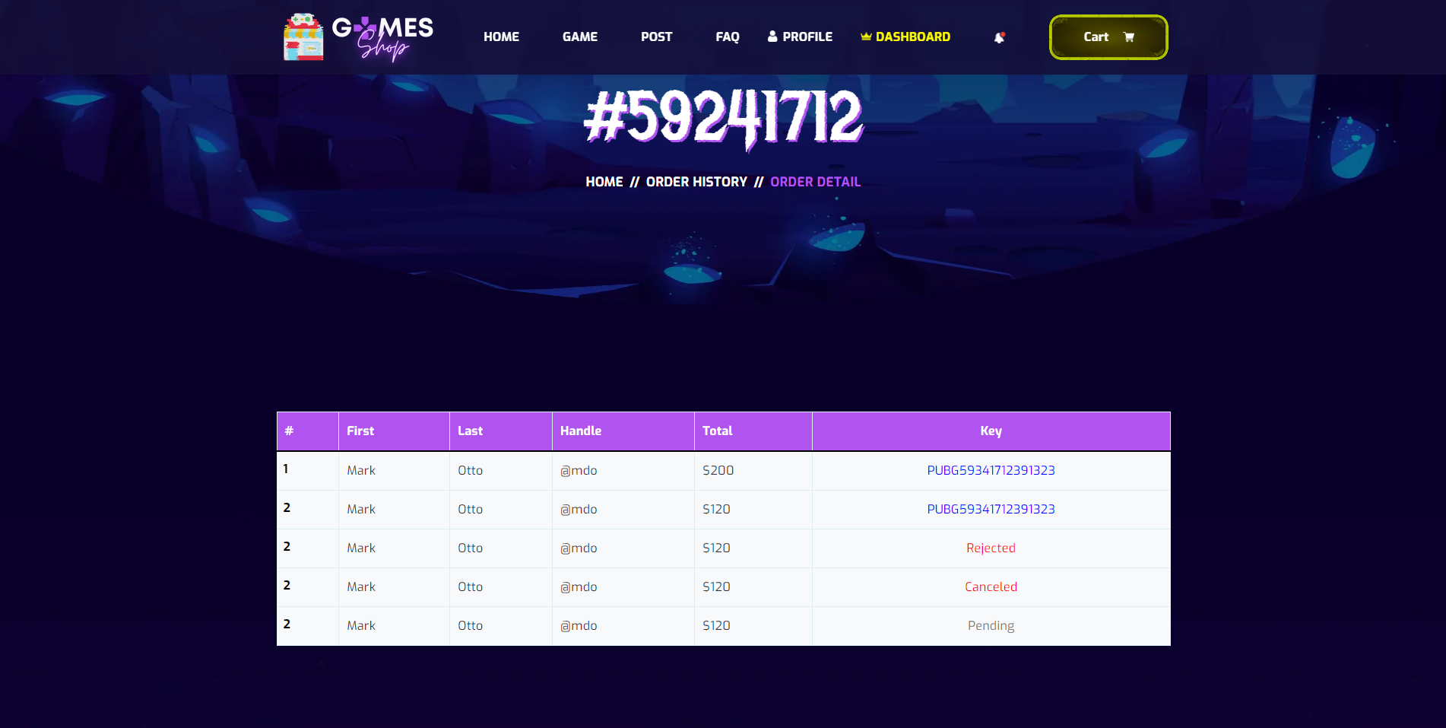

**Figure 2.18.1**: Order History Detail Screen

|  |  |  |
| --- | --- | --- |
| **UI Element: Order History detail** | | |
| **UI Element Description** | | |
| ID | 18 | |
| Description | Screen show order detail and them status | |
| **UI Element Displays** | | |
| Precondition | Connect internet | |
| User is not logged in | Screen show error page | |
| User is logged in | Screen show Order detail page | |
| **UI Element Behaviours** | | |
| **Precondition** | **Action** | **Respond** |
| User is not logged in | Input order detail url page in browser | Display error page |
| User is logged | Click on Detail button at order history page | Display order detail page |

* 1. Dashboard

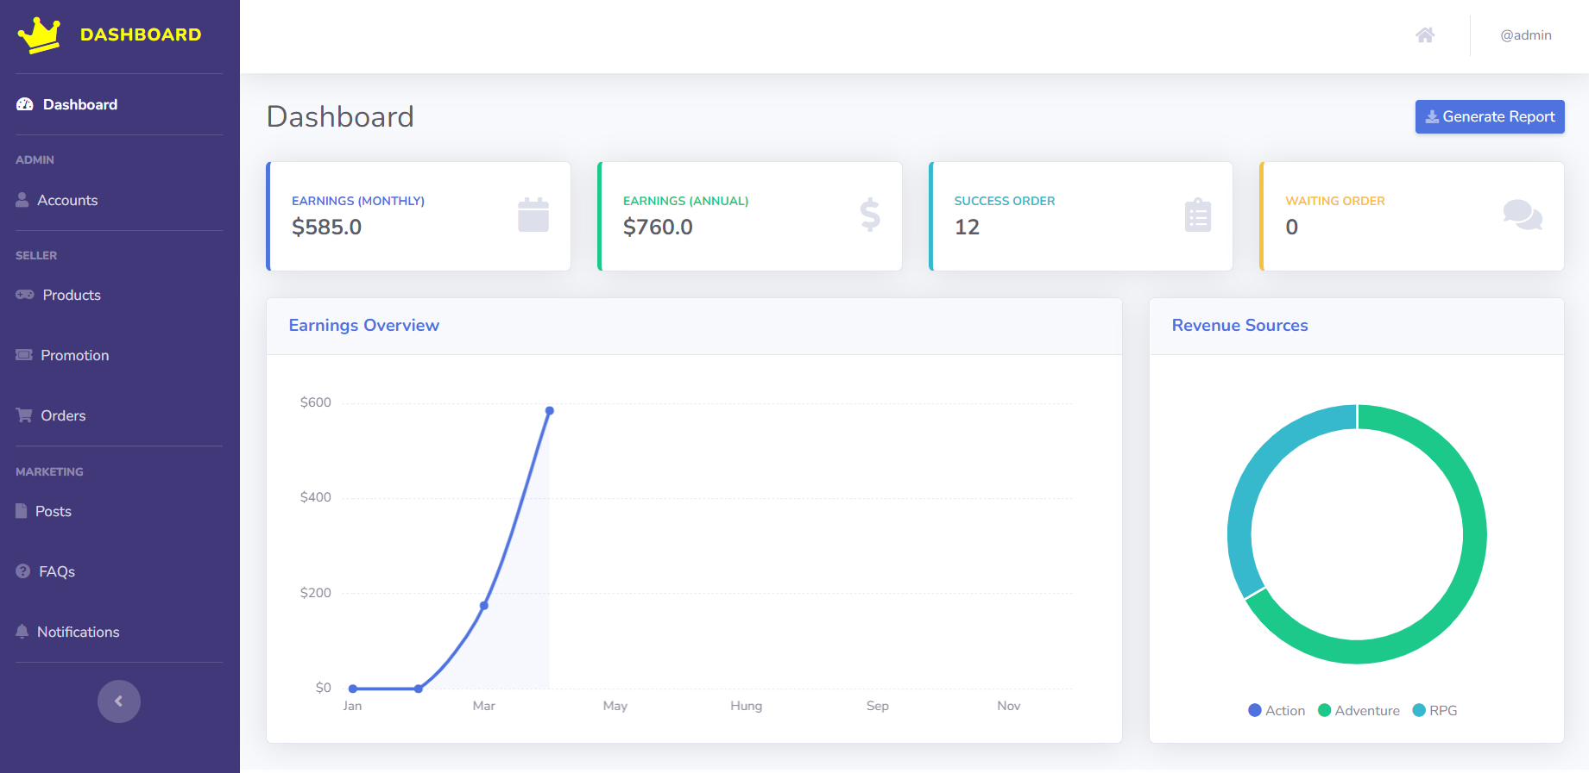

**Figure 2.19.1:** Screen Dashboard shows all store income information

(Login with role Admin)

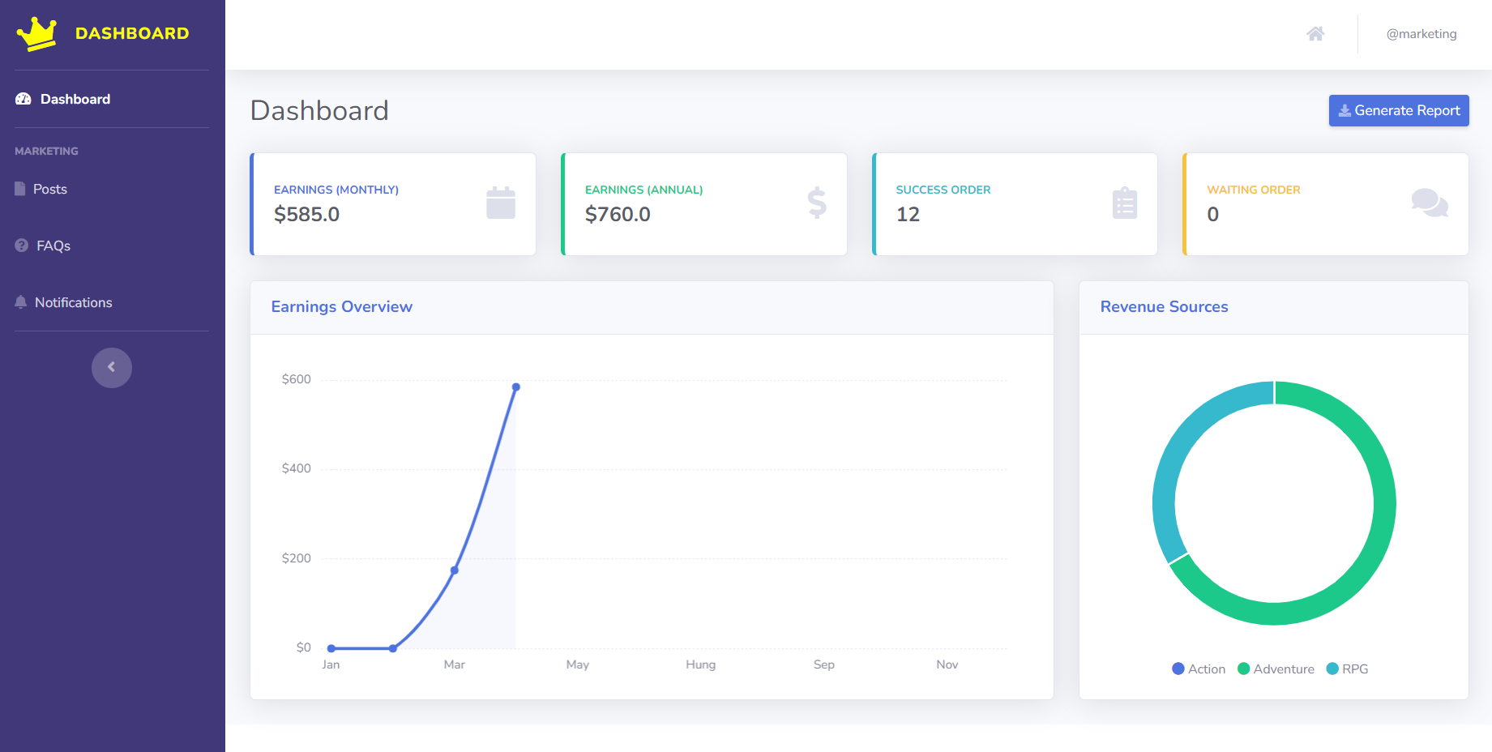

**Figure 2.19.2:** Screen Dashboard shows all store income information

(Login with role Marketing)

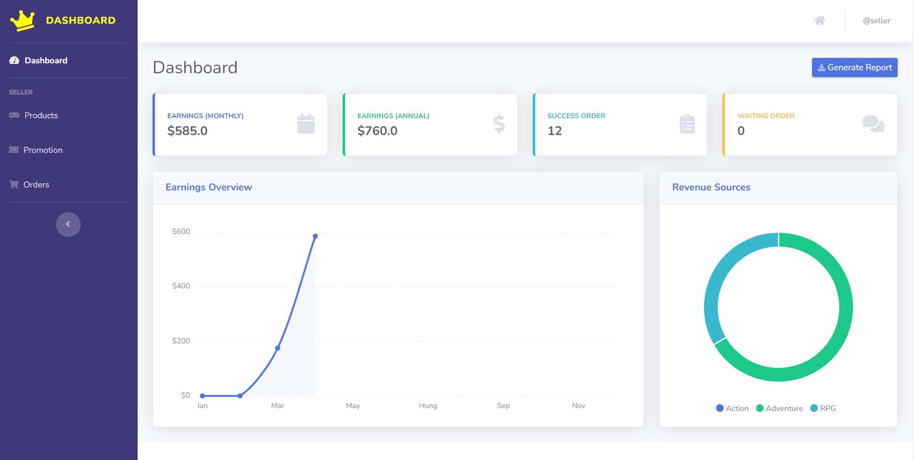

**Figure 2.19.3:** Screen Dashboard shows all store income information

(Login with role Seller)

|  |  |  |
| --- | --- | --- |
| **UI Element: Dashboard** | | |
| **UI Element Description** | | |
| ID | 19 | |
| Description | Screen show Dashboard | |
| **UI Element Displays** | | |
| Precondition | Display | |
| Staff is logged in | Screen show all store income information | |
| **UI Element Behaviours** | | |
| **Precondition** | **Action** | **Respond** |
| Staff are logged in | Click on Account in list dasdboard | Take Staff to the user account management page |
| Staff are logged in | Click on Product in list dasdboard | Take Staff to the product management page |
| Staff are logged in | Click on Promotion in list dasdboard | Take Staff to the promotion management page |
| Staff are logged in | Click on Order in list dasdboard | Take Staff to the order management page |
| Staff are logged in | Click on Post in list dasdboard | Take Staff to the post-management page |
| Staff are logged in | Click on FAQs in list dasdboard | Take Staff to the FAQs management page |
| Staff are logged in | Click on the notification in list dasdboard | Take Staff to the notification management page |

* 1. Account Management

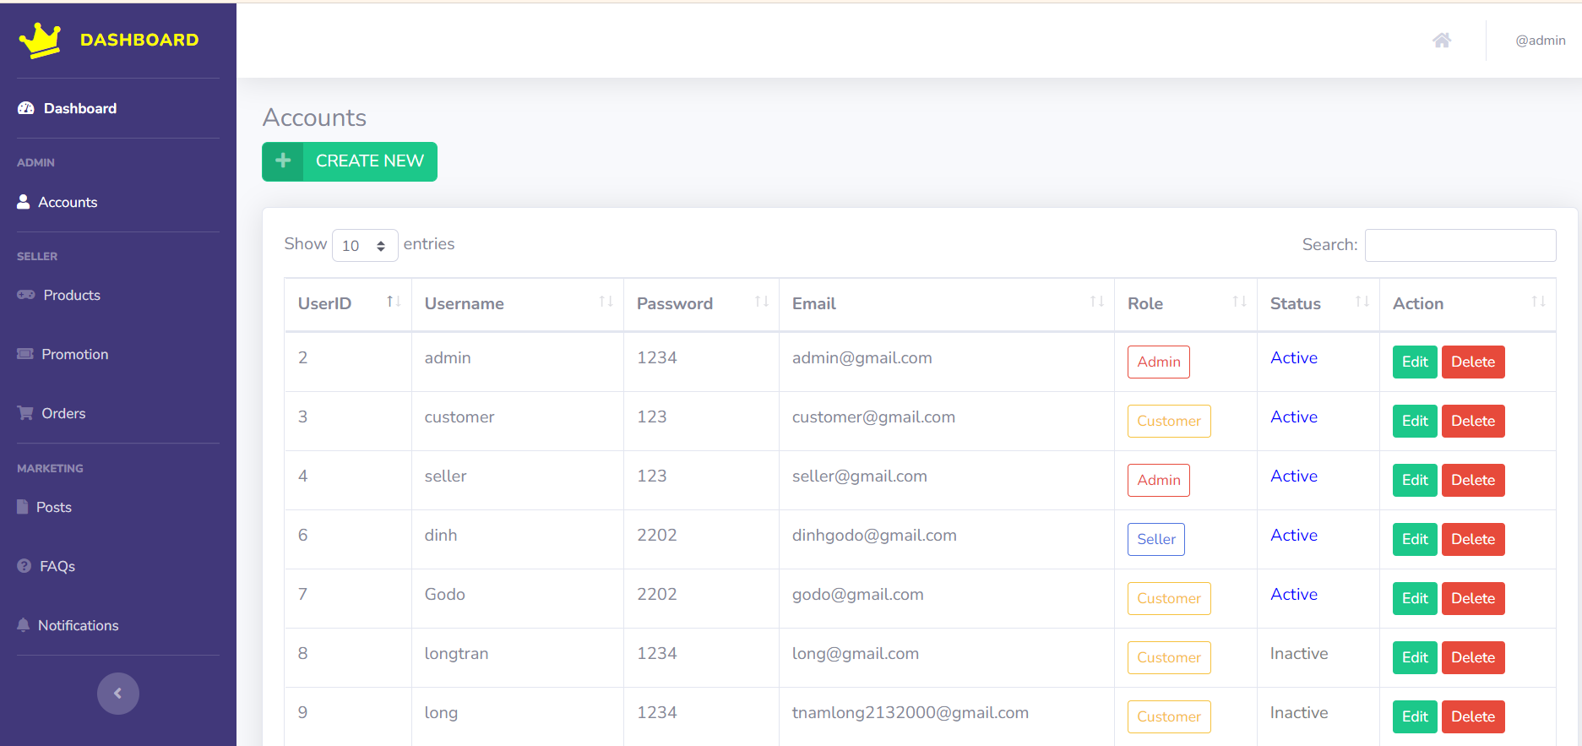

**Figure 2.20.1**: List of Account

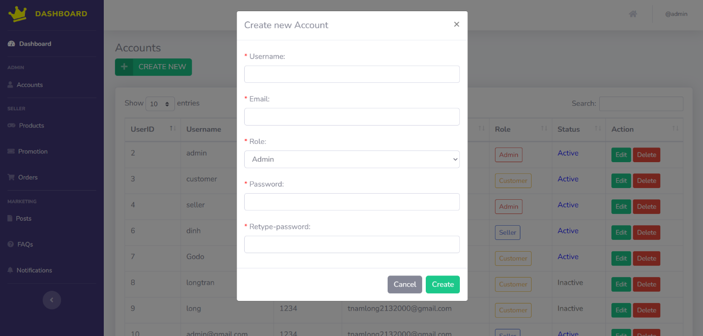

**Figure 2.20.2**: Create Account

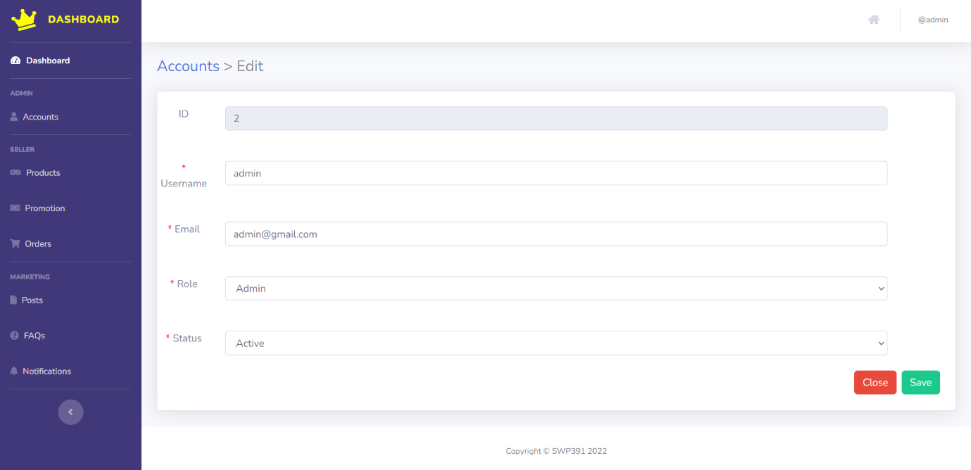

**Figure 2.20.3**: Edit Account

|  |  |  |
| --- | --- | --- |
| **UI Element: View List Account Management** | | |
| **UI Element Description** | | |
| ID | 20 | |
| Description | Screen show Account Management list and also can Create, Edit, Delete Account | |
| **UI Element Displays** | | |
| Precondition | Display | |
| Staff is not logged in | Screen don’t show anything | |
| Staff is logged in | Screen show all accounts | |
| Staff are click on “Create new “ button | Screen show Create modal | |
| Staff are click on “Edit “ button | Screen show Edit account modal | |
| Staff are click on “Delete “ button | Screen show Delete modal | |
| **UI Element Behaviors** | | |
| **Precondition** | **Action** | **Respond** |
| Staff is not logged in | Input manage URL in Browser | System will send back an error page and redirect back to home page |
| Staff is logged in | Click on Manage in navigation bar and then Accounts in sidebar or Input Account Manage URL in Browser | System will show screen of dashboard with full functions of staff includes : Create Account , Edit Account and Delete Account |

* 1. Product Management

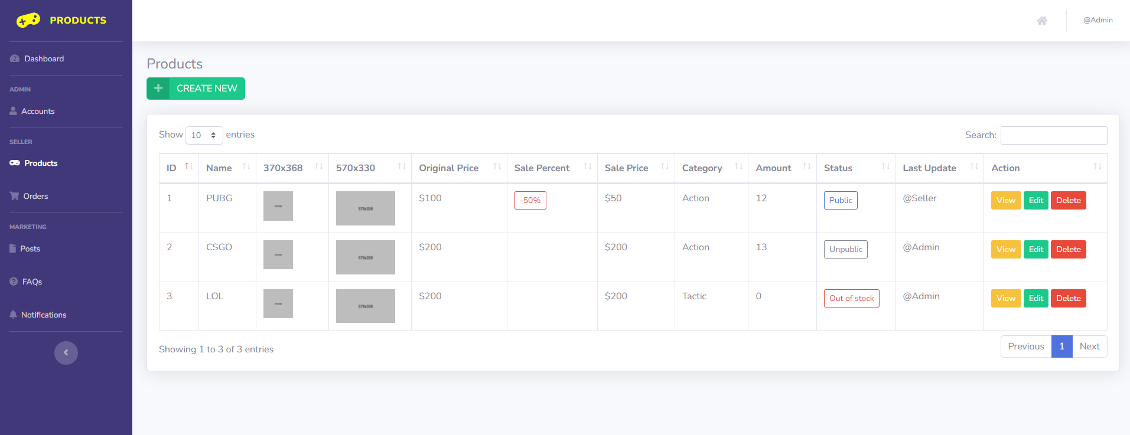

**Figure 2.21.1**: Product list

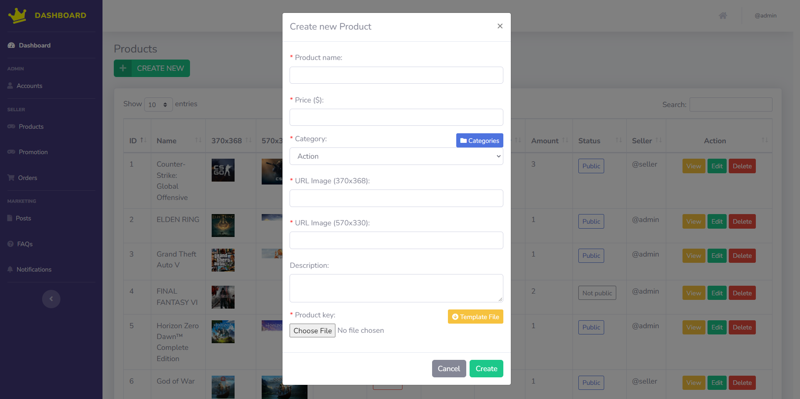

**Figure 2.21.2**: Create new product

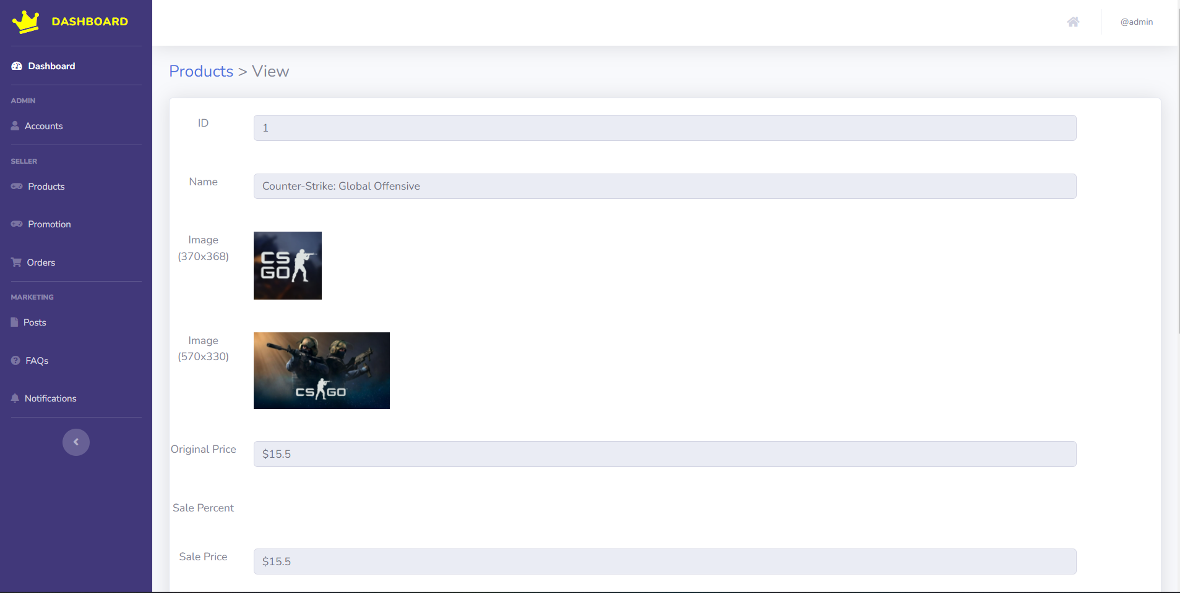

**Figure 2.21.3**: View product

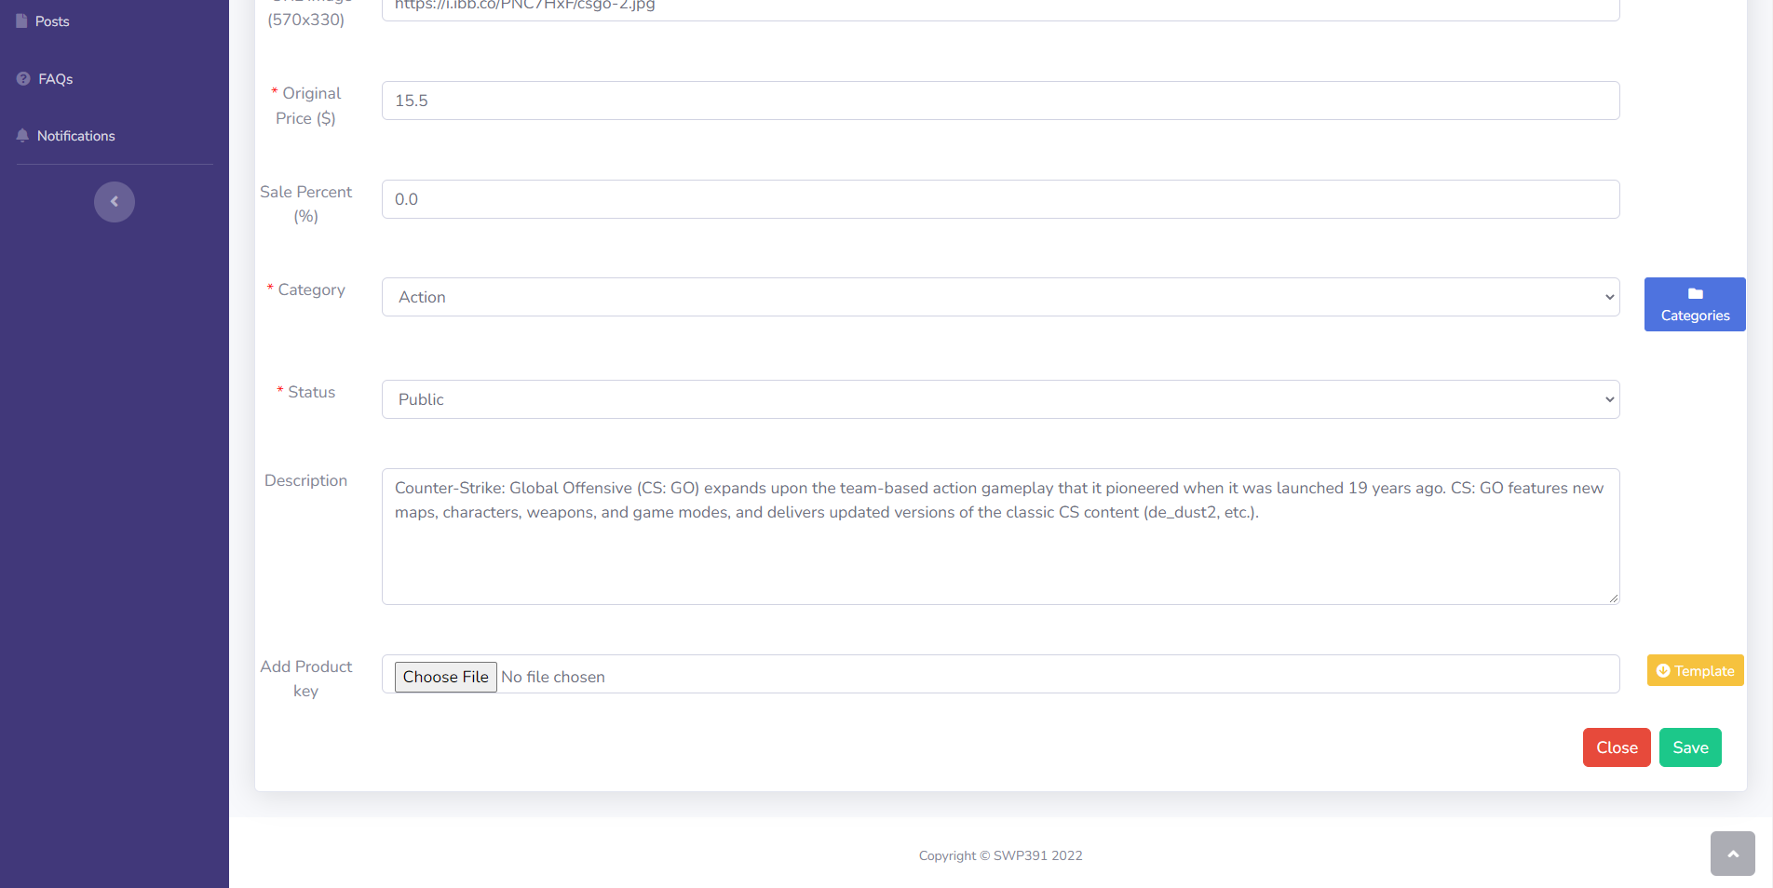

**Figure 2.21.4**: Edit product

|  |  |  |
| --- | --- | --- |
| **UI Element: Product management** | | |
| **UI Element Description** | | |
| ID | 21 | |
| Description | Product management show list all products, seller also can Create new, view, edit and delete product | |
| **UI Element Displays** | | |
| Precondition | Connect internet | |
| Staff are not logged in | Screen don’t show anything | |
| Staff are logged | Screen show Product Management list page | |
| Staff are click on “Create new” button | Screen show Create modal | |
| Staff are click on “View” button | Screen show View detail product page | |
| Staff are click on “Edit” button | Screen show Edit product page | |
| Staff are click on “Delete” button | Screen show Delete modal | |
| **UI Element Behaviors** | | |
| **Precondition** | **Action** | **Respond** |
| Staff are not logged in | Input Product Management url page in browse | System will redirect to Homepage |
| Staff are logged in | Click on Product tab in Manage sidebar | System will redirect to Product Management |

* 1. Categories Management

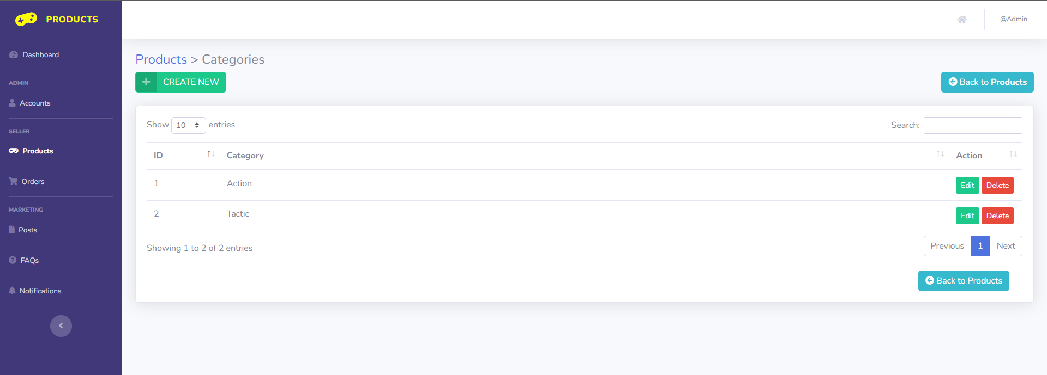

**Figure 2.22.1**: Category list

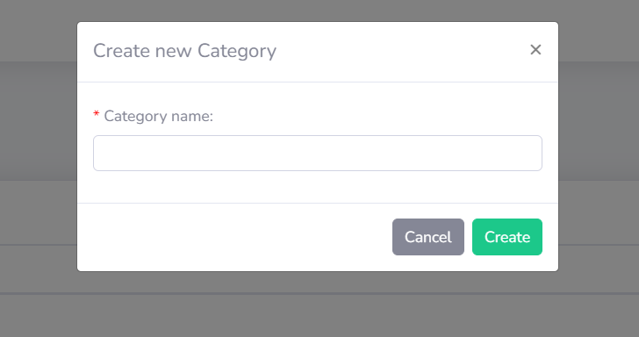

**Figure 2.22.2**: Create new category

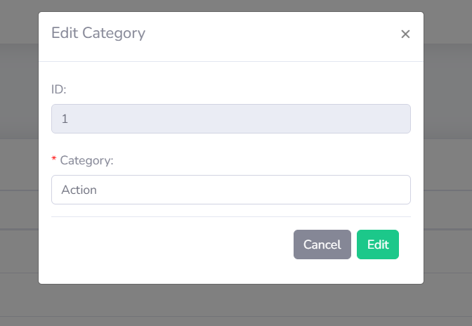

**Figure 2.22.3**: Edit category

|  |  |  |
| --- | --- | --- |
| **UI Element: Category management** | | |
| **UI Element Description** | | |
| ID | 22 | |
| Description | Category Management display and manage all category | |
| **UI Element Displays** | | |
| Precondition | Connect internet | |
| Staff are not logged in | Screen don’t show anything | |
| Staff are logged | Screen show Category Management list page | |
| Staff are click on “Create new” button | Screen show Create modal | |
| Staff are click on “Edit” button | Screen show Edit category page | |
| Staff are click on “Delete” button | Screen show Delete modal | |
| **UI Element Behaviors** | | |
| **Precondition** | **Action** | **Respond** |
| Staff are not logged in | Input Category Management url page in browse | System will redirect to Homepage |
| Staff are logged in | Click on Category button in Product Management page | System will redirect to Category Management |

* 1. Order Management

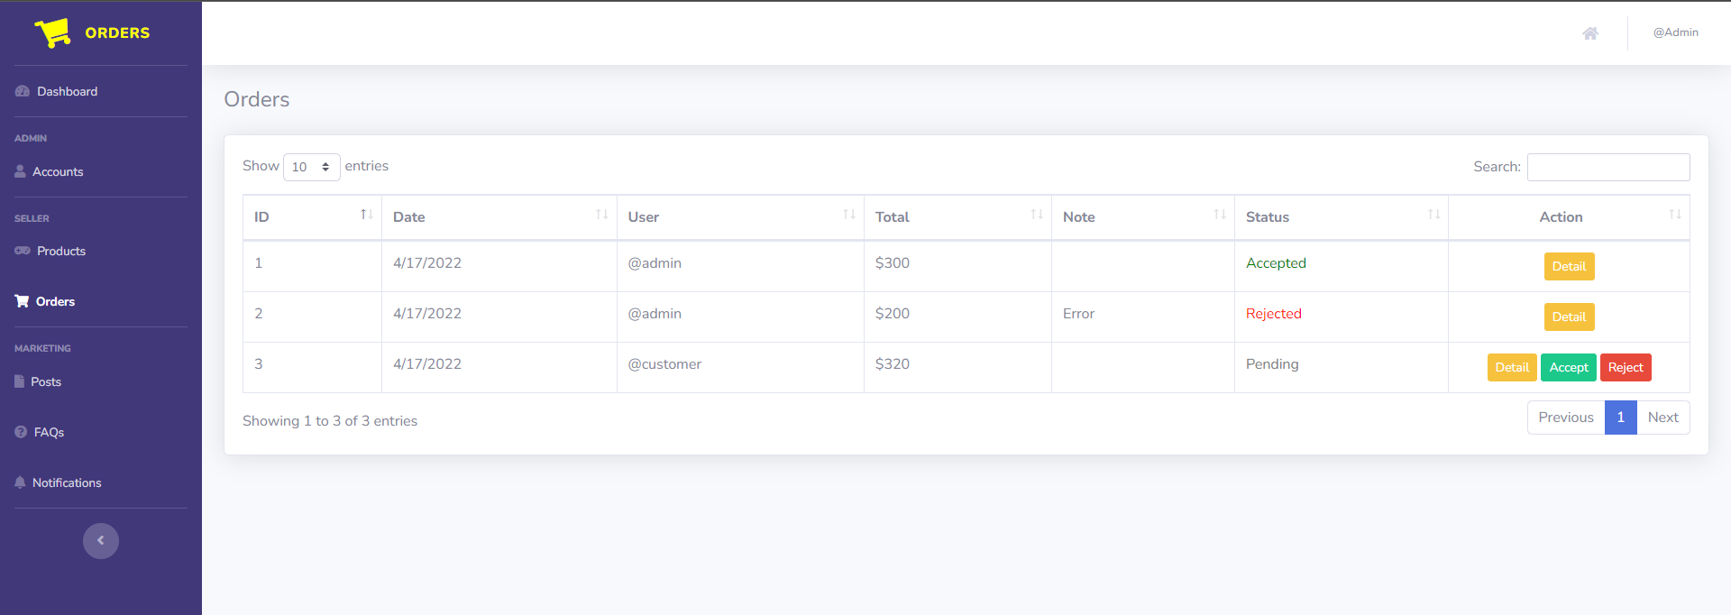

**Figure 2.23.1**: Order Dashboard Screen

|  |  |  |
| --- | --- | --- |
| **UI Element: Order Management** | | |
| **UI Element Description** | | |
| ID | 23 | |
| Description | Screen show Order Dashboard screen of that author | |
| **UI Element Displays** | | |
| Precondition | Access in to the website, Checkout successfully | |
| User is logged in | Screen show Order Dashboard | |
| **UI Element Behaviors** | | |
| **Precondition** | **Action** | **Respond** |
| User | Click on Accept button | System will set status Accepted for that order |
| User | Click on reject button | System will set status Reject for that order |
| User | Click on Detail button | System will redirect to Order Detail screen |

* 1. Posts Management

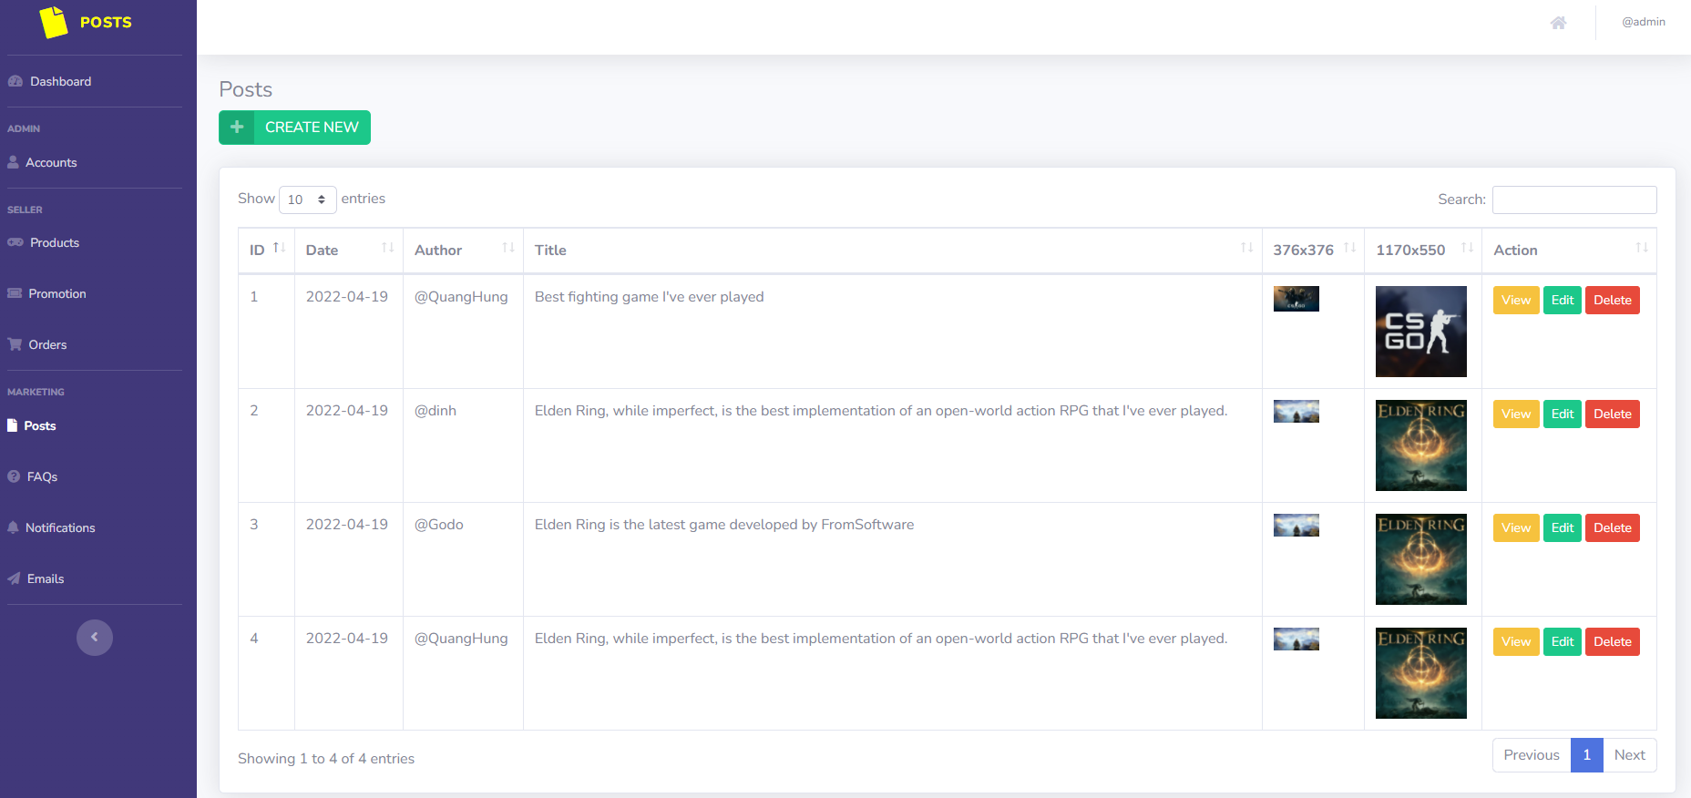

**Figure 2.24.1:** Posts Management screen

|  |  |  |
| --- | --- | --- |
| **UI Element: Posts Management** | | |
| **UI Element Description** | | |
| ID | 24 | |
| Description | Screen show Posts Management | |
| **UI Element Displays** | | |
| Precondition | Display | |
| Staff is not logged in | Screen don’t show anything | |
| Staff is logged in | Screen show all Posts | |
| Staff are click on “Create new” button | Screen show Create modal | |
| Staff are click on “Edit” button | Screen show Edit modal | |
| Staff are click on “Delete” button | Screen show Delete Modal | |
| **UI Element Behaviors** | | |
| **Precondition** | **Action** | **Respond** |
| Staff is not logged in | Input manage URL in Browser | System will send back an error page and redirect back to home page |
| Staff is logged in | Click on Manage in navigation bar and then Posts in sidebar or Input Posts Manage URL in Browser | System will show screen of management with full functions of staff includes : Create Posts , Edit Posts and Delete Posts |

* 1. FAQs Management

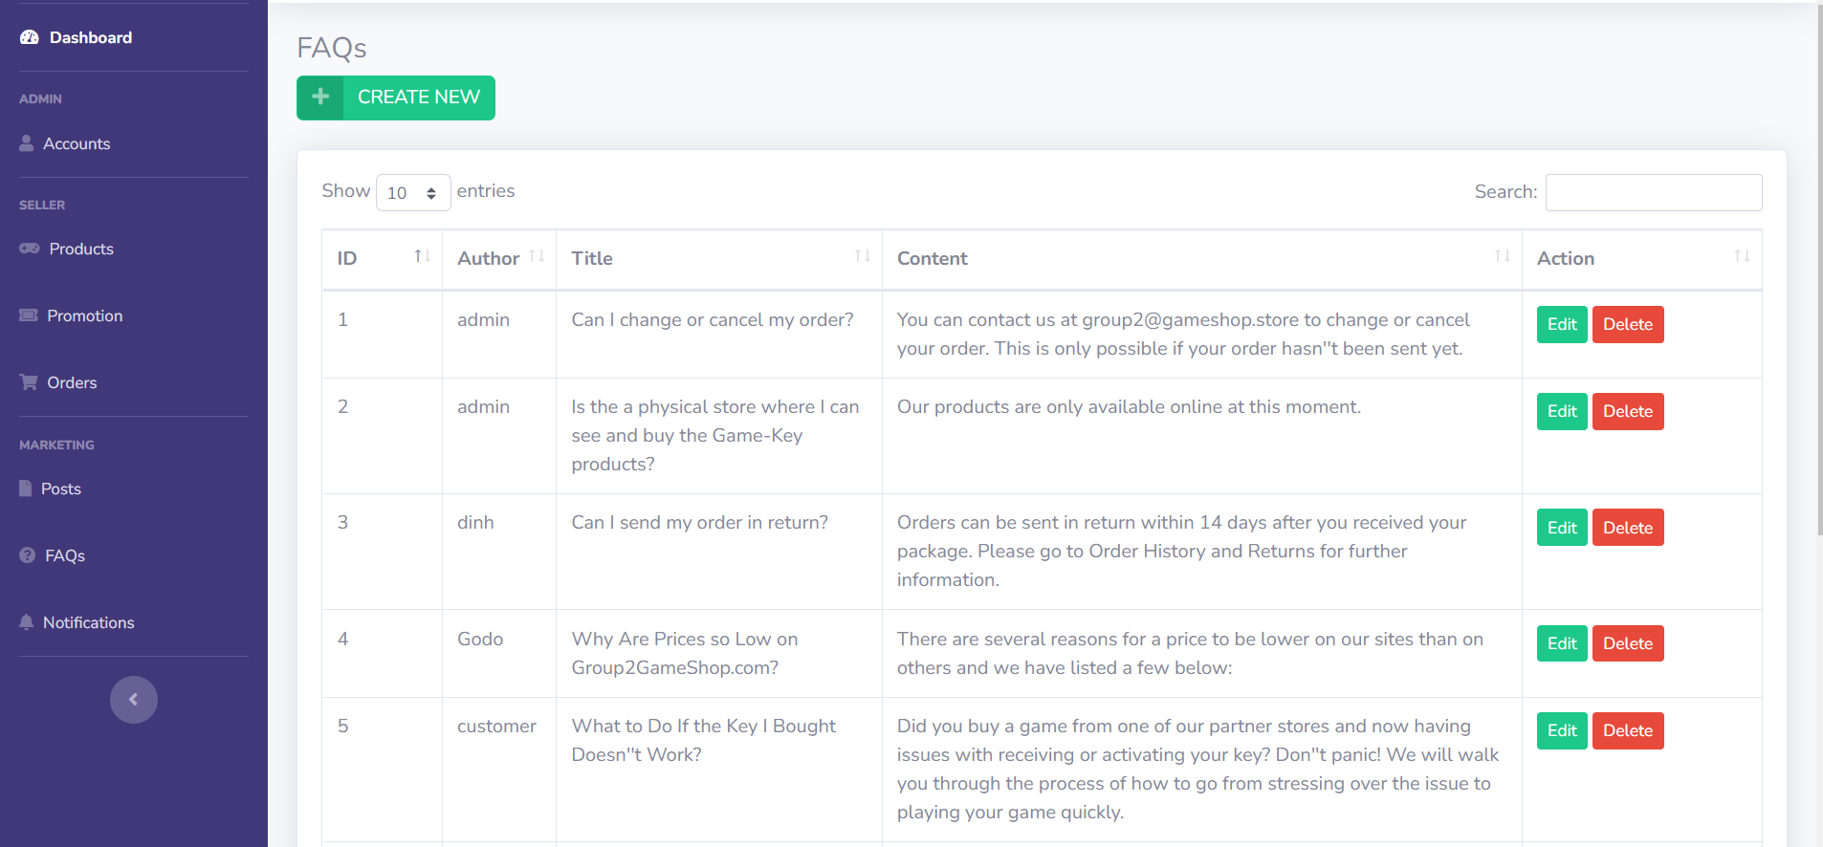**Figure 2.25.1**: List FAQs Management

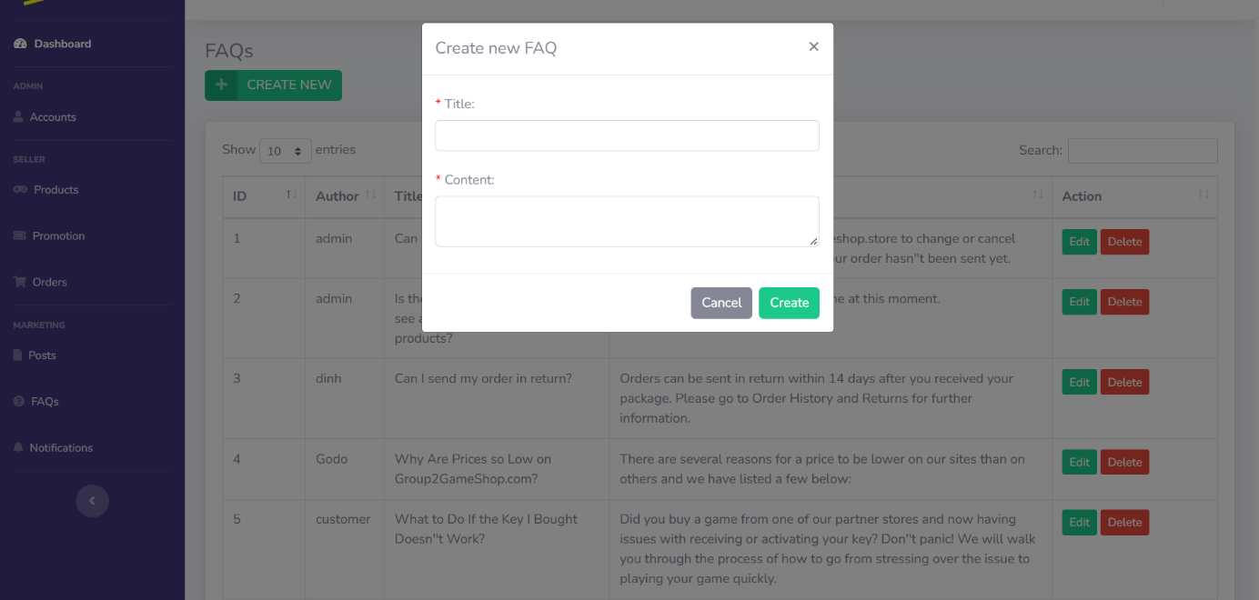

**Figure 2.25.2**: Create FAQ

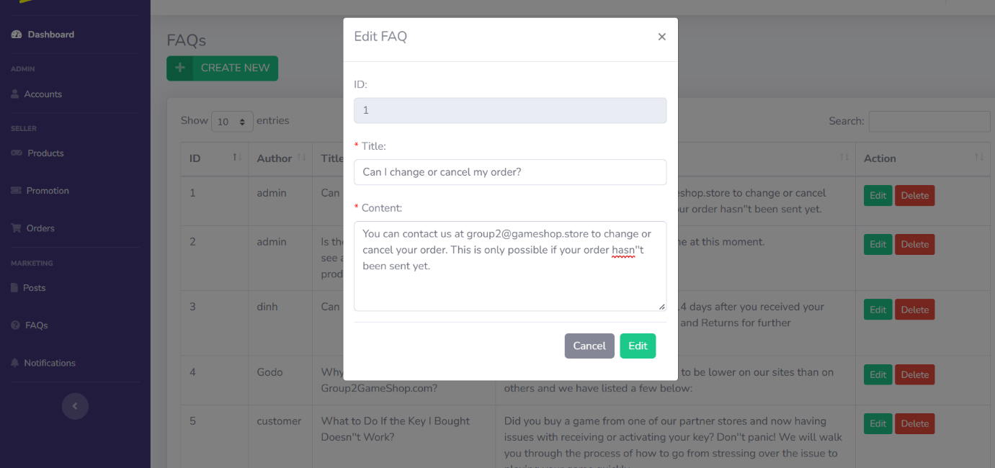

**Figure 2.25.3**: Edit FAQ

|  |  |  |
| --- | --- | --- |
| **UI Element: FAQs Management** | | |
| **UI Element Description** | | |
| ID | 25 | |
| Description | Screen show FAQs Management | |
| **UI Element Displays** | | |
| Precondition | Display | |
| Staff is not logged in | Screen don’t show anything | |
| Staff is logged in | Screen show all FAQs | |
| Staff are click on “Create new” button | Screen show Create modal | |
| Staff are click on “Edit” button | Screen show Edit modal | |
| Staff are click on “Delete” button | Screen show Delete Modal | |
| **UI Element Behaviors** | | |
| **Precondition** | **Action** | **Respond** |
| Staff is not logged in | Input manage URL in Browser | System will send back an error page and redirect back to home page |
| Staff is logged in | Click on Manage in navigation bar and then FAQs in sidebar or Input Account Manage URL in Browser | System will show screen of dashboard with full functions of staff includes : Create FAQs , Edit FAQs and Delete FAQs |

* 1. Notifications Management

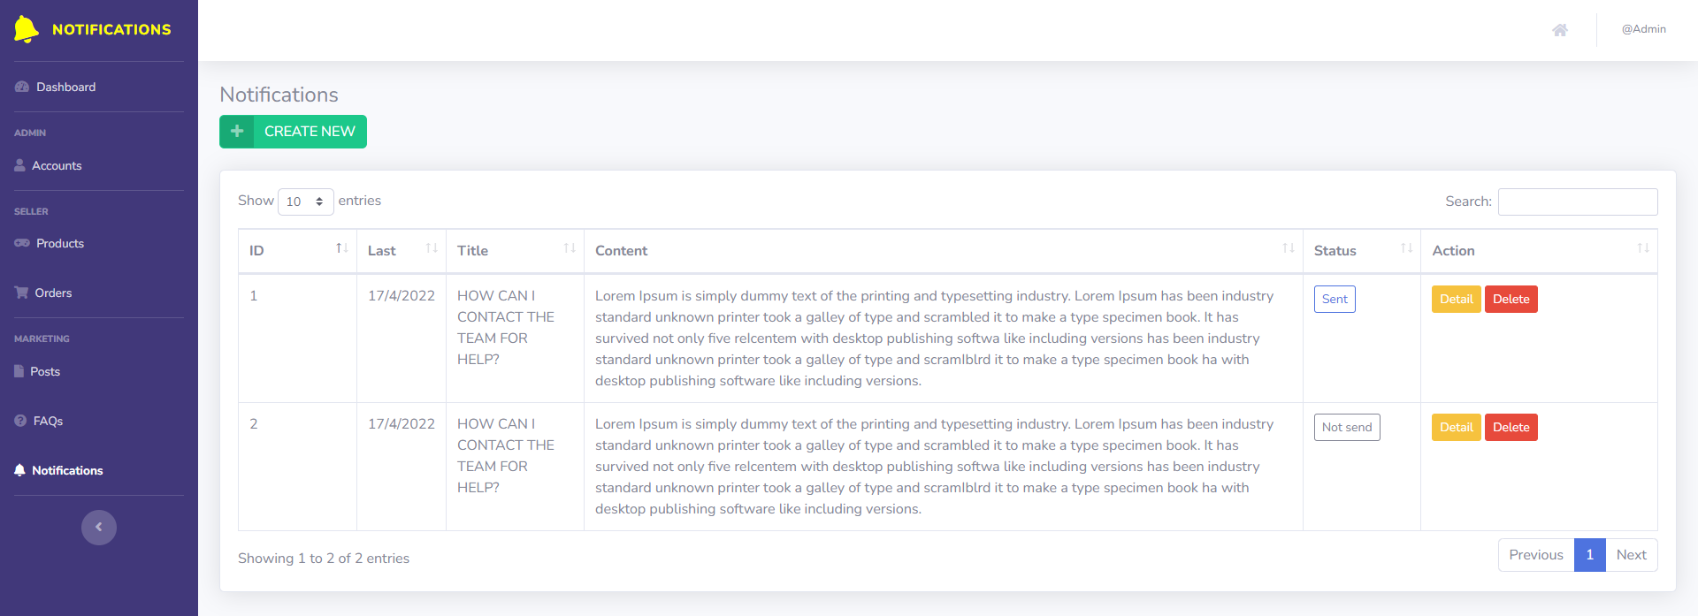

**Figure 2.26.1:** Screen Notification Management

|  |  |  |
| --- | --- | --- |
| **UI Element: Notifications Management** | | |
| **UI Element Description** | | |
| ID | 26 | |
| Description | Screen show Notifications Management | |
| **UI Element Displays** | | |
| Precondition | Display | |
| Staff is not logged in | Screen don’t show anything | |
| Staff is logged in | Screen show all Notifications | |
| Staff are click on “Create new” button | Screen show Create modal | |
| Staff are click on “Delete” button | Screen show Delete Modal | |
| **UI Element Behaviors** | | |
| **Precondition** | **Action** | **Respond** |
| Staff is not logged in | Input manage URL in Browser | System will send back an error page and redirect back to home page |
| Staff is logged in | Click on Manage in navigation bar and then Posts in sidebar or Input Posts Manage URL in Browser | System will show screen of management with full functions of staff includes : Create Notifications and Delete Notifications |

* 1. Product Review

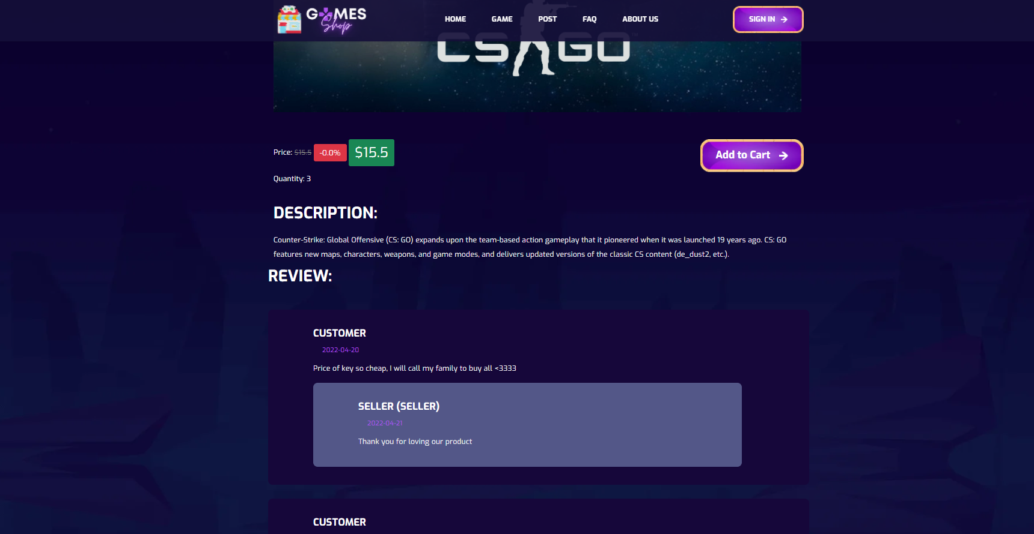

**Figure 2.27.1**: Review list in Product detail

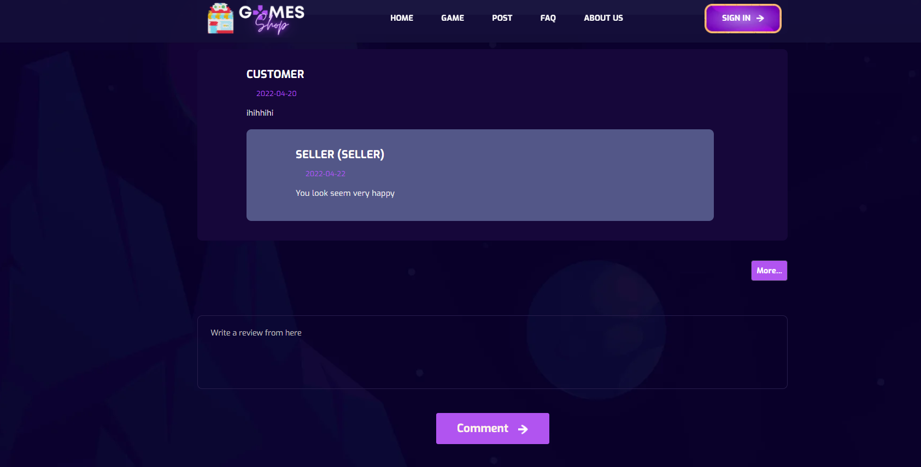

**Figure 2.27.2**: Review box to input new review for customer

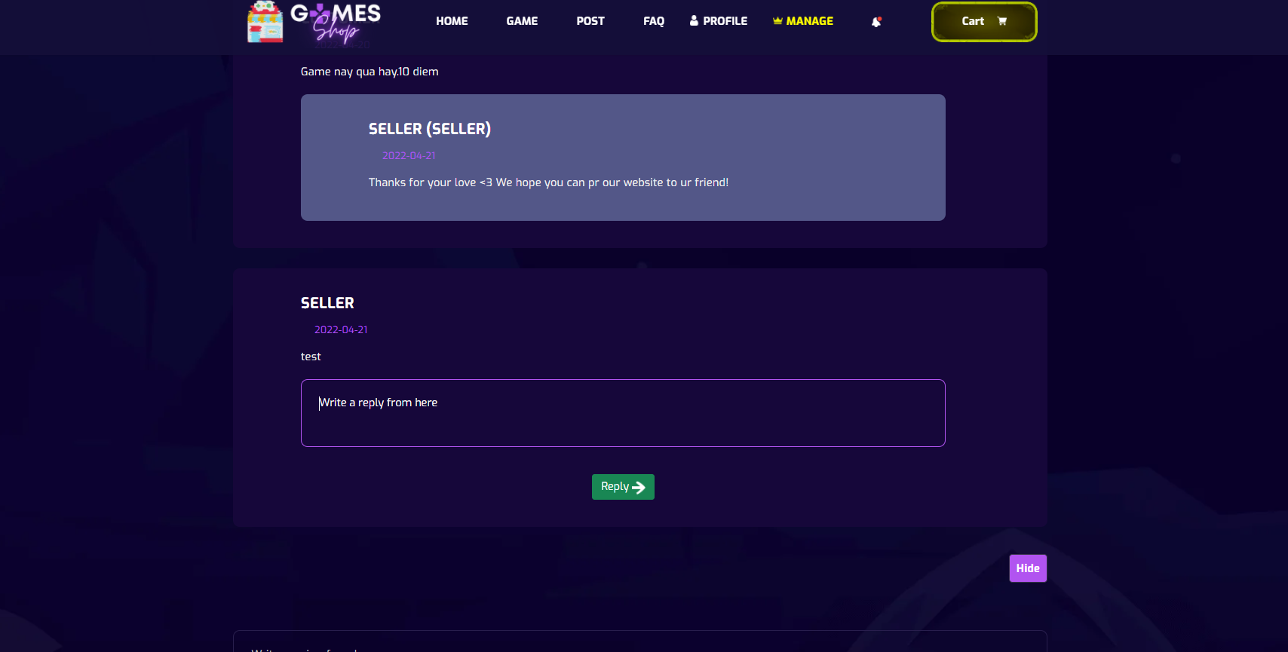

**Figure 2.27.3**: Review box to input new review for customer

|  |  |  |
| --- | --- | --- |
| **UI Element: Product Review** | | |
| **UI Element Description** | | |
| ID |  | |
| Description | Users click on any product to show detail. Scroll down to view Review, Reply. Users can comment. Seller and Marketer can reply user’s review | |
| **UI Element Displays** | | |
| Precondition | Connect Internet | |
| User is not logged in | Screen show all review, reply review of product | |
| User is logged in | Screen show all review, reply review of product | |
| Staff is not logged in | Screen show all review, reply review of product, not show reply fields for review | |
| Staff is logged in | Screen show all review, reply of product, reply fields for review | |
| Staff input new reply for any review | Screen show alert success and reload to show new reply of review | |
| **UI Element Behaviours** | | |
| **Precondition** | **Action** | **Respond** |
| User | Click on any product | System will redirect to product detail page, show all review,reply of review |
| Staff is not logged in | Click on any product | System will redirect to product detail page, show all review, reply of review |
| Staff is logged in | Click on any product | System will redirect to product detail page show all review, reply of review, show reply fields for which review with no reply |

* 1. Promotion Management

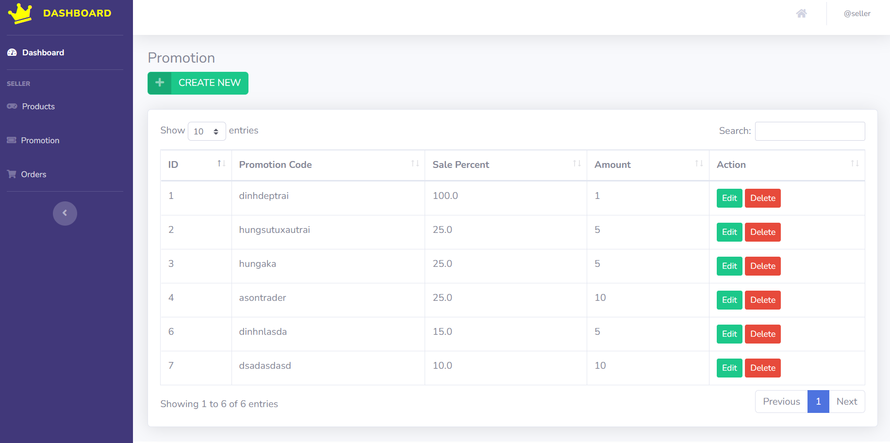

**Figure 2.28.1**: List Promotion Management

|  |  |  |
| --- | --- | --- |
| **UI Element: List Promotion Management** | | |
| **UI Element Description** | | |
| ID | 28 | |
| Description | Screen show Promotion Dashboard | |
| **UI Element Displays** | | |
| Precondition | Display | |
| Staff is logged in | Screen show all list promotion | |
| **UI Element Behaviours** | | |
| **Precondition** | **Action** | **Respond** |
| Staff are logged in | Click on Create new | Take Staff to the create new promotion modal |
| Staff are logged in | Click on Edit | Take Staff to the Edit page |
| Staff are logged in | Click on Delete | The user deletes the promotion code they want and reloads the page |
| Staff are logged in | Click on Next | To go to the next page of the promotion code |
| Staff are logged in | Click on Previous | To return to the previous page of the promotion code |

* 1. Send Email Management

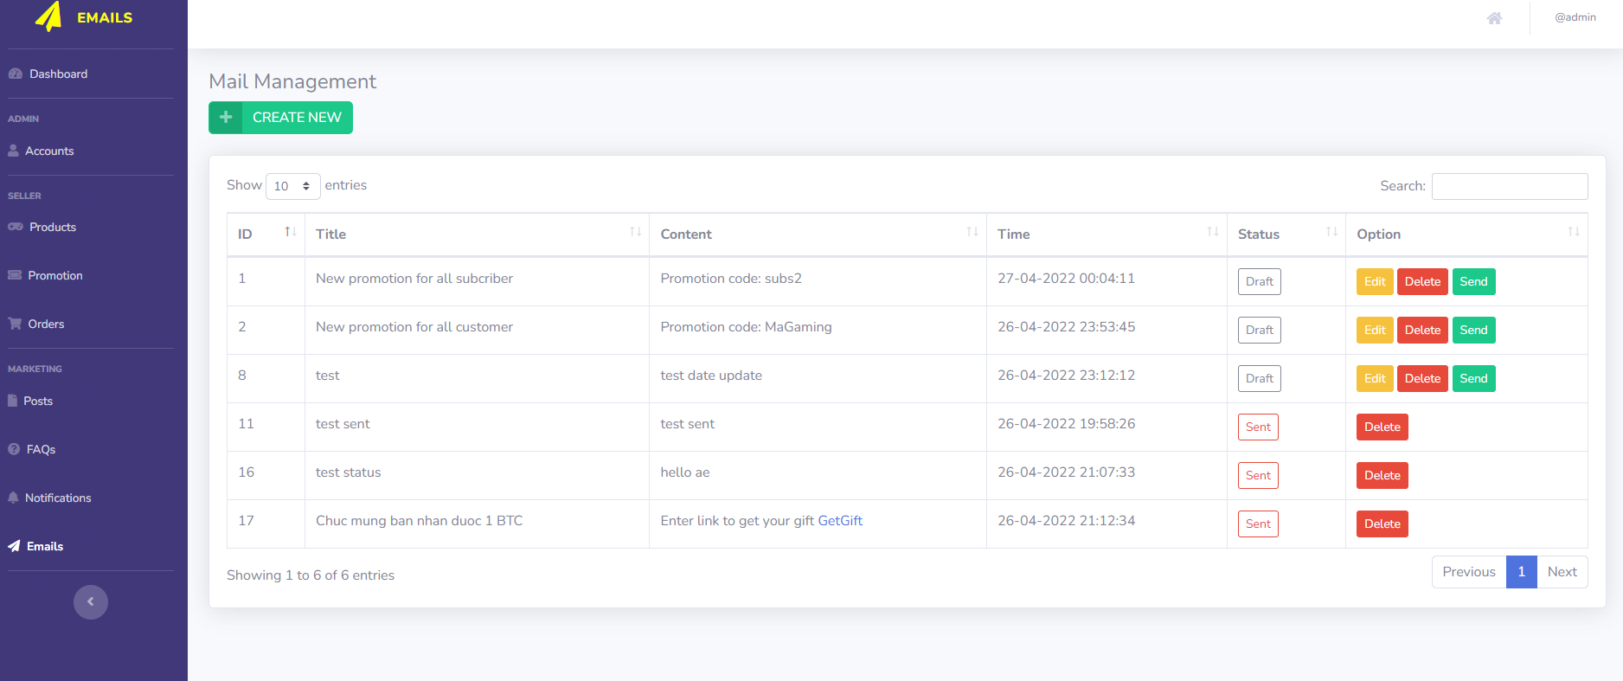

**Figure 2.29.1**: Send Email list

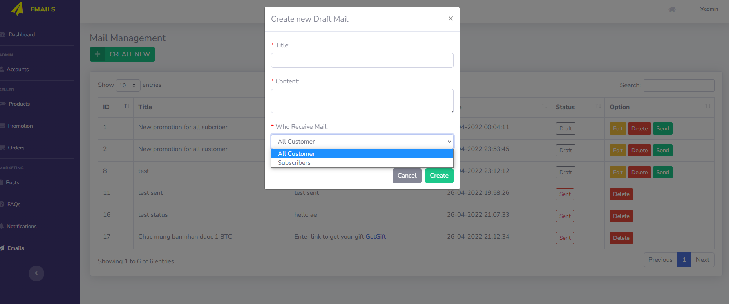

**Figure 2.29.2**: Create new mail

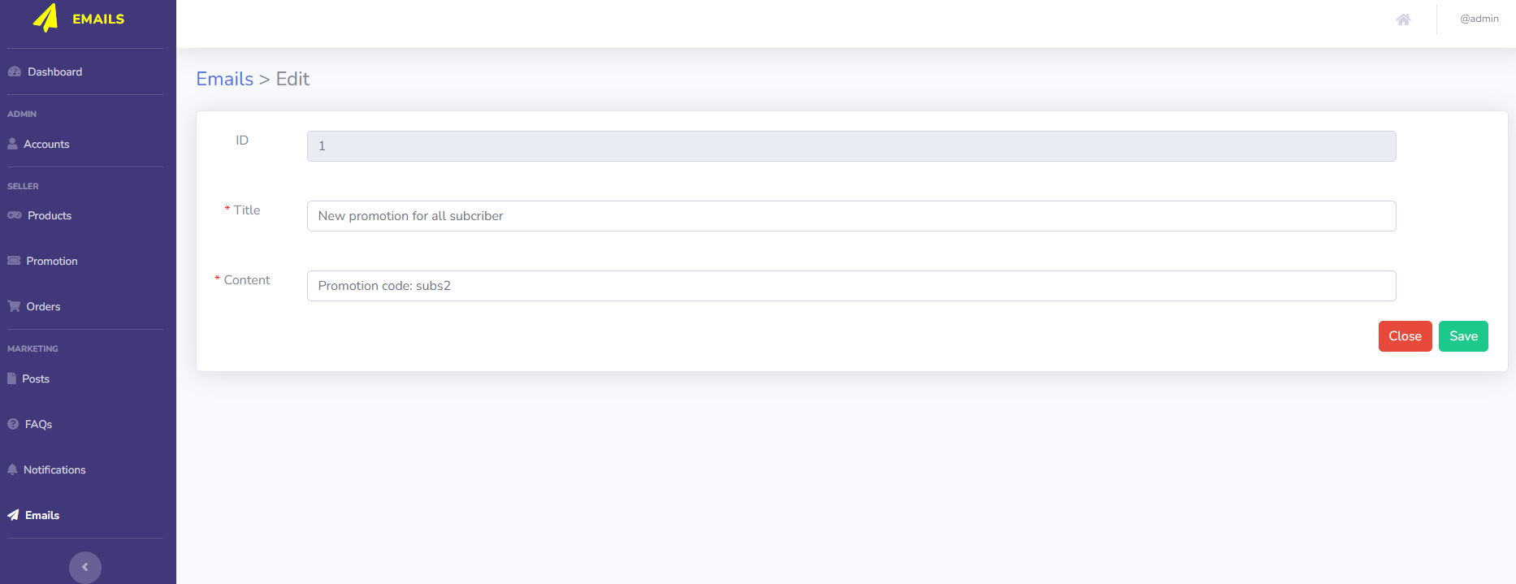

**Figure 2.29.3**: Edit email

|  |  |  |
| --- | --- | --- |
| **UI Element: Send Email Management** | | |
| **UI Element Description** | | |
| ID | 29 | |
| Description | Send Email Management show list all email with status “draft” or “sent”, Marketing also can Create new, edit and delete send-mail | |
| **UI Element Displays** | | |
| Precondition | Connect internet | |
| Staff are not logged in | Screen don’t show anything | |
| Staff are logged | Screen show Send-Email Management list page | |
| Staff are click on “Create new” button | Screen show Create modal | |
| Staff are click on “Edit” button | Screen show Edit Mail page | |
| Staff are click on “Delete” button | Screen show Delete modal | |
| Staff are click on “Send” button | Screen show Send modal | |
| **UI Element Behaviours** | | |
| **Precondition** | **Action** | **Respond** |
| Staff are not logged in | Input Email Management url page in browse | System will redirect to Error Page |
| Staff are logged in | Click on Email tab in Manage sidebar | System will redirect to Email Management |

* 1. About Us

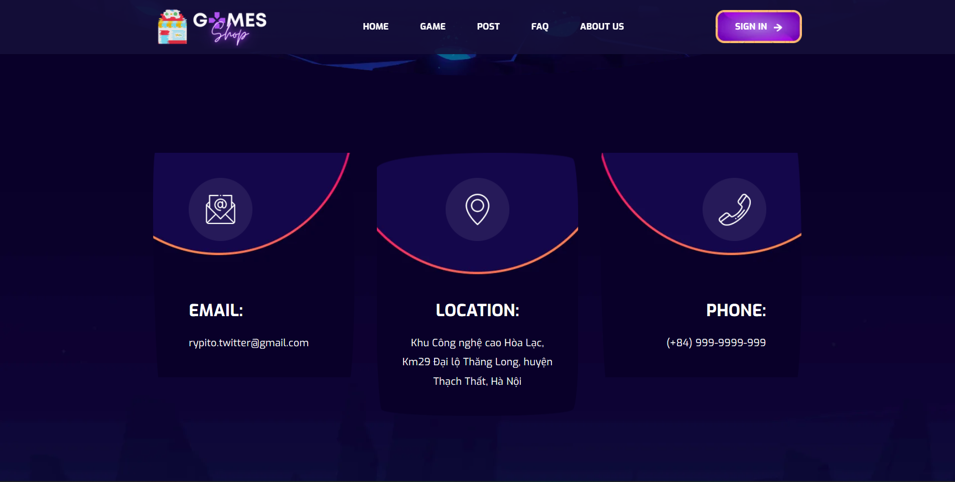

**Figure 2.31.1**: About us

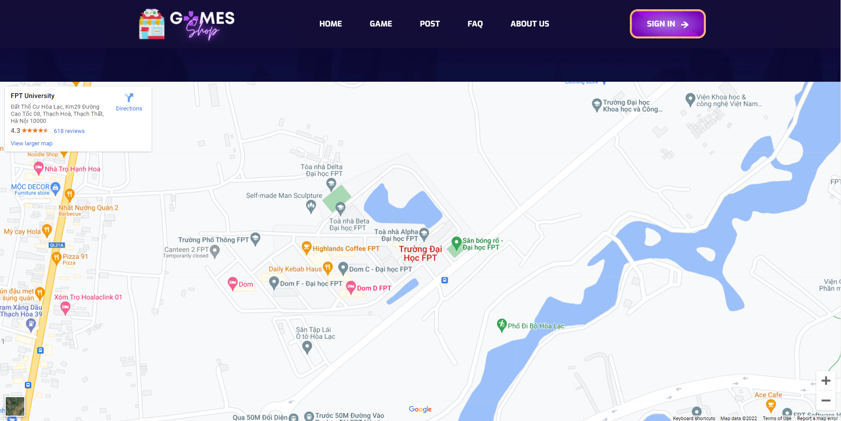

**Figure 2.31.2**: About us

|  |  |  |
| --- | --- | --- |
| **UI Element: About us** | | |
| **UI Element Description** | | |
| ID | 30 | |
| Description | Screen show About us screen | |
| **UI Element Displays** | | |
| Precondition | Connect internet | |
| Staff is logged in | Screen show all about us | |
| **UI Element Behaviours** | | |
| **Precondition** | **Action** | **Respond** |
| User not logged in | Input About Us url page in browse | Display about us page |
| User logged in | Click on About Us button in nav-bar | Display about us page |

1. Use-case Requirements
   1. Use-case diagram

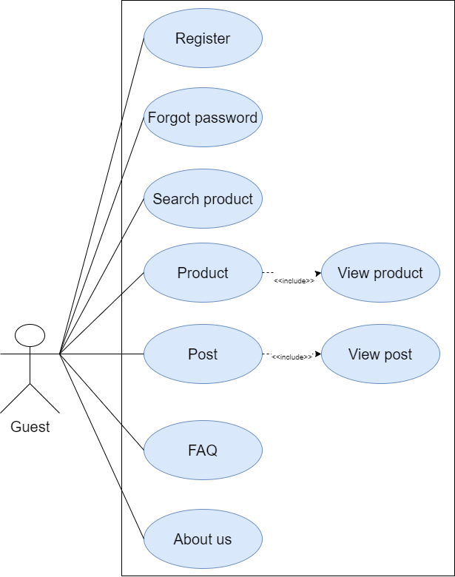

**Figure 3.1.1**: Guest Use-case diagram

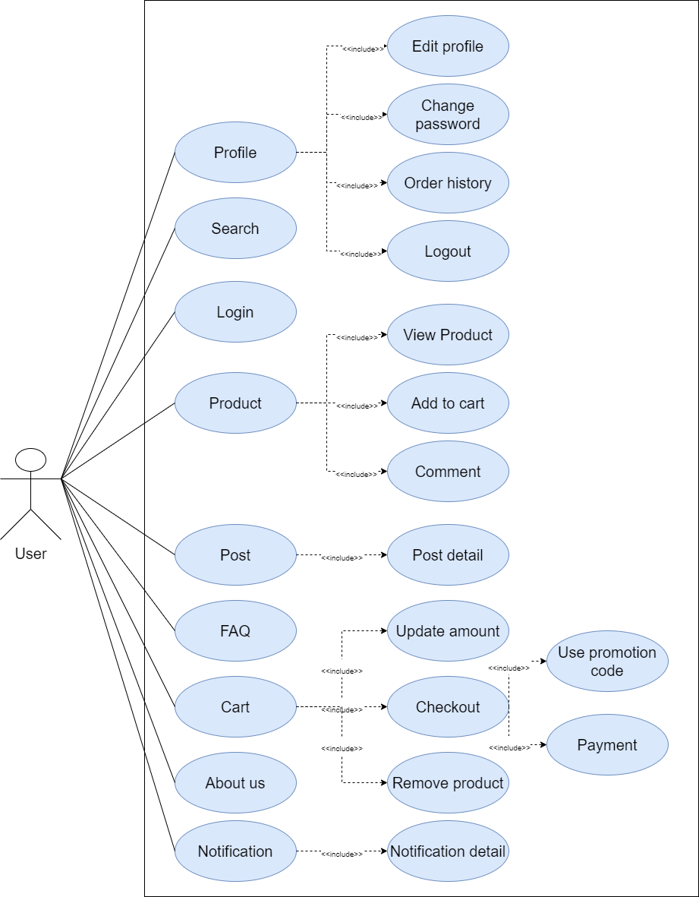

**Figure 3.1.2**: User Use-case diagram

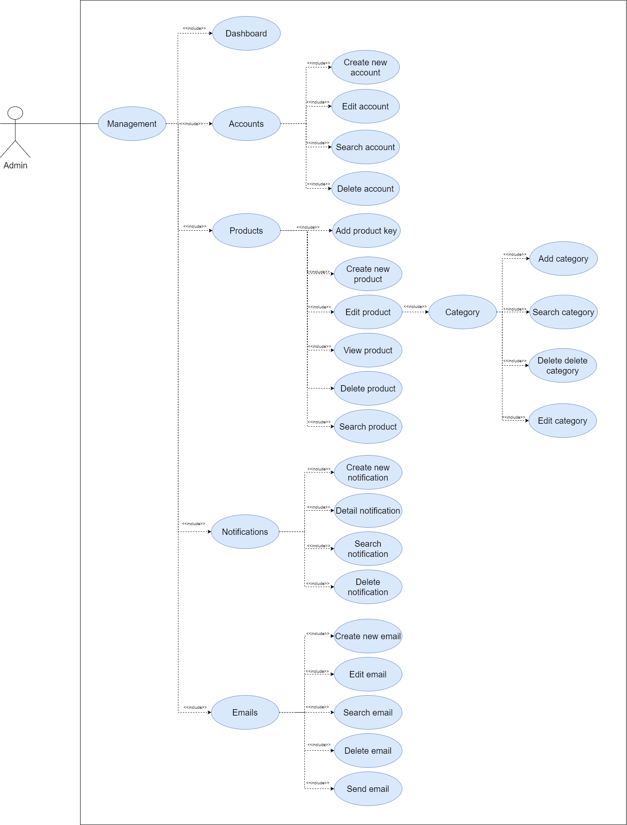

**Figure 3.1.3**: Admin Use-case diagram

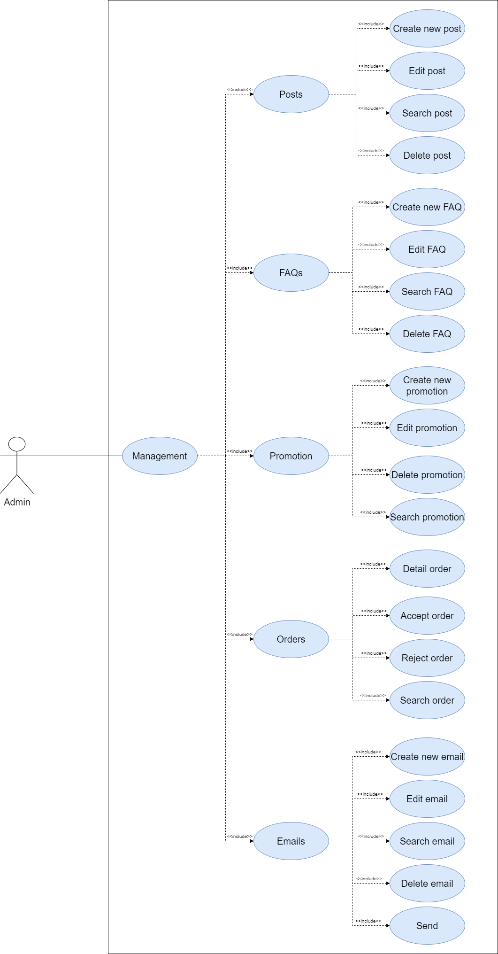

**Figure 3.1.4**: Admin Use-case diagram 2

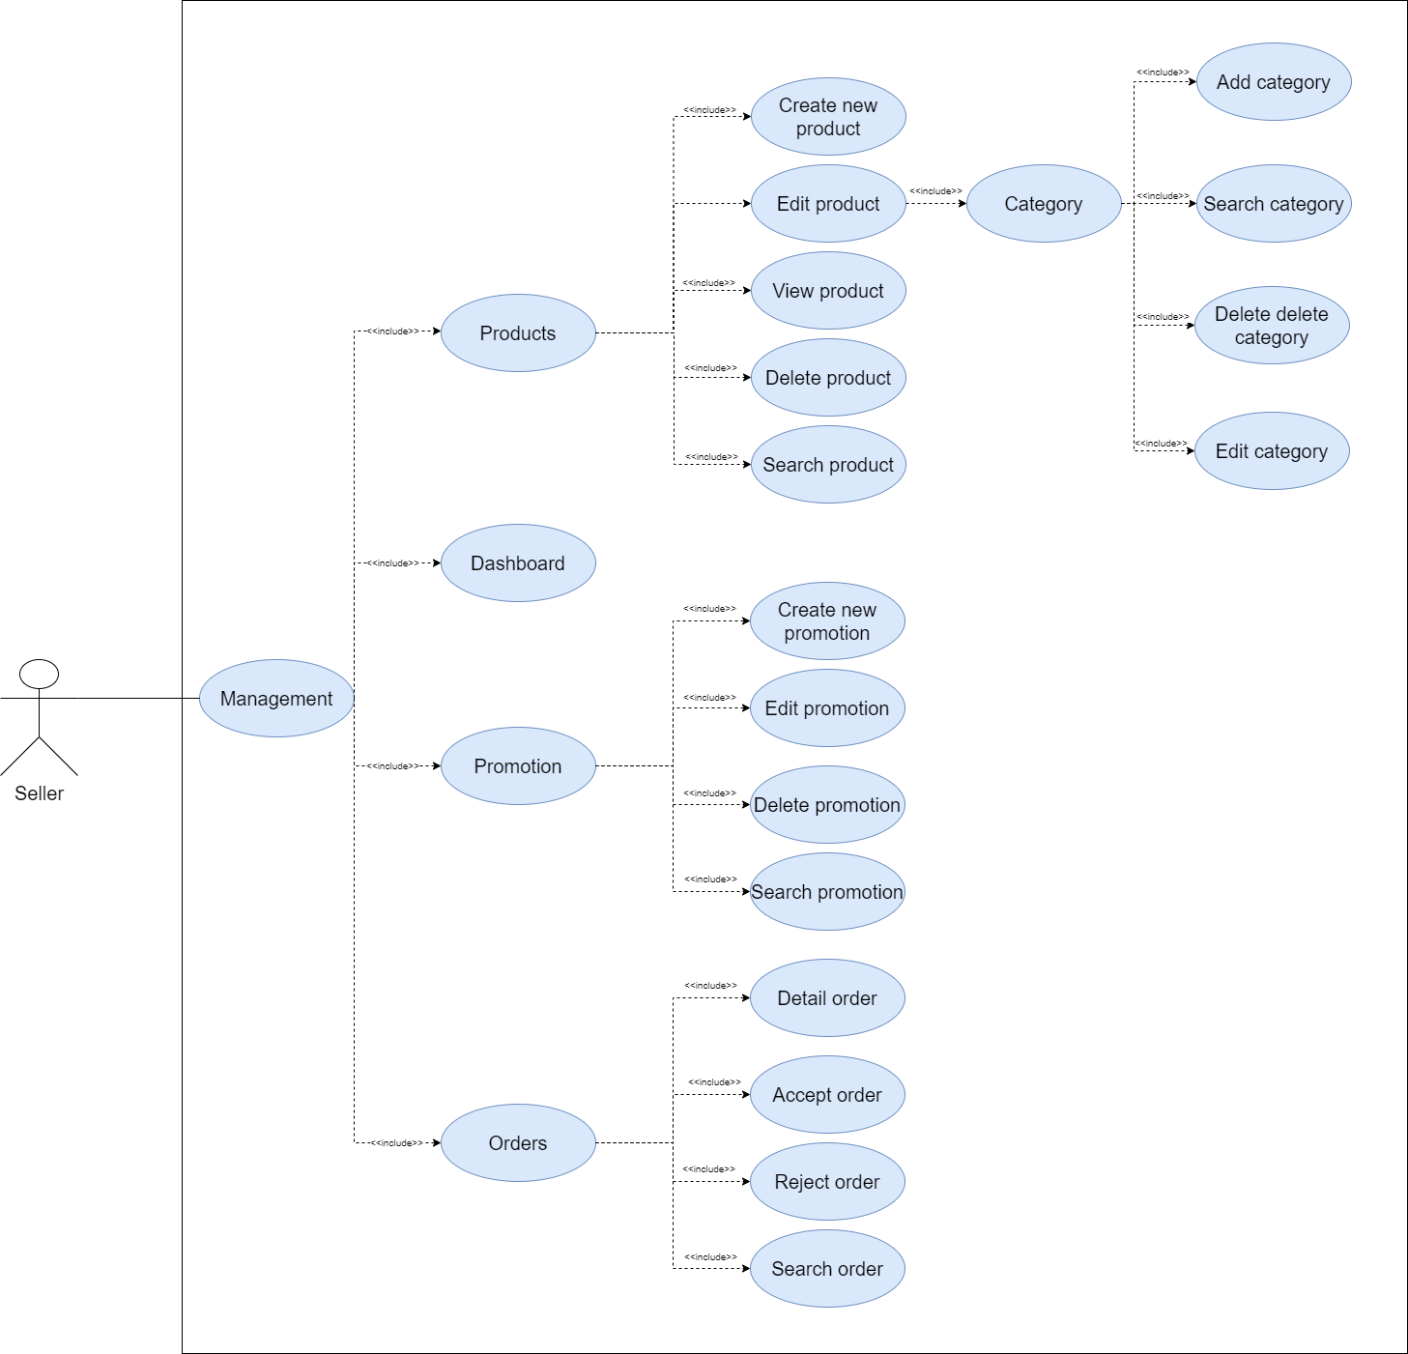

**Figure 3.1.5**: Seller Use-case diagram

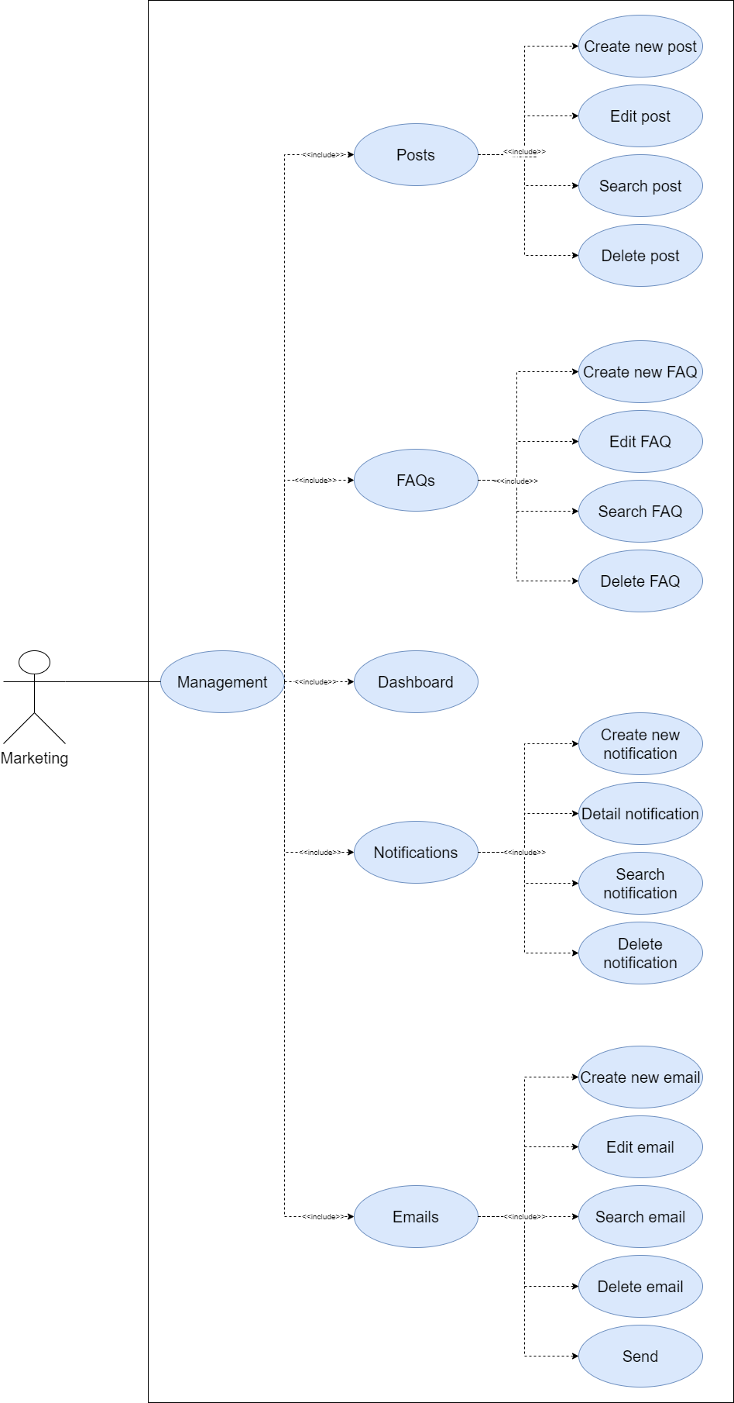

**Figure 3.1.6**: Marketing Use-case diagram

* 1. Use-case list

|  |  |  |
| --- | --- | --- |
| **ID** | **Name** | **Actor** |
| UC01 | Login | Guest, Common user, Staff, Admin, |
| UC02 | Logout | Common user, Staff, Admin, |
| UC03 | Register | Guest |
| UC04 | Forgot password | Guest |
| UC05 | Reset password | Guest |
| UC06 | Search product | Guest, Common user, Staff, Admin |
| UC07 | Filter products | Guest, Common user, Staff, Admin |
| UC08 | View List product | Guest, Common user, Staff, Admin |
| UC09 | View product detail | Guest, Common user,Staff,Admin |
| UC10 | View product review | Guest, Common user, Staff, Admin |
| UC11 | Add new review | Common user |
| UC12 | View review‘s reply | Guest, Common user,Staff,Admin |
| UC13 | Add new review‘s reply | Staff |
| UC14 | View List post | Guest, Common user,Staff,Admin |
| UC15 | View post detail | Guest, Common user,Staff,Admin |
| UC16 | View suggest relate posts | Guest, Common user,Staff,Admin |
| UC17 | Add product to Cart | Common user, Staff, Admin |
| UC18 | View cart | Common user, Staff, Admin |
| UC19 | Update cart | Common user, Staff, Admin |
| UC20 | Delete cart | Common user, Staff, Admin |
| UC21 | Checkout | Common user, Staff, Admin |
| UC22 | Use promotion code | Common user, Staff, Admin |
| UC23 | Payment | Common user, Staff, Admin |
| UC24 | View order history | Common user, Staff, Admin |
| UC25 | View order detail | Common user, Staff, Admin |
| UC26 | Update order status (cancel) | Common user, Staff, Admin |
| UC27 | View user profile | Common user, Staff, Admin |
| UC28 | Edit user profile | Common user, Staff, Admin |
| UC29 | Change user password | Common user, Staff, Admin |
| UC30 | View List FAQ | Guest Common user, Staff, Admin |
| UC31 | View FAQ detail | Guest Common user, Staff, Admin |
| UC32 | View About us | Guest Common user, Staff, Admin |
| UC33 | View unread notification | Common user, Staff, Admin |
| UC34 | View notifications | Common user, Staff, Admin |
| UC35 | View detail notification | Common user, Staff, Admin |
| UC36 | View Dashboard | Staff, Admin |
| UC37 | View accounts list management | Admin |
| UC38 | Update accounts management | Admin |
| UC39 | Delete accounts management | Admin |
| UC40 | Search accounts | Seller, Admin |
| UC41 | View products list management | Seller, Admin |
| UC42 | Update products management | Seller, Admin |
| UC43 | Delete products management | Seller, Admin |
| UC44 | Search products management | Seller, Admin |
| UC45 | View posts list management | Marketing, Admin |
| UC46 | Update posts management | Marketing, Admin |
| UC47 | Delete posts management | Marketing, Admin |
| UC48 | Search posts management | Marketing, Admin |
| UC49 | View FAQ list management | Marketing, Admin |
| UC50 | Create new FAQ management | Marketing, Admin |
| UC51 | Update FAQ management | Marketing, Admin |
| UC52 | Search FAQ management | Marketing, Admin |
| UC53 | View orders list management | Seller, Admin |
| UC54 | View orders detail management | Seller, Admin |
| UC55 | Update order management | Seller, Admin |
| UC56 | Search order management | Seller, Admin |
| UC57 | View notifications management | Marketing, Admin |
| UC58 | Update notifications management | Marketing, Admin |
| UC59 | Delete notifications management | Marketing, Admin |
| UC60 | Search notifications management | Marketing, Admin |
| UC61 | View email list management | Marketing, Admin |
| UC62 | View email detail management | Marketing, Admin |
| UC63 | Update email management | Marketing, Admin |
| UC64 | Delete email management | Marketing, Admin |
| UC65 | Search email management | Marketing, Admin |
| UC66 | View promotions list management | Seller, Admin |
| UC67 | Update promotions management | Seller, Admin |
| UC68 | Delete promotions management | Seller, Admin |
| UC69 | Search promotions management | Seller, Admin |
| UC70 | View categories list management | Seller, Admin |
| UC71 | Update category management | Seller, Admin |
| UC72 | Delete category management | Seller, Admin |
| UC73 | Search category management | Seller, Admin |
| UC74 | User subscribe | Common user, Staff, Admin |

* 1. Use-case description
     1. Login

|  |  |  |  |
| --- | --- | --- | --- |
| Use case ID: | UC01 | | |
| Use case name: | Login | | |
| Created by: | HungTHHE140042 | Last Updated By: | HungTHHE140042 |
| Date created: | 27/04/2022 | Date Last Updated | 27/04/2022 |
| Actor: | Guest, Common user, Staff, Admin | | |
| Description: | This use case describes how an actor logs into website | | |
| Preconditions: | The actor has an email | | |
| Post-conditions: | The actor is logged-in to the system successful | | |
| Priority: | Medium | | |
| Frequency of use: | regularly | | |
| Normal course of events: | 1. Actor: clicks on the “Login” button. 2. **System**: displays “Login” screen. 3. Actor: Login by Email. 4. **System**: displays homepage. | | |
|
|
| Alternative courses: | N/A | | |
| Exceptions: | N/A | | |
| Includes: | N/A | | |

* + 1. Logout

|  |  |  |  |
| --- | --- | --- | --- |
| Use case ID: | UC02 | | |
| Use case name: | Logout | | |
| Created by: | HungTHHE140042 | Last Updated By: | HungTHHE140042 |
| Date created: | 27/04/2022 | Date Last Updated | 27/04/2022 |
| Actor: | Common user, Staff, Admin | | |
| Description: | This use case describes how an actor logout website | | |
| Preconditions: | The actor has login to the website | | |
| Post-conditions: | The actor is logged-out to the system successful | | |
| Priority: | Medium | | |
| Frequency of use: | sometimes | | |
| Normal course of events: | 1. Actor: clicks on the “Logout” button. 2. **System**: displays “Logout pop-up” screen. 3. Actor: clicks on the “Yes” button. 4. **System**: displays homepage. | | |
|
|
| Alternative courses: | N/A | | |
| Exceptions: | N/A | | |
| Includes: | N/A | | |

* + 1. Register

|  |  |  |  |
| --- | --- | --- | --- |
| Use case ID: | UC03 | | |
| Use case name: | Register | | |
| Created by: | HungTHHE140042 | Last Updated By: | HungTHHE140042 |
| Date created: | 27/04/2022 | Date Last Updated | 27/04/2022 |
| Actor: | Guest | | |
| Description: | This use case describes how an actor register account to login website | | |
| Preconditions: | The actor have an email not register yet | | |
| Post-conditions: | The actor is get an verify link in email | | |
| Priority: | Medium | | |
| Frequency of use: | sometimes | | |
| Normal course of events: | 1. Actor: clicks on the “Sign up” button. 2. **System**: displays “Sign up” screen. 3. Actor: Input all fields. Click on the “Sign up” button. 4. **System**: displays “go to your email to get link verify”. | | |
|
|
| Alternative courses: | N/A | | |
| Exceptions: | N/A | | |
| Includes: | N/A | | |

* + 1. Forgot password

|  |  |  |  |
| --- | --- | --- | --- |
| Use case ID: | UC04 | | |
| Use case name: | Forgot password | | |
| Created by: | HungTHHE140042 | Last Updated By: | HungTHHE140042 |
| Date created: | 27/04/2022 | Date Last Updated | 27/04/2022 |
| Actor: | Guest | | |
| Description: | This use case describes how an actor get the “reset password” link | | |
| Preconditions: | The actor has access to the website | | |
| Post-conditions: | The actor get the “reset password” link in email successful | | |
| Priority: | Medium | | |
| Frequency of use: | sometimes | | |
| Normal course of events: | 1. Actor: clicks on the “Forget password?” button. 2. **System**: displays “Forget password” screen with email field. 3. Actor: Input email field. Click on the “Send” button. 4. Actor: Go to mail to get “Reset password” link. Click on the link. 5. **System**: displays “Reset password” screen. | | |
|
|
| Alternative courses: | N/A | | |
| Exceptions: | N/A | | |
| Includes: | N/A | | |

* + 1. Reset password

|  |  |  |  |
| --- | --- | --- | --- |
| Use case ID: | UC05 | | |
| Use case name: | Reset password | | |
| Created by: | HungTHHE140042 | Last Updated By: | HungTHHE140042 |
| Date created: | 27/04/2022 | Date Last Updated | 27/04/2022 |
| Actor: | Guest | | |
| Description: | This use case describes how an actor reset their account’s password | | |
| Preconditions: | The actor has access to the website | | |
| Post-conditions: | The actor reset their password successful | | |
| Priority: | Medium | | |
| Frequency of use: | sometimes | | |
| Normal course of events: | 1. **System**: displays “Reset password” screen. 2. Actor: Input “new password” twice. Click on the “Save” button. 3. **System**: displays “homepage” screen. | | |
|
| Alternative courses: | N/A | | |
| Exceptions: | N/A | | |
| Includes: | N/A | | |

* + 1. Search product

|  |  |  |  |
| --- | --- | --- | --- |
| Use case ID: | UC06 | | |
| Use case name: | Search product | | |
| Created by: | SangNQHE140244 | Last Updated By: | SangNQHE140244 |
| Date created: | 27/04/2022 | Date Last Updated | 27/04/2022 |
| Actor: | Guest, Common user, Staff, Admin | | |
| Description: | This use case describes how an actor search product on website | | |
| Preconditions: | The actor has access to the website | | |
| Post-conditions: | The actor search product successful | | |
| Priority: | Medium | | |
| Frequency of use: | regularly | | |
| Normal course of events: | 1. Actor: clicks in the “Search” box and clicks the “Search” button on the homepage screen. 2. **System**: displays “product” screen with product match search box. | | |
|
| Alternative courses: | 1. Actor: clicks in the “Search” box and clicks the “Search” button on the “Product List” screen. 2. **System**: displays “product” screen with product match search box. | | |
|
| Exceptions: | N/A | | |
| Includes: | N/A | | |

* + 1. Filter products

|  |  |  |  |
| --- | --- | --- | --- |
| Use case ID: | UC07 | | |
| Use case name: | Filter products | | |
| Created by: | SangNQHE140244 | Last Updated By: | SangNQHE140244 |
| Date created: | 27/04/2022 | Date Last Updated | 27/04/2022 |
| Actor: | Guest, Common user, Staff, Admin | | |
| Description: | This use case describes how an actor filter product list on website | | |
| Preconditions: | The actor has access to the website | | |
| Post-conditions: | The actor filtered product list successful | | |
| Priority: | Medium | | |
| Frequency of use: | regularly | | |
| Normal course of events: | 1. Actor: Click on filter by “category” or “price”. Clicks in the “Search” box and clicks the “Search” button on the homepage screen. 2. **System**: displays “product” screen with product match search box. | | |
|
| Alternative courses: | 1. Actor: Click on filter by “category” or “price”. Clicks in the “Search” box and clicks the “Search” button on the homepage screen. 2. **System**: displays “product” screen with product match search box. | | |
|
| Exceptions: | N/A | | |
| Includes: | N/A | | |

* + 1. View List product

|  |  |  |  |
| --- | --- | --- | --- |
| Use case ID: | UC08 | | |
| Use case name: | View List product | | |
| Created by: | SangNQHE140244 | Last Updated By: | SangNQHE140244 |
| Date created: | 27/04/2022 | Date Last Updated | 27/04/2022 |
| Actor: | Guest, Common user, Staff, Admin | | |
| Description: | This use case describes how an actor view product list on website | | |
| Preconditions: | The actor has access to the website | | |
| Post-conditions: | The actor view product list successful | | |
| Priority: | Medium | | |
| Frequency of use: | regularly | | |
| Normal course of events: | 1. Actor: clicks on the “Game” button on navbar. 2. **System**: displays “Game” screen with product list. | | |
|
| Alternative courses: | N/A | | |
| Exceptions: | N/A | | |
| Includes: | N/A | | |

* + 1. View product detail

|  |  |  |  |
| --- | --- | --- | --- |
| Use case ID: | UC09 | | |
| Use case name: | View product detail | | |
| Created by: | SangNQHE140244 | Last Updated By: | HungDQHE140063 |
| Date created: | 27/04/2022 | Date Last Updated | 27/04/2022 |
| Actor: | Guest, Common user, Staff, Admin | | |
| Description: | This use case describes how an actor view product detail on website | | |
| Preconditions: | The actor has access to the website | | |
| Post-conditions: | The actor view product detail successful | | |
| Priority: | Medium | | |
| Frequency of use: | regularly | | |
| Normal course of events: | 1. Actor: Click on any “product title” on the “Game list” screen. 2. **System**: displays “product detail” screen. | | |
| Alternative courses: | 1. Actor: Click on any “product title” in the homepage screen. 2. **System**: displays “product detail” screen. | | |
| Exceptions: | N/A | | |
| Includes: | N/A | | |

* + 1. View product review

|  |  |  |  |
| --- | --- | --- | --- |
| Use case ID: | UC10 | | |
| Use case name: | View product review | | |
| Created by: | HungDQHE140063 | Last Updated By: | HungDQHE140063 |
| Date created: | 27/04/2022 | Date Last Updated | 27/04/2022 |
| Actor: | Guest, Common user, Staff, Admin | | |
| Description: | This use case describes how an actor view product review website | | |
| Preconditions: | The actor has access to the website | | |
| Post-conditions: | The actor view product review list successful | | |
| Priority: | Medium | | |
| Frequency of use: | regularly | | |
| Normal course of events: | 1. **System**: displays “Product detail” screen. 2. Actor: Scroll down. 3. **System**: displays some reviews in the review list. 4. Actor: Click on the “More…” button. 5. **System**: displays more reviews in the review list. | | |
|
|
| Alternative courses: | N/A | | |
| Exceptions: | N/A | | |
| Includes: | N/A | | |

* + 1. Add new review

|  |  |  |  |
| --- | --- | --- | --- |
| Use case ID: | UC11 | | |
| Use case name: | Add new review | | |
| Created by: | HungDQHE140063 | Last Updated By: | HungDQHE140063 |
| Date created: | 27/04/2022 | Date Last Updated | 27/04/2022 |
| Actor: | Common user | | |
| Description: | This use case describes how an actor logs into website | | |
| Preconditions: | The actor has login to the website | | |
| Post-conditions: | The actor is comment new review successful | | |
| Priority: | Medium | | |
| Frequency of use: | regularly | | |
| Normal course of events: | 1. Actor: Input in “Review” box, “clicks on the “Comment” button. 2. **System**: reload “product detail” screen. | | |
|
| Alternative courses: | N/A | | |
| Exceptions: | N/A | | |
| Includes: | N/A | | |

* + 1. View review‘s reply

|  |  |  |  |
| --- | --- | --- | --- |
| Use case ID: | UC12 | | |
| Use case name: | View review‘s reply | | |
| Created by: | HungDQHE140063 | Last Updated By: | HungDQHE140063 |
| Date created: | 27/04/2022 | Date Last Updated | 27/04/2022 |
| Actor: | Guest, Common user, Staff, Admin | | |
| Description: | This use case describes how an actor view reply list of reviews | | |
| Preconditions: | The actor has access to the website | | |
| Post-conditions: | The actor view reply of each review successful | | |
| Priority: | Medium | | |
| Frequency of use: | regularly | | |
| Normal course of events: | 1. **System**: displays “Product detail” screen. 2. Actor: Scroll down. 3. **System**: displays some reviews in the review list with reply(if any). 4. Actor: Click on the “More…” button. 5. **System**: displays more reviews in the review list with reply(if any). | | |
|
|
| Alternative courses: | N/A | | |
| Exceptions: | N/A | | |
| Includes: | N/A | | |

* + 1. Add new review‘s reply

|  |  |  |  |
| --- | --- | --- | --- |
| Use case ID: | UC13 | | |
| Use case name: | Add new review‘s reply | | |
| Created by: | HungDQHE140063 | Last Updated By: | HungDQHE140063 |
| Date created: | 27/04/2022 | Date Last Updated | 27/04/2022 |
| Actor: | Staff | | |
| Description: | This use case describes how an staff comment new reply | | |
| Preconditions: | The actor has login to the website | | |
| Post-conditions: | The actor comment new reply the system successful | | |
| Priority: | Medium | | |
| Frequency of use: | sometimes | | |
| Normal course of events: | 1. Actor: Input in the “reply” box of any review, “clicks on the “Reply” button. 2. **System**: reload “product detail” screen. | | |
|
| Alternative courses: | N/A | | |
| Exceptions: | N/A | | |
| Includes: | N/A | | |

* + 1. View List post

|  |  |  |  |
| --- | --- | --- | --- |
| Use case ID: | UC14 | | |
| Use case name: | View List post | | |
| Created by: | SonTNSE04223 | Last Updated By: | SonTNSE04223 |
| Date created: | 27/04/2022 | Date Last Updated | 27/04/2022 |
| Actor: | Guest, Common user, Staff, Admin | | |
| Description: | This use case describes how an actor view list post on website | | |
| Preconditions: | The actor has access to the website | | |
| Post-conditions: | The actor view list post successful | | |
| Priority: | Medium | | |
| Frequency of use: | sometimes | | |
| Normal course of events: | 1. Actor: clicks on the “Post” button on navbar. 2. **System**: displays “Post” screen with post list. | | |
|
| Alternative courses: | N/A | | |
| Exceptions: | N/A | | |
| Includes: | N/A | | |

* + 1. View post detail

|  |  |  |  |
| --- | --- | --- | --- |
| Use case ID: | UC15 | | |
| Use case name: | Logout | | |
| Created by: | SonTNSE04223 | Last Updated By: | SonTNSE04223 |
| Date created: | 27/04/2022 | Date Last Updated | 27/04/2022 |
| Actor: | Guest, Common user,Staff,Admin | | |
| Description: | This use case describes how an actor view detail of a post on website | | |
| Preconditions: | The actor has access to the website | | |
| Post-conditions: | The actor view detail of a post successful | | |
| Priority: | Medium | | |
| Frequency of use: | sometimes | | |
| Normal course of events: | 1. Actor: Click on any “post title” on the “Post list” screen. 2. **System**: displays “post detail” screen. | | |
|
| Alternative courses: | 1. Actor: Click on any “product title” in the homepage screen. 2. **System**: displays “post detail” screen. | | |
|
| Exceptions: | N/A | | |
| Includes: | N/A | | |

* + 1. View suggest relate posts

|  |  |  |  |
| --- | --- | --- | --- |
| Use case ID: | UC16 | | |
| Use case name: | View suggest relate posts | | |
| Created by: | SonTNSE04223 | Last Updated By: | SonTNSE04223 |
| Date created: | 27/04/2022 | Date Last Updated | 27/04/2022 |
| Actor: | Guest, Common user, Staff, Admin | | |
| Description: | Display posts relate with same author current post | | |
| Preconditions: | Connect internet | | |
| Post-conditions: | N/A | | |
| Priority: | Low | | |
| Frequency of use: | Sometimes | | |
| Normal course of events: | 1. Actor: clicks on the “Post” button. 2. **System**: displays “Post” screen. 3. Actor: clicks on the “Post title” button. 4. **System**: displays “Post detail” screen. 5. Actor: scroll down in the “Post detail” screen 6. **System**: displays “Relate post” screen. | | |
|
|
|
| Alternative courses: | N/A | | |
| Exceptions: | N/A | | |
| Includes: | N/A | | |

* + 1. Add product to Cart

|  |  |  |  |
| --- | --- | --- | --- |
| Use case ID: | UC17 | | |
| Use case name: | Add product to Cart | | |
| Created by: | SangNQHE140244 | Last Updated By: | SangNQHE140244 |
| Date created: | 27/04/2022 | Date Last Updated | 27/04/2022 |
| Actor: | Common user, Staff, Admin | | |
| Description: | Customer add product to cart | | |
| Preconditions: | The actor has login to the website | | |
| Post-conditions: | Product has added to cart | | |
| Priority: | High | | |
| Frequency of use: | Regularly | | |
| Normal course of events: | 1. Actor: clicks on the “Add to Cart” button. 2. **System**: displays status alert. | | |
|
| Alternative courses: | “Add to cart” button at Product detail page | | |
| Exceptions: | N/A | | |
| Includes: | N/A | | |

* + 1. View cart

|  |  |  |  |
| --- | --- | --- | --- |
| Use case ID: | UC18 | | |
| Use case name: | View cart | | |
| Created by: | SangNQHE140244 | Last Updated By: | SangNQHE140244 |
| Date created: | 27/04/2022 | Date Last Updated | 27/04/2022 |
| Actor: | Common user, Staff, Admin | | |
| Description: | View detail and quantity product in cart | | |
| Preconditions: | The actor has login to the website | | |
| Post-conditions: | View detail of cart successful. | | |
| Priority: | High | | |
| Frequency of use: | Regularly | | |
| Normal course of events: | 1. Actor: clicks on the “Cart” button at nav-bar. 2. **System**: displays “Cart” screen. | | |
| Alternative courses: | N/A | | |
| Exceptions: | N/A | | |
| Includes: | N/A | | |

* + 1. Update cart

|  |  |  |  |
| --- | --- | --- | --- |
| Use case ID: | UC19 | | |
| Use case name: | Update cart | | |
| Created by: | SangNQHE140244 | Last Updated By: | SangNQHE140244 |
| Date created: | 27/04/2022 | Date Last Updated | 27/04/2022 |
| Actor: | Common user, Staff, Admin | | |
| Description: | Increase, decrease, remove products in cart | | |
| Preconditions: | The actor has login to the website | | |
| Post-conditions: | Update cart successful | | |
| Priority: | High | | |
| Frequency of use: | Regularly | | |
| Normal course of events: | 1. Actor: clicks on the “+” button. 2. **System**: displays status alert. 3. Actor: clicks on the “-” button. 4. **System**: displays status alert. | | |
|
|
| Alternative courses: | N/A | | |
| Exceptions: | N/A | | |
| Includes: | N/A | | |

* + 1. Delete cart

|  |  |  |  |
| --- | --- | --- | --- |
| Use case ID: | UC20 | | |
| Use case name: | Delete cart | | |
| Created by: | SangNQHE140244 | Last Updated By: | SangNQHE140244 |
| Date created: | 27/04/2022 | Date Last Updated | 27/04/2022 |
| Actor: | Common user, Staff, Admin | | |
| Description: | This use case describes how an actor logout website | | |
| Preconditions: | The actor has login to the website | | |
| Post-conditions: | Remove cart successful | | |
| Priority: | High | | |
| Frequency of use: | Regularly | | |
| Normal course of events: | 1. Actor: clicks on the “X” button. 2. **System**: displays status alert. | | |
|
| Alternative courses: | N/A | | |
| Exceptions: | N/A | | |
| Includes: | N/A | | |

* + 1. Checkout

|  |  |  |  |
| --- | --- | --- | --- |
| Use case ID: | UC21 | | |
| Use case name: | Checkout | | |
| Created by: | SangNQHE140244 | Last Updated By: | SangNQHE140244 |
| Date created: | 27/04/2022 | Date Last Updated | 27/04/2022 |
| Actor: | Common user, Staff, Admin | | |
| Description: | Customers check out their cart | | |
| Preconditions: | The actor has an email | | |
| Post-conditions: | The actor is logged-in to the system successful | | |
| Priority: | High | | |
| Frequency of use: | Regularly | | |
| Normal course of events: | 1. Actor: clicks on the “Checkout” button in Cart page. 2. **System**: displays “Checkout” screen. | | |
|
| Alternative courses: | N/A | | |
| Exceptions: | N/A | | |
| Includes: | N/A | | |

* + 1. Use promotion code

|  |  |  |  |
| --- | --- | --- | --- |
| Use case ID: | UC22 | | |
| Use case name: | Use promotion code | | |
| Created by: | SangNQHE140244 | Last Updated By: | SangNQHE140244 |
| Date created: | 27/04/2022 | Date Last Updated | 27/04/2022 |
| Actor: | Common user, Staff, Admin | | |
| Description: | User use promotion code to discount order | | |
| Preconditions: | The actor has login to the website | | |
| Post-conditions: | Order decrease total price | | |
| Priority: | Medium | | |
| Frequency of use: | Sometimes | | |
| Normal course of events: | 1. Actor: input promotion code and clicks on the “Use” button. 2. **System**: displays “Checkout” screen and decrease total (if promotion code exist) | | |
|
| Alternative courses: | N/A | | |
| Exceptions: | N/A | | |
| Includes: | N/A | | |

* + 1. Payment

|  |  |  |  |
| --- | --- | --- | --- |
| Use case ID: | UC23 | | |
| Use case name: | Payment | | |
| Created by: | SangNQHE140244 | Last Updated By: | SangNQHE140244 |
| Date created: | 27/04/2022 | Date Last Updated | 27/04/2022 |
| Actor: | Common user, Staff, Admin | | |
| Description: | Payment page display bank information and money customer must be pay before order done. | | |
| Preconditions: | The actor has login to the website | | |
| Post-conditions: | Display payment page and bank information successful | | |
| Priority: | Low | | |
| Frequency of use: | Sometimes | | |
| Normal course of events: | 1. Actor: clicks on the “Payment” button at Checkout page 2. **System**: displays “Payment” screen. | | |
|
| Alternative courses: | N/A | | |
| Exceptions: | N/A | | |
| Includes: | N/A | | |

* + 1. View order history

|  |  |  |  |
| --- | --- | --- | --- |
| Use case ID: | UC24 | | |
| Use case name: | View order history | | |
| Created by: |  | Last Updated By: |  |
| Date created: | 27/04/2022 | Date Last Updated | 27/04/2022 |
| Actor: | Common user, Staff, Admin | | |
| Description: | This use case description how to customer view order history, and them status | | |
| Preconditions: | The actor has login to the website | | |
| Post-conditions: | Display order history screen successful | | |
| Priority: | Medium | | |
| Frequency of use: | Sometimes | | |
| Normal course of events: | 1. Actor: clicks on the “Order History” button. 2. **System**: displays “Order history” screen. | | |
|
| Alternative courses: | N/A | | |
| Exceptions: | N/A | | |
| Includes: | N/A | | |

* + 1. View order detail

|  |  |  |  |
| --- | --- | --- | --- |
| Use case ID: | UC25 | | |
| Use case name: | View order detail | | |
| Created by: |  | Last Updated By: |  |
| Date created: | 27/04/2022 | Date Last Updated | 27/04/2022 |
| Actor: | Common user, Staff, Admin | | |
| Description: | This use case describes how to customer view detail of an order | | |
| Preconditions: | The actor has login to the website | | |
| Post-conditions: | Display order detail screen successful | | |
| Priority: | Medium | | |
| Frequency of use: | Sometimes | | |
| Normal course of events: | 1. Actor: clicks on the “Detail” button at Order History page. 2. **System**: displays “Order detail” screen. | | |
|
| Alternative courses: | Click on Notification or link at Notification detail | | |
| Exceptions: | N/A | | |
| Includes: | N/A | | |

* + 1. Update order status (cancel)

|  |  |  |  |
| --- | --- | --- | --- |
| Use case ID: | UC26 | | |
| Use case name: | Update order status (cancel) | | |
| Created by: |  | Last Updated By: |  |
| Date created: | 27/04/2022 | Date Last Updated | 27/04/2022 |
| Actor: | Common user, Staff, Admin | | |
| Description: | This use case describes how to cancel a pending order | | |
| Preconditions: | The actor has login to the website | | |
| Post-conditions: | Cancel a pending order successful | | |
| Priority: | Medium | | |
| Frequency of use: | Sometimes | | |
| Normal course of events: | 1. Actor: clicks on the “Cancel” button. 2. **System**: displays status alert | | |
|
| Alternative courses: | N/A | | |
| Exceptions: | N/A | | |
| Includes: | N/A | | |

* + 1. View user profile

|  |  |  |  |
| --- | --- | --- | --- |
| Use case ID: | UC27 | | |
| Use case name: | View user profile | | |
| Created by: | HungDQHE140063 | Last Updated By: | HungDQHE140063 |
| Date created: | 27/04/2022 | Date Last Updated | 27/04/2022 |
| Actor: | Common user, Staff, Admin | | |
| Description: | This use case describes how user can view and profile | | |
| Preconditions: | The actor has login to the website | | |
| Post-conditions: | Display profile screen, and information | | |
| Priority: | Medium | | |
| Frequency of use: | Sometimes | | |
| Normal course of events: | 1. Actor: clicks on the “Profile” button at nav-bar. 2. **System**: displays “Profile” screen. | | |
|
| Alternative courses: | N/A | | |
| Exceptions: | N/A | | |
| Includes: | N/A | | |

* + 1. Edit user profile

|  |  |  |  |
| --- | --- | --- | --- |
| Use case ID: | UC28 | | |
| Use case name: | Edit user profile | | |
| Created by: | HungDQHE140063 | Last Updated By: | HungDQHE140063 |
| Date created: | 27/04/2022 | Date Last Updated | 27/04/2022 |
| Actor: | Common user, Staff, Admin | | |
| Description: | This use case describes how users can edit their profile | | |
| Preconditions: | The actor has login to the website | | |
| Post-conditions: | Edit profile successful (username) | | |
| Priority: | Low | | |
| Frequency of use: | Sometimes | | |
| Normal course of events: | 1. Actor: Edit username field and clicks on the “Save” button at Profile screen 2. **System**: displays status alert. | | |
|
| Alternative courses: | N/A | | |
| Exceptions: | N/A | | |
| Includes: | N/A | | |

* + 1. Change user password

|  |  |  |  |
| --- | --- | --- | --- |
| Use case ID: | UC29 | | |
| Use case name: | Change user password | | |
| Created by: | HungDQHE140063 | Last Updated By: | HungDQHE140063 |
| Date created: | 27/04/2022 | Date Last Updated | 27/04/2022 |
| Actor: | Common user, Staff, Admin | | |
| Description: | This use case describes how a user can change their password account | | |
| Preconditions: | The actor has login to the website | | |
| Post-conditions: | Display ‘Change password’ screen and change password successful | | |
| Priority: | Low | | |
| Frequency of use: | Sometimes | | |
| Normal course of events: | 1. Actor: clicks on the “Change password” button at nav-bar. 2. **System**: displays “Change password” screen. 3. Actor: Input new password field and clicks on “Save” button. 4. **System**: display status alert. | | |
|
|
| Alternative courses: | N/A | | |
| Exceptions: | N/A | | |
| Includes: | N/A | | |

* + 1. View List FAQ

|  |  |  |  |
| --- | --- | --- | --- |
| Use case ID: | UC30 | | |
| Use case name: | View List FAQ | | |
| Created by: | HungDQHE140063 | Last Updated By: | HungDQHE140063 |
| Date created: | 27/04/2022 | Date Last Updated | 27/04/2022 |
| Actor: | Guest Common user, Staff, Admin | | |
| Description: | This use case describes how FAQ page display | | |
| Preconditions: | The actor has login to the website | | |
| Post-conditions: | Display FAQ page successful | | |
| Priority: | Medium | | |
| Frequency of use: | Sometimes | | |
| Normal course of events: | 1. Actor: clicks on the “FAQ” button at nav-bar. 2. **System**: displays “FAQ” screen. | | |
|
| Alternative courses: | N/A | | |
| Exceptions: | N/A | | |
| Includes: | N/A | | |

* + 1. View FAQ detail

|  |  |  |  |
| --- | --- | --- | --- |
| Use case ID: | UC31 | | |
| Use case name: | View FAQ detail | | |
| Created by: | HungDQHE140063 | Last Updated By: | HungDQHE140063 |
| Date created: | 27/04/2022 | Date Last Updated | 27/04/2022 |
| Actor: | Guest,Common user, Staff, Admin | | |
| Description: | This use case describes show FAQ detail | | |
| Preconditions: | Have an internet-connected device | | |
| Post-conditions: | View FAQ detail successfully | | |
| Priority: | Low | | |
| Frequency of use: | regularly | | |
| Normal course of events: | 1. Actor: clicks on the “FAQ” button. 2. **System**: displays “FAQ” screen. 3. Actor: clicks on “FAQtitle” button 4. **System**: displays “FAQ Detail” screen. | | |
|
|
| Alternative courses: | N/A | | |
| Exceptions: | N/A | | |
| Includes: | N/A | | |

* + 1. View About us

|  |  |  |  |
| --- | --- | --- | --- |
| Use case ID: | UC32 | | |
| Use case name: | View About us | | |
| Created by: | HungTHHE140042 | Last Updated By: | HungTHHE140042 |
| Date created: | 27/04/2022 | Date Last Updated | 27/04/2022 |
| Actor: | Guest Common user, Staff, Admin | | |
| Description: | This use case for view about us | | |
| Preconditions: | Have an internet-connected device | | |
| Post-conditions: | View about us successfully | | |
| Priority: | low | | |
| Frequency of use: | sometimes | | |
| Normal course of events: | 1. Actor: Go to the bottom page . 2. Actor: click on “About us” button 3. **System**: displays “About us” screen. | | |
|
| Alternative courses: | N/A | | |
| Exceptions: | N/A | | |
| Includes: | N/A | | |

* + 1. View unread notification

|  |  |  |  |
| --- | --- | --- | --- |
| Use case ID: | UC33 | | |
| Use case name: | View unread notification | | |
| Created by: | LongTNHE140955 | Last Updated By: | LongTNHE140955 |
| Date created: | 27/04/2022 | Date Last Updated | 27/04/2022 |
| Actor: | Common user, Staff, Admin | | |
| Description: | This use case describes how an actor can see notification on the bell | | |
| Preconditions: | The actor has login to the website | | |
| Post-conditions: | The actor is click on notification button and see notification on the bell | | |
| Priority: | low | | |
| Frequency of use: | usually | | |
| Normal course of events: | 1. Actor: login successfully. 2. **System**: displays “Homepage” screen. 3. Actor: Look at the bell . 4. **System**: displays “Bell” is red. | | |
|
|
| Alternative courses: | N/A | | |
| Exceptions: | N/A | | |
| Includes: | N/A | | |

* + 1. View notifications

|  |  |  |  |
| --- | --- | --- | --- |
| Use case ID: | UC34 | | |
| Use case name: | View notifications | | |
| Created by: | LongTNHE140955 | Last Updated By: | LongTNHE140955 |
| Date created: | 27/04/2022 | Date Last Updated | 27/04/2022 |
| Actor: | Common user, Staff, Admin | | |
| Description: | This use case describes how an actor can see notification | | |
| Preconditions: | The actor has login to the website | | |
| Post-conditions: | The actor see notification successfully | | |
| Priority: | low | | |
| Frequency of use: | usually | | |
| Normal course of events: | 1. Actor: login successfully. 2. **System**: displays “Homepage” screen. 3. Actor: clicks on the “Notification” button. 4. **System**: displays “Notification” screen. | | |
|
|
| Alternative courses: | N/A | | |
| Exceptions: | N/A | | |
| Includes: | N/A | | |

* + 1. View detail notification

|  |  |  |  |
| --- | --- | --- | --- |
| Use case ID: | UC35 | | |
| Use case name: | View detail notification | | |
| Created by: | LongTNHE140955 | Last Updated By: | LongTNHE140955 |
| Date created: | 27/04/2022 | Date Last Updated | 27/04/2022 |
| Actor: | Common user, Staff, Admin | | |
| Description: | This use case describes how an actor view detail notification | | |
| Preconditions: | The actor has login to the website | | |
| Post-conditions: | The actor has seen notification | | |
| Priority: | low | | |
| Frequency of use: | usually | | |
| Normal course of events: | 1. Actor: login successfully. 2. **System**: displays “Homepage” screen. 3. Actor: clicks on the “Notification” button. 4. **System**: displays “Notification” screen. 5. Actor: clicks on the notification wanna read. 6. **System**: displays “Notification detail” screen. | | |
|
|
|
| Alternative courses: | N/A | | |
| Exceptions: | N/A | | |
| Includes: | N/A | | |

* + 1. View Dashboard

|  |  |  |  |
| --- | --- | --- | --- |
| Use case ID: | UC36 | | |
| Use case name: | Staff, Admin | | |
| Created by: | DinhNLHE140992 | Last Updated By: | DinhNLHE140992 |
| Date created: | 27/04/2022 | Date Last Updated | 27/04/2022 |
| Actor: | Staff, Admin | | |
| Description: | This use case describes how an actor access in Dashboard | | |
| Preconditions: | The Staff, Admin has login to the website | | |
| Post-conditions: | The Staff, Admin has accessed | | |
| Priority: | High | | |
| Frequency of use: | Usually | | |
| Normal course of events: | 1. Actor: Click on the “Manage” button. 2. **System**: displays “DashBoard” screen. | | |
|
| Alternative courses: | N/A | | |
| Exceptions: | N/A | | |
| Includes: | N/A | | |

* + 1. View accounts list management

|  |  |  |  |
| --- | --- | --- | --- |
| Use case ID: | UC37 | | |
| Use case name: | View accounts list management | | |
| Created by: | LongTNHE140955 | Last Updated By: | LongTNHE140955 |
| Date created: | 27/04/2022 | Date Last Updated | 27/04/2022 |
| Actor: | Admin | | |
| Description: | This use case describes how an actor view accounts list | | |
| Preconditions: | The Admin has login to the website | | |
| Post-conditions: | The Admin can see view accounts list | | |
| Priority: | Medium | | |
| Frequency of use: | Usually | | |
| Normal course of events: | 1. Actor: click on the “Manage” button. 2. **System**: displays “DashBoard” screen. 3. Actor: click on the “Accounts” button. 4. **System**: displays “Accounts Management” screen. | | |
|
|
| Alternative courses: | N/A | | |
| Exceptions: | N/A | | |
| Includes: | N/A | | |

* + 1. Update accounts management

|  |  |  |  |
| --- | --- | --- | --- |
| Use case ID: | UC38 | | |
| Use case name: | Update accounts management | | |
| Created by: | LongTNHE140955 | Last Updated By: | LongTNHE140955 |
| Date created: | 27/04/2022 | Date Last Updated | 27/04/2022 |
| Actor: | Admin | | |
| Description: | This use case describes how an actor can edit account | | |
| Preconditions: | The Admin has login to the website | | |
| Post-conditions: | The Admin has edited account | | |
| Priority: | Medium | | |
| Frequency of use: | sometimes | | |
| Normal course of events: | 1. Actor: clicks on the “Manage” button. 2. **System**: displays “DashBoard” screen. 3. Actor: clicks on the “Account” button. 4. **System**: displays “Account Management” screen. 5. Actor: clicks on the “Edit” button. 6. **System**: displays “Edit ” screen. 7. Actor: clicks on the “Save” button. | | |
|
|
|
| Alternative courses: | N/A | | |
| Exceptions: | N/A | | |
| Includes: | N/A | | |

* + 1. Delete accounts management

|  |  |  |  |
| --- | --- | --- | --- |
| Use case ID: | UC39 | | |
| Use case name: | Delete accounts management | | |
| Created by: | LongTNHE140955 | Last Updated By: | LongTNHE140955 |
| Date created: | 27/04/2022 | Date Last Updated | 27/04/2022 |
| Actor: | Admin | | |
| Description: | This use case describes an actor delete account | | |
| Preconditions: | The actor has login to the website | | |
| Post-conditions: | The actor deleted successfully | | |
| Priority: | Medium | | |
| Frequency of use: | Usually | | |
| Normal course of events: | 1. Actor: clicks on the “Delete” button. 2. **System**: displays “Delete pop-up” screen. 3. Actor: clicks on the “Delete” button. 4. **System**: displays “Accounts Management” screen. | | |
|
|
| Alternative courses: | N/A | | |
| Exceptions: | N/A | | |
| Includes: | N/A | | |

* + 1. Search accounts

|  |  |  |  |
| --- | --- | --- | --- |
| Use case ID: | UC40 | | |
| Use case name: | Search accounts | | |
| Created by: | LongTNHE140955 | Last Updated By: | LongTNHE140955 |
| Date created: | 27/04/2022 | Date Last Updated | 27/04/2022 |
| Actor: | Admin | | |
| Description: | This use case describes how an actor search accounts on website | | |
| Preconditions: | The actor has access to the website | | |
| Post-conditions: | The actor search accounts successful | | |
| Priority: | Medium | | |
| Frequency of use: | regularly | | |
| Normal course of events: | 1. Actor: clicks in the “Search” box in account management 2. **System**: displays “account ” screen with account match search box. | | |
|
| Alternative courses: | N/A | | |
| Exceptions: | N/A | | |
| Includes: | N/A | | |

* + 1. View products list management

|  |  |  |  |
| --- | --- | --- | --- |
| Use case ID: | UC41 | | |
| Use case name: | View products list management | | |
| Created by: | HungTHHE140042 | Last Updated By: | HungTHHE140042 |
| Date created: | 27/04/2022 | Date Last Updated | 27/04/2022 |
| Actor: | Seller, Admin | | |
| Description: | This use case describes how an actor access into products list | | |
| Preconditions: | The Admin has access to the website | | |
| Post-conditions: | The actor see products list successfully | | |
| Priority: | Medium | | |
| Frequency of use: | regularly | | |
| Normal course of events: | 1. Actor: clicks on the “Manage” button. 2. **System**: displays “DashBoard” screen. 3. Actor: clicks on the “Products” button. 4. **System**: displays “Products Management” screen. | | |
|
|
| Alternative courses: | N/A | | |
| Exceptions: | N/A | | |
| Includes: | N/A | | |

* + 1. Update products management

|  |  |  |  |
| --- | --- | --- | --- |
| Use case ID: | UC42 | | |
| Use case name: | Update products management | | |
| Created by: | HungTHHE140042 | Last Updated By: | HungTHHE140042 |
| Date created: | 27/04/2022 | Date Last Updated | 27/04/2022 |
| Actor: | Seller, Admin | | |
| Description: | This use case describes how an actor update products | | |
| Preconditions: | The actor access to the website | | |
| Post-conditions: | The actor edit product successfully | | |
| Priority: | Medium | | |
| Frequency of use: | sometimes | | |
| Normal course of events: | 1. Actor: clicks on the “Manage” button. 2. **System**: displays “DashBoard” screen. 3. Actor: clicks on the “Product” button. 4. **System**: displays “Products Management” screen. 5. Actor: clicks on the “Edit” button. 6. **System**: displays “Edit ” screen. 7. Actor: clicks on the “Save” button. | | |
|
|
|
| Alternative courses: | N/A | | |
| Exceptions: | N/A | | |
| Includes: | N/A | | |

* + 1. Delete products management

|  |  |  |  |
| --- | --- | --- | --- |
| Use case ID: | UC43 | | |
| Use case name: | Delete products management | | |
| Created by: | HungTHHE140042 | Last Updated By: | HungTHHE140042 |
| Date created: | 27/04/2022 | Date Last Updated | 27/04/2022 |
| Actor: | Seller, Admin | | |
| Description: | This use case describes how an actor delete product | | |
| Preconditions: | The actor has login to the website | | |
| Post-conditions: | The actor delete product successful | | |
| Priority: | Medium | | |
| Frequency of use: | Usually | | |
| Normal course of events: | 1. Actor: clicks on the “Delete” button. 2. **System**: displays “Delete pop-up” screen. 3. Actor: clicks on the “Delete” button. 4. **System**: displays “Products Management” screen. | | |
|
|
| Alternative courses: | N/A | | |
| Exceptions: | N/A | | |
| Includes: | N/A | | |

* + 1. Search products management

|  |  |  |  |
| --- | --- | --- | --- |
| Use case ID: | UC44 | | |
| Use case name: | Search products management | | |
| Created by: | HungTHHE140042 | Last Updated By: | HungTHHE140042 |
| Date created: | 27/04/2022 | Date Last Updated | 27/04/2022 |
| Actor: | Seller, Admin | | |
| Description: | This use case describes how an actor search products on website | | |
| Preconditions: | The actor has access to the website | | |
| Post-conditions: | The actor search product successful | | |
| Priority: | Medium | | |
| Frequency of use: | regularly | | |
| Normal course of events: | 1. Actor: clicks in the “Search” box and clicks the “Search” button on the homepage screen. 2. **System**: displays “product” screen with product match search box. | | |
|
| Alternative courses: | N/A | | |
| Exceptions: | N/A | | |
| Includes: | N/A | | |

* + 1. View posts list management

|  |  |  |  |
| --- | --- | --- | --- |
| Use case ID: | UC45 | | |
| Use case name: | View posts list management | | |
| Created by: | SonTNSE04223 | Last Updated By: | SonTNSE04223 |
| Date created: | 27/04/2022 | Date Last Updated | 27/04/2022 |
| Actor: | Marketing, Admin | | |
| Description: | This use case describes how an actor access into posts list | | |
| Preconditions: | The actor has access to the website | | |
| Post-conditions: | The actor see products list successfully | | |
| Priority: | Medium | | |
| Frequency of use: | regularly | | |
| Normal course of events: | 1. Actor: clicks on the “Manage” button. 2. **System**: displays “DashBoard” screen. 3. Actor: clicks on the “Posts” button. 4. **System**: displays “Posts Management” screen. | | |
|
|
| Alternative courses: | N/A | | |
| Exceptions: | N/A | | |
| Includes: | N/A | | |

* + 1. Update posts management

|  |  |  |  |
| --- | --- | --- | --- |
| Use case ID: | UC46 | | |
| Use case name: | Update posts management | | |
| Created by: | SonTNSE04223 | Last Updated By: | SonTNSE04223 |
| Date created: | 27/04/2022 | Date Last Updated | 27/04/2022 |
| Actor: | Admin, Marketing | | |
| Description: | This use case describes how update posts management | | |
| Preconditions: | The actor has login with role Admin and Marketing | | |
| Post-conditions: | Post change update successfully and reload PostPage | | |
| Priority: | Medium | | |
| Frequency of use: | sometimes | | |
| Normal course of events: | 1. Actor: Login with role admin, marketing. 2. Actor: Click on “Manage” on the toolbar. 3. Actor: clicks on “Posts” on the toolbar. 4. **System**: displays Post Management Page. 5. Actor: Click the “Edit” button to go to the Manage Details Page. 6. Actor: Click the button “Save” to update the change post. 7. **System**: reload Post Management Page | | |
|
|
|
| Alternative courses: | N/A | | |
| Exceptions: | N/A | | |
| Includes: | N/A | | |

* + 1. Delete posts management

|  |  |  |  |
| --- | --- | --- | --- |
| Use case ID: | UC47 | | |
| Use case name: | Delete posts management | | |
| Created by: | SonTNSE04223 | Last Updated By: | SonTNSE04223 |
| Date created: | 27/04/2022 | Date Last Updated | 27/04/2022 |
| Actor: | Admin, Marketing | | |
| Description: | This use case describes how delete posts management | | |
| Preconditions: | The actor has login with role Admin and Marketing | | |
| Post-conditions: | Post change delete successfully and reload PostPage | | |
| Priority: | Medium | | |
| Frequency of use: | sometimes | | |
| Normal course of events: | 1. Actor: Login with role admin, marketing. 2. Actor: Click on “Manage” on the toolbar. 3. Actor: clicks on “Posts” on the toolbar. 4. **System**: displays Post Management Page. 5. Actor: Click the button “Delete” to delete the post. 6. Actor: Click the button “Save” to update the change post. 7. **System**: reload Post Management Page | | |
|
|
|
| Alternative courses: | N/A | | |
| Exceptions: | N/A | | |
| Includes: | N/A | | |

* + 1. Search posts management

|  |  |  |  |
| --- | --- | --- | --- |
| Use case ID: | UC48 | | |
| Use case name: | Search posts management | | |
| Created by: | SonTNSE04223 | Last Updated By: | SonTNSE04223 |
| Date created: | 27/04/2022 | Date Last Updated | 27/04/2022 |
| Actor: | Admin, Marketing | | |
| Description: | This use case describes how search posts management | | |
| Preconditions: | The actor has login with role Admin and Marketing | | |
| Post-conditions: | Displays a list of posts you need to find | | |
| Priority: | Medium | | |
| Frequency of use: | sometimes | | |
| Normal course of events: | 1. Actor: Login with role admin, marketing. 2. Actor: Click on “Manage” on the toolbar. 3. Actor: clicks on “Posts” on the toolbar. 4. **System**: displays Post Management Page. 5. Actor: Enter the post you are looking for in the search bar and click "search" button to search. 6. **System**: reload Post Management Page. | | |
|
|
|
| Alternative courses: | N/A | | |
| Exceptions: | N/A | | |
| Includes: | N/A | | |

* + 1. View FAQ list management

|  |  |  |  |
| --- | --- | --- | --- |
| Use case ID: | UC49 | | |
| Use case name: | View FAQ list management | | |
| Created by: | LongTNHE140954 | Last Updated By: | LongTNHE140954 |
| Date created: | 27/04/2022 | Date Last Updated | 27/04/2022 |
| Actor: | Admin, Marketing | | |
| Description: | This use case describes how view FAQ list management | | |
| Preconditions: | The actor has login with role Admin and Marketing | | |
| Post-conditions: | Display the FAQ Management Page and display the FAQ list | | |
| Priority: | Medium | | |
| Frequency of use: | sometimes | | |
| Normal course of events: | 1. Actor: Login with role admin, marketing. 2. Actor: Click on “Manage” on the toolbar. 3. Actor: clicks on “FAQs” on the toolbar. 4. **System**: displays FAQ Management Page. | | |
|
|
| Alternative courses: | N/A | | |
| Exceptions: | N/A | | |
| Includes: | N/A | | |

* + 1. Create new FAQ management

|  |  |  |  |
| --- | --- | --- | --- |
| Use case ID: | UC50 | | |
| Use case name: | Create new FAQ management | | |
| Created by: | LongTNHE140954 | Last Updated By: | LongTNHE140954 |
| Date created: | 27/04/2022 | Date Last Updated | 27/04/2022 |
| Actor: | Admin, Marketing | | |
| Description: | This use case describes how create new FAQ management | | |
| Preconditions: | The actor has login with role Admin and Marketing | | |
| Post-conditions: | FAQ change create new successfully and reload FAQ Management Page | | |
| Priority: | Medium | | |
| Frequency of use: | sometimes | | |
| Normal course of events: | 1. Actor: Login with role admin, marketing. 2. Actor: Click on “Manage” on the toolbar. 3. Actor: clicks on “FAQ” on the toolbar. 4. **System**: displays FAQ Management Page. 5. Actor: Click the “Create new” button to go to the create modal FAQ. 6. Actor: Click the button “Create” to create the FAQ. 7. **System**: reload FAQ Management Page | | |
|
|
|
| Alternative courses: | N/A | | |
| Exceptions: | N/A | | |
| Includes: | N/A | | |

* + 1. Update FAQ management

|  |  |  |  |
| --- | --- | --- | --- |
| Use case ID: | UC51 | | |
| Use case name: | Update FAQ management | | |
| Created by: | LongTNHE140954 | Last Updated By: | LongTNHE140954 |
| Date created: | 27/04/2022 | Date Last Updated | 27/04/2022 |
| Actor: | Admin, Marketing | | |
| Description: | This use case describes how edit FAQ management | | |
| Preconditions: | The actor has login with role Admin and Marketing | | |
| Post-conditions: | FAQ change update successfully and reload FAQ Management Page | | |
| Priority: | Medium | | |
| Frequency of use: | sometimes | | |
| Normal course of events: | 1. Actor: Login with role admin, marketing. 2. Actor: Click on “Manage” on the toolbar. 3. Actor: clicks on “FAQ” on the toolbar. 4. **System**: displays FAQ Management Page. 5. Actor: Click the “Edit” button to go to the FAQ Manage Details Page. 6. Actor: Click the button “Save” to update the change FAQ. 7. **System**: reload FAQ Management Page | | |
|
|
|
| Alternative courses: | N/A | | |
| Exceptions: | N/A | | |
| Includes: | N/A | | |

* + 1. Search FAQ management

|  |  |  |  |
| --- | --- | --- | --- |
| Use case ID: | UC52 | | |
| Use case name: | Search FAQ management | | |
| Created by: | LongTNHE140954 | Last Updated By: | LongTNHE140954 |
| Date created: | 27/04/2022 | Date Last Updated | 27/04/2022 |
| Actor: | Admin, Marketing | | |
| Description: | This use case describes how search FAQ management | | |
| Preconditions: | The actor has login with role Admin and Marketing | | |
| Post-conditions: | Displays a list of FAQ you need to find | | |
| Priority: | Medium | | |
| Frequency of use: | sometimes | | |
| Normal course of events: | 1. Actor: Login with role admin, marketing. 2. Actor: Click on “Manage” on the toolbar. 3. Actor: clicks on “FAQs” on the toolbar. 4. **System**: displays FAQ Management Page. 5. Actor: Enter the FAQ you are looking for in the search bar and click "search" button to search. 6. **System**: reload FAQ Management Page. | | |
|
|
|
| Alternative courses: | N/A | | |
| Exceptions: | N/A | | |
| Includes: | N/A | | |

* + 1. View orders list management

|  |  |  |  |
| --- | --- | --- | --- |
| Use case ID: | UC53 | | |
| Use case name: | View orders list management | | |
| Created by: | SangNQHE140245 | Last Updated By: | SangNQHE140245 |
| Date created: | 27/04/2022 | Date Last Updated | 27/04/2022 |
| Actor: | Seller, Admin | | |
| Description: | This use case describes how view order list management | | |
| Preconditions: | The actor has login with role Admin and Seller | | |
| Post-conditions: | Display the Order Management Page and display the order list | | |
| Priority: | Medium | | |
| Frequency of use: | sometimes | | |
| Normal course of events: | 1. Actor: Login with role admin, seller. 2. Actor: Click on “Manage” on the toolbar. 3. Actor: clicks on “Orders” on the toolbar. 4. **System**: displays Order Management Page. | | |
|
|
| Alternative courses: | N/A | | |
| Exceptions: | N/A | | |
| Includes: | N/A | | |

* + 1. View orders detail management

|  |  |  |  |
| --- | --- | --- | --- |
| Use case ID: | UC54 | | |
| Use case name: | View orders detail management | | |
| Created by: | SangNQHE140245 | Last Updated By: | SangNQHE140245 |
| Date created: | 27/04/2022 | Date Last Updated | 27/04/2022 |
| Actor: | Seller, Admin | | |
| Description: | This use case describes how view order detail in list management | | |
| Preconditions: | The actor has login with role Admin and Seller | | |
| Post-conditions: | Display the Order Details Management Page | | |
| Priority: | Medium | | |
| Frequency of use: | sometimes | | |
| Normal course of events: | 1. Actor: login with role admin, seller. 2. Actor: click on “Manage” on the toolbar. 3. Actor: clicks on “Orders” on the toolbar. 4. Actor: clicks on “Detail” on action. 5. **System**: displays Order Details Management Page. | | |
|
|
| Alternative courses: | N/A | | |
| Exceptions: | N/A | | |
| Includes: | N/A | | |

* + 1. Update order management

|  |  |  |  |
| --- | --- | --- | --- |
| Use case ID: | UC55 | | |
| Use case name: | Update order management | | |
| Created by: | SangNQHE140245 | Last Updated By: | SangNQHE140245 |
| Date created: | 27/04/2022 | Date Last Updated | 27/04/2022 |
| Actor: | Seller, Admin | | |
| Description: | This use case describes how edit order management | | |
| Preconditions: | The actor has login with role Admin and Seller | | |
| Post-conditions: | Order change update successfully and reload Order Management Page | | |
| Priority: | Medium | | |
| Frequency of use: | sometimes | | |
| Normal course of events: | 1. Actor: Login with role admin, marketing. 2. Actor: Click on “Manage” on the toolbar. 3. Actor: clicks on “Order” on the toolbar. 4. **System**: displays Order Management Page. 5. Actor: Click the “Edit” button to go to the Order Manage Details Page. 6. Actor: Click the button “Save” to update the change Order. 7. **System**: reload Order Management Page | | |
|
|
|
| Alternative courses: | N/A | | |
| Exceptions: | N/A | | |
| Includes: | N/A | | |

* + 1. Search order management

|  |  |  |  |
| --- | --- | --- | --- |
| Use case ID: | UC56 | | |
| Use case name: | Search order management | | |
| Created by: | SangNQHE140245 | Last Updated By: | SangNQHE140245 |
| Date created: | 27/04/2022 | Date Last Updated | 27/04/2022 |
| Actor: | Seller, Admin | | |
| Description: | This use case describes how search order management | | |
| Preconditions: | The actor has login with role Admin and Seller | | |
| Post-conditions: | Displays a list of order you need to find | | |
| Priority: | Medium | | |
| Frequency of use: | sometimes | | |
| Normal course of events: | 1. Actor: Login with role admin, marketing. 2. Actor: Click on “Manage” on the toolbar. 3. Actor: clicks on “Orders” on the toolbar. 4. **System**: displays Order Management Page. 5. Actor: Enter the Order you are looking for in the search bar and click "search" button to search. 6. **System**: reload Order Management Page. | | |
|
|
|
| Alternative courses: | N/A | | |
| Exceptions: | N/A | | |
| Includes: | N/A | | |

* + 1. View notifications management

|  |  |  |  |
| --- | --- | --- | --- |
| Use case ID: | UC57 | | |
| Use case name: | View notifications management | | |
| Created by: | LongNTHE140954 | Last Updated By: | LongNTHE140954 |
| Date created: | 27/04/2022 | Date Last Updated | 27/04/2022 |
| Actor: | Marketing, Admin | | |
| Description: | This use case describes how view notification management | | |
| Preconditions: | The actor has login with role Admin and Marketing | | |
| Post-conditions: | Display the Notification Management Page and display the notification list | | |
| Priority: | Medium | | |
| Frequency of use: | sometimes | | |
| Normal course of events: | 1. Actor: Login with role admin, marketing. 2. Actor: Click on “Manage” on the toolbar. 3. Actor: clicks on “Notifications” on the toolbar. 4. **System**: displays Notification Management Page. | | |
|
|
| Alternative courses: | N/A | | |
| Exceptions: | N/A | | |
| Includes: | N/A | | |

* + 1. Update notifications management

|  |  |  |  |
| --- | --- | --- | --- |
| Use case ID: | UC58 | | |
| Use case name: | Update notifications management | | |
| Created by: | LongNTHE140954 | Last Updated By: | LongNTHE140954 |
| Date created: | 27/04/2022 | Date Last Updated | 27/04/2022 |
| Actor: | Marketing, Admin | | |
| Description: | This use case describes how edit notification management | | |
| Preconditions: | The actor has login with role Admin and Marketing | | |
| Post-conditions: | Notification change update successfully and reload Notification Management Page | | |
| Priority: | Medium | | |
| Frequency of use: | sometimes | | |
| Normal course of events: | 1. Actor: Login with role admin, marketing. 2. Actor: Click on “Manage” on the toolbar. 3. Actor: clicks on “Notifications” on the toolbar. 4. **System**: displays Notification Management Page. 5. Actor: Click the “Edit” button to go to the Notification Manage Details Page. 6. Actor: Click the button “Save” to update the change Notification. 7. **System**: reload Notification Management Page | | |
|
|
|
| Alternative courses: | N/A | | |
| Exceptions: | N/A | | |
| Includes: | N/A | | |

* + 1. Delete notifications management

|  |  |  |  |
| --- | --- | --- | --- |
| Use case ID: | UC59 | | |
| Use case name: | Delete notifications management | | |
| Created by: | LongNTHE140954 | Last Updated By: | LongNTHE140954 |
| Date created: | 27/04/2022 | Date Last Updated | 27/04/2022 |
| Actor: | Marketing, Admin | | |
| Description: | This use case describes how search notification management | | |
| Preconditions: | The actor has login with role Admin and Marketing | | |
| Post-conditions: | Displays a list of notification you need to find | | |
| Priority: | Medium | | |
| Frequency of use: | sometimes | | |
| Normal course of events: | 1. Actor: Login with role admin, marketing. 2. Actor: Click on “Manage” on the toolbar. 3. Actor: clicks on “Notification” on the toolbar. 4. **System**: displays Notification Management Page. 5. Actor: Enter the Notification you are looking for in the search bar and click "search" button to search. 6. **System**: reload Notification Management Page. | | |
|
|
|
| Alternative courses: | N/A | | |
| Exceptions: | N/A | | |
| Includes: | N/A | | |

* + 1. Search notifications management

|  |  |  |  |
| --- | --- | --- | --- |
| Use case ID: | UC60 | | |
| Use case name: | Search notifications management | | |
| Created by: | LongTNHE140954 | Last Updated By: | LongTNHE140954 |
| Date created: | 27/04/2022 | Date Last Updated | 27/04/2022 |
| Actor: | Marketing, Admin | | |
| Description: | This use case describes how search | | |
| Preconditions: | The actor has login to the website | | |
| Post-conditions: | The actor is logged-out to the system successful | | |
| Priority: | Medium | | |
| Frequency of use: | sometimes | | |
| Normal course of events: | 1. Actor: Login with role admin, marketing. 2. Actor: Click on “Manage” on the toolbar. 3. Actor: clicks on “Notifications” on the toolbar. 4. **System**: displays Notification Management Page. 5. Actor: Enter the Notification you are looking for in the search bar and click "search" button to search. 6. **System**: reload Notification Management Page. | | |
|
|
|
| Alternative courses: | N/A | | |
| Exceptions: | N/A | | |
| Includes: | N/A | | |

* + 1. View email list management

|  |  |  |  |
| --- | --- | --- | --- |
| Use case ID: | UC61 | | |
| Use case name: | View email list management | | |
| Created by: | HungDQHE140063 | Last Updated By: | HungDQHE140063 |
| Date created: | 27/04/2022 | Date Last Updated | 27/04/2022 |
| Actor: | Marketing, Admin | | |
| Description: | This use case describes how an actor manage email on management | | |
| Preconditions: | The actor has login into website | | |
| Post-conditions: | The actor view table manage email successful | | |
| Priority: | Medium | | |
| Frequency of use: | regularly | | |
| Normal course of events: | 1. Actor: clicks on the “manage” button. 2. **System**: displays “management” screen. 3. Actor: clicks on the “Email” button. 4. **System**: displays “Email Management” screen. | | |
|
|
| Alternative courses: | N/A | | |
| Exceptions: | N/A | | |
| Includes: | N/A | | |

* + 1. View email detail management

|  |  |  |  |
| --- | --- | --- | --- |
| Use case ID: | UC62 | | |
| Use case name: | View email detail management | | |
| Created by: | HungDQHE140063 | Last Updated By: | HungDQHE140063 |
| Date created: | 27/04/2022 | Date Last Updated | 27/04/2022 |
| Actor: | Marketing, Admin | | |
| Description: | This use case describes how an actor manage email on management | | |
| Preconditions: | The actor has login into website | | |
| Post-conditions: | The actor view table manage email successful | | |
| Priority: | Medium | | |
| Frequency of use: | sometimes | | |
| Normal course of events: | 1. Actor: clicks on the “manage” button. 2. **System**: displays “management” screen. 3. Actor: clicks on the “Email” button. 4. **System**: displays “Email Management” screen. | | |
|
|
| Alternative courses: | N/A | | |
| Exceptions: | N/A | | |
| Includes: | N/A | | |

* + 1. Update email management

|  |  |  |  |
| --- | --- | --- | --- |
| Use case ID: | UC63 | | |
| Use case name: | Update email management | | |
| Created by: | HungDQHE140063 | Last Updated By: | HungDQHE140063 |
| Date created: | 27/04/2022 | Date Last Updated | 27/04/2022 |
| Actor: | Marketing, Admin | | |
| Description: | This use case describes how an actor update email on management | | |
| Preconditions: | The actor has login into website | | |
| Post-conditions: | The actor update email successful | | |
| Priority: | Medium | | |
| Frequency of use: | sometimes | | |
| Normal course of events: | 1. Actor: clicks on the “send” or “edit” button. 2. **System**: displays “edit” screen or send email modal. 3. Actor: clicks on the “send” button. 4. **System**: reload “Email Management” screen. | | |
|
|
| Alternative courses: | N/A | | |
| Exceptions: | N/A | | |
| Includes: | N/A | | |

* + 1. Delete email management

|  |  |  |  |
| --- | --- | --- | --- |
| Use case ID: | UC64 | | |
| Use case name: | Delete email management | | |
| Created by: | HungDQHE140063 | Last Updated By: | HungDQHE140063 |
| Date created: | 27/04/2022 | Date Last Updated | 27/04/2022 |
| Actor: | Marketing, Admin | | |
| Description: | This use case describes how an actor delete email on management | | |
| Preconditions: | The actor has login into website | | |
| Post-conditions: | The actor delete email successful | | |
| Priority: | Medium | | |
| Frequency of use: | sometimes | | |
| Normal course of events: | 1. Actor: clicks on the “send” or “edit” button. 2. **System**: displays “edit” screen or send email modal. 3. Actor: clicks on the “send” button. 4. **System**: reload “Email Management” screen. | | |
|
|
| Alternative courses: | N/A | | |
| Exceptions: | N/A | | |
| Includes: | N/A | | |

* + 1. Search email management

|  |  |  |  |
| --- | --- | --- | --- |
| Use case ID: | UC65 | | |
| Use case name: | Search email management | | |
| Created by: | HungDQHE140063 | Last Updated By: | HungDQHE140063 |
| Date created: | 27/04/2022 | Date Last Updated | 27/04/2022 |
| Actor: | Marketing, Admin | | |
| Description: | This use case describes how an actor search email on management | | |
| Preconditions: | The actor has login into website | | |
| Post-conditions: | The actor view table manage email successful | | |
| Priority: | Medium | | |
| Frequency of use: | sometimes | | |
| Normal course of events: | 1. Actor: input “search” box, clicks on the “search” button. 2. **System**: reload “email list” screen. | | |
|
| Alternative courses: | N/A | | |
| Exceptions: | N/A | | |
| Includes: | N/A | | |

* + 1. View promotions list management

|  |  |  |  |
| --- | --- | --- | --- |
| Use case ID: | UC66 | | |
| Use case name: | View promotions list management | | |
| Created by: | DinhNLHE140992 | Last Updated By: | DinhNLHE140992 |
| Date created: | 27/04/2022 | Date Last Updated | 27/04/2022 |
| Actor: | Seller, Admin | | |
| Description: | This use case describes how view promotions list management | | |
| Preconditions: | The actor has login with role Admin and Seller | | |
| Post-conditions: | Display the Promotions List Management Page and display the Promotions list | | |
| Priority: | Medium | | |
| Frequency of use: | sometimes | | |
| Normal course of events: | 1. Actor: Login with role admin, marketing. 2. Actor: Click on “Manage” on the toolbar. 3. Actor: clicks on “Promotions” on the toolbar. 4. **System**: displays Promotions Management Page. | | |
|
|
| Alternative courses: | N/A | | |
| Exceptions: | N/A | | |
| Includes: | N/A | | |

* + 1. Update promotions management

|  |  |  |  |
| --- | --- | --- | --- |
| Use case ID: | UC67 | | |
| Use case name: | Update promotions management | | |
| Created by: | DinhNLHE140992 | Last Updated By: | DinhNLHE140992 |
| Date created: | 27/04/2022 | Date Last Updated | 27/04/2022 |
| Actor: | Seller, Admin | | |
| Description: | This use case describes how update promotion management | | |
| Preconditions: | The actor has login with role Admin and Seller | | |
| Post-conditions: | Promotion change update successfully and reload Promotion Management Page | | |
| Priority: | Medium | | |
| Frequency of use: | sometimes | | |
| Normal course of events: | 1. Actor: Login with role admin, seller. 2. Actor: Click on “Manage” on the toolbar. 3. Actor: clicks on “Promotion” on the toolbar. 4. **System**: displays PromotionManagement Page. 5. Actor: Click the “Edit” button to go to the Promotion Manage Details Page. 6. Actor: Click the button “Save” to update the change Promotion. 7. **System**: reload Promotion Management Page | | |
|
|
|
| Alternative courses: | N/A | | |
| Exceptions: | N/A | | |
| Includes: | N/A | | |

* + 1. Delete promotions management

|  |  |  |  |
| --- | --- | --- | --- |
| Use case ID: | UC68 | | |
| Use case name: | Delete promotions management | | |
| Created by: | DinhNLHE140992 | Last Updated By: | DinhNLHE140992 |
| Date created: | 27/04/2022 | Date Last Updated | 27/04/2022 |
| Actor: | Seller, Admin | | |
| Description: | This use case describes how an actor delete promotion on management | | |
| Preconditions: | The actor has login into website | | |
| Post-conditions: | The actor delete promotion successful | | |
| Priority: | Medium | | |
| Frequency of use: | sometimes | | |
| Normal course of events: | 1. Actor: clicks on the “delete” button. 2. **System**: displays modal delete 3. Actor: clicks on the “delete” button. 4. **System**: reload “Promotion Management” screen. | | |
|
|
| Alternative courses: | N/A | | |
| Exceptions: | N/A | | |
| Includes: | N/A | | |

* + 1. Search promotions management

|  |  |  |  |
| --- | --- | --- | --- |
| Use case ID: | UC69 | | |
| Use case name: | Search promotions management | | |
| Created by: | DinhNLHE140992 | Last Updated By: | DinhNLHE140992 |
| Date created: | 27/04/2022 | Date Last Updated | 27/04/2022 |
| Actor: | Seller, Admin | | |
| Description: | This use case describes how search promotion management | | |
| Preconditions: | The actor has login with role Admin and Seller | | |
| Post-conditions: | Displays a list of promotion you need to find | | |
| Priority: | Medium | | |
| Frequency of use: | sometimes | | |
| Normal course of events: | 1. Actor: Login with role admin, seller. 2. Actor: Click on “Manage” on the toolbar. 3. Actor: clicks on “Promotion” on the toolbar. 4. **System**: displays Promotion Management Page. 5. Actor: Enter the Promotion you are looking for in the search bar and click "search" button to search. 6. **System**: reload Promotion Management Page. | | |
|
|
|
| Alternative courses: | N/A | | |
| Exceptions: | N/A | | |
| Includes: | N/A | | |

* + 1. View categories list management

|  |  |  |  |
| --- | --- | --- | --- |
| Use case ID: | UC70 | | |
| Use case name: | View categories list management | | |
| Created by: | SonTNSE04223 | Last Updated By: | SonTNSE04223 |
| Date created: | 27/04/2022 | Date Last Updated | 27/04/2022 |
| Actor: | Seller, Admin | | |
| Description: | This use case describes how an actor view categories list management | | |
| Preconditions: | The actor has access into the website | | |
| Post-conditions: | The actor view categories list management successful | | |
| Priority: | Medium | | |
| Frequency of use: | sometimes | | |
| Normal course of events: | 1. Actor: click on the “Manage” button. 2. **System**: displays “DashBoard” screen. 3. Actor: click on the “Categories ” button. 4. **System**: displays “Categories Management” screen. | | |
|
|
| Alternative courses: | N/A | | |
| Exceptions: | N/A | | |
| Includes: | N/A | | |

* + 1. Update category management

|  |  |  |  |
| --- | --- | --- | --- |
| Use case ID: | UC71 | | |
| Use case name: | Update category management | | |
| Created by: | SonTNSE04223 | Last Updated By: | SonTNSE04223 |
| Date created: | 27/04/2022 | Date Last Updated | 27/04/2022 |
| Actor: | Seller, Admin | | |
| Description: | This use case describes how edit notification management | | |
| Preconditions: | The actor has login with role Admin and Seller | | |
| Post-conditions: | Category change update successfully and reload Category Management Page | | |
| Priority: | Medium | | |
| Frequency of use: | sometimes | | |
| Normal course of events: | 1. Actor: Login with role admin, marketing. 2. Actor: Click on “Manage” on the toolbar. 3. Actor: clicks on “Products” on the toolbar. 4. **System**: displays Product Management Page. 5. Actor: Click the “Edit” button to go to the Product Manage Details Page. 6. Actor: Click the “Category” button to go Category Manage 7. Actor: Click the “Edit” button to go to the Category Manage Details Page. 8. Actor: Click the button “Save” to update the change Category. 9. **System**: reload Category Management Page | | |
|
|
|
| Alternative courses: | Create new in Product Detail Management | | |
| Exceptions: | N/A | | |
| Includes: | N/A | | |

* + 1. Delete category management

|  |  |  |  |
| --- | --- | --- | --- |
| Use case ID: | UC72 | | |
| Use case name: | Delete category management | | |
| Created by: | SonTNSE04223 | Last Updated By: | SonTNSE04223 |
| Date created: | 27/04/2022 | Date Last Updated | 27/04/2022 |
| Actor: | Seller, Admin | | |
| Description: | This use case describes how an actor Delete category | | |
| Preconditions: | The actor has access into the website | | |
| Post-conditions: | The actor delete category to the system successful | | |
| Priority: | Medium | | |
| Frequency of use: | sometimes | | |
| Normal course of events: | 1. Actor: clicks on the “Delete” button. 2. **System**: displays “Delete pop-up” screen. 3. Actor: clicks on the “Delete” button. 4. **System**: displays “Category Management” screen | | |
|
|
| Alternative courses: | N/A | | |
| Exceptions: | N/A | | |
| Includes: | N/A | | |

* + 1. Search category management

|  |  |  |  |
| --- | --- | --- | --- |
| Use case ID: | UC73 | | |
| Use case name: | Search category management | | |
| Created by: | SonTNSE04223 | Last Updated By: | SonTNSE04223 |
| Date created: | 27/04/2022 | Date Last Updated | 27/04/2022 |
| Actor: | Seller, Admin | | |
| Description: | This use case describes how search category management | | |
| Preconditions: | The actor has login with role Admin and Seller | | |
| Post-conditions: | Displays a list of category you need to find | | |
| Priority: | Medium | | |
| Frequency of use: | sometimes | | |
| Normal course of events: | 1. Actor: Login with role admin, seller. 2. Actor: Click on “Manage” on the toolbar. 3. Actor: clicks on “Promotion” on the toolbar. 4. **System**: displays Promotion Management Page. 5. Actor: Enter the Promotion you are looking for in the search bar and click the "search" button to search. 6. **System**: reload Promotion Management Page. | | |
|
|
|
| Alternative courses: | N/A | | |
| Exceptions: | N/A | | |
| Includes: | N/A | | |

* + 1. User subscribe

|  |  |  |  |
| --- | --- | --- | --- |
| Use case ID: | UC04 | | |
| Use case name: | User subscribe | | |
| Created by: | HungTHHE140042 | Last Updated By: | HungTHHE140042 |
| Date created: | 27/04/2022 | Date Last Updated | 27/04/2022 |
| Actor: | Common user, Staff, Admin | | |
| Description: | This use case describes how to user subscribe receive the newest website information | | |
| Preconditions: | The actor has login to the website | | |
| Post-conditions: | User subscribe receive email successful | | |
| Priority: | Medium | | |
| Frequency of use: | Sometimes | | |
| Normal course of events: | 1. Actor: clicks on the Checkbox at Profile screen and click button “Save”. 2. **System**: displays status alert update | | |
|
| Alternative courses: | N/A | | |
| Exceptions: | N/A | | |
| Includes: | N/A | | |